Michael Phillip

Dr. Robert Lestón

ENG17101

26 October 2015

Income Inequality

It always wasn’t this way: the American economic landscape which divides the wealth between the have and the have-nots or what main-stream America would calls the 99 versus the 1 percent. There was a period in time when the American pie was actually shared with a vast majority of Americans. Do you remember seeing those times on TV with shows like “Leave it to Beaver?” But times have changed!

Take a walk down any major-American-city street and the shattered lives of the forgotten are on display – homeless men, women, and children. The city residents usually ignore them or tolerate the mild inconvenience of their existence. But if this walk is expanded further, the shadows of the American economy receive the light it so desperately deserves. There are whole communities of people, of all races, who have been left behind in this era of globalization and neoliberal capitalism. They live in abject poverty, lack health care and education – and more importantly, they lack hope of a better future. This is not only an American problem but a global injustice which has grown exponentially. The question begs to be asked: what is the root cause of this great social and economic inequality? I argue the fundamental cause of this condition is income inequality as a direct result of American globalization and termination of the Britton Woods agreement of 1944.

This paper is organized into four sections: the first section is an extended introduction which gives background details for the later analysis; the second section outlines the details of monetary flow; third section gives an overview of how these policies are exploiting Americans; the fourth and final section details one possible solution.

1. Background

Ankie Hoogvelt states, the Bretton Woods agreement was established in 1944 at the end of World War II, after American and ally victory, to establish a monetary policy to fix exchange rates (56). This policy was drafted by British John Maynard Keynes and American Harry Dexter White (Hoogvelt 56). Both of these men agreed on many aspects of the agreement but disagreed on one key component: the use of a world currency. Keynes wanted to create a global currency and White wanted to use the American dollar as the world’s reserve currency. The US currency at that time was convertible to gold for foreign countries, and was the leading exporter of goods (Hoogvelt 56).

Eric Helleiner argues during the creation of the Britton woods agreement, “…US policy makers sought to build a multilateral economic order which could accommodate the ‘developmentalist’ goals of Latin American governments” (944). He further states the US wanted to build a new model of economic relations between all of the Americas (944). The fundamental idea of the agreement lead to a relative smooth expansion of American interest, international trade, and investments (Hoogvelt 56). However, as America became more imperialistic, as can be seen through its involvement with the Korean and Vietnam wars, US policy makers abandoned one of the tenants behind the Bretton Woods agreement and laid the foundation for the further problems to occur (Hoogvelt 56). Also, while this was occurring, the US dollar became over valued overtime, and there were massive out flows of the dollar into foreign entities due to US deficits. This lead to speculation as a result of the impossibility of reverting US dollars into native currency due to restrictions in the Britton Woods agreement. Facing a critical crisis due to speculation, President Nixon declared the US currency would no longer be convertible to gold and became a fiat currency. Soon afterwards, other nations followed. This lead to the creation of a multitude of financial instruments to spread, and reduce risk (Hoogvelt 56).

2. Monetary Flow

Hoogvelt states: the expansion of the financial markets and globalization is a direct result of the demise of the Bretton Woods agreement (52). He argues prior to the 1971 there was a relative global financial stability. After the Bretton Woods collapse, the instability of the financial markets, with the creation of exotic financial instruments, created the opportunities for the expansion of international financial markets. He also states these opportunities could not be fully realized until the technological progress of the 1980’s. He continues by stating this laid the foundations for the economic collapse of 2008 (Hoogvelt 53). I would state when evaluating corporate profits as seen in figure 1, there is a noticeably increase in corporate profits beginning in the 1970s and growing rapidly until today. This corresponds with Hoogvelt’s arguments.

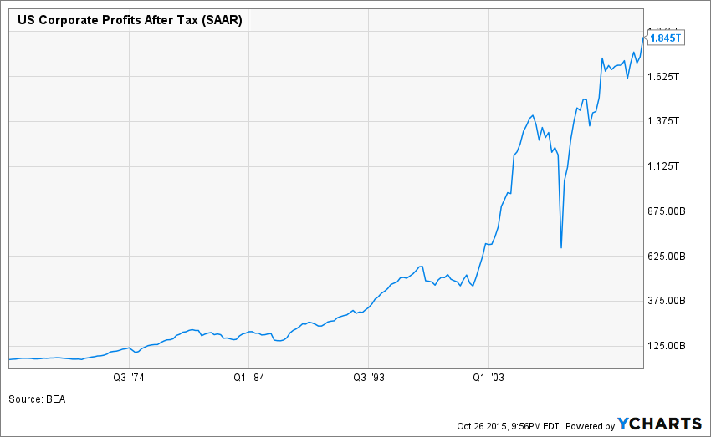

Fig. 1. This chart is of US Corporate profits from 1965 until 2015 (Y Chart).

Regarding labor in this new global economy Hoogvelt states it best: “The ascendancy of real time over clock time meant the core dichotomy between capital and labour was fundamentally altered with capital operating in real time and labour continuing in clock time” (Hoogvelt 54). This difference between labor and capital laid the foundation for the income inequality which began in the 1970s and has been further exasperated today.

Hoogvelt continues: the financial sector has become the dominate sector of the global economy. Small businesses profits are siphoned off the top in the market speculation. He also states the global trading of currencies averages about $3 trillion per day (54). “World GDP has tripled from 109 in 1980 to 316 trillion in 2005” (54). This economic growth is largely due to the financial sector (54). But this growth was not seen by employees, Hoogvelt states employee compensation drops from 60.1 % in 1980 to 56.3% of GDP (Hoogvelt 54). Also, the top tenth of taxable income increased from 35% to 49% - this is almost a 33% increase.

This picture comes into further focus when actual employee paychecks are analyzed. According to Drew Desilver real wage growth has been stagnant for decades (see fig. 2). When inflation is accounted for, today’s hourly wage is the same as it was in 1979. Yet, corporate profits appear to growing exponentially (see fig. 1). We now come to the issue of public debt. Nisreen Salti states 75% of interest payments on the national debt is going to the top 10% of households (of which the top 1% receive over 40%). The poorest the 30% of households receive a little over 1% of interest payments (5).

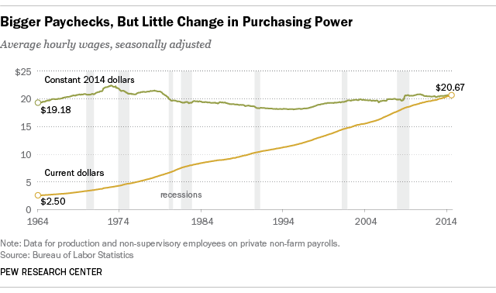

Fig. 2. This is the real purchasing power of workers (Desilver).

3. Exploitation

Corporate profits are at all time highs, even after the great recession. The profits these firms are making are largely fictionalized creations of intelligent minds. But who wins and who loses in this zero-sum game? With wages stagnant, investment banker compensation six times the American average, and CEOs compensation 512 times the American average, where is the distribution of wealth? It seems to me, it is clearly concentrated within a small fragment of society.

The American country as a whole is being exploited. Corporations have picked up and shipped jobs overseas at alarming rates – this is all well documented. The ratio of corporate investments (e.g. research and development) has been halved (Hoogvelt 54). The total amount of cash dividends has tripled (Hoogvelt 54). Money is being divested from research and the generation of new ideas are exchanged for profits. The global future is sold so a few can profit. How long can this system be sustained before the technological edge America holds wanes?

The American workers are being exploited. According to “An Economy Doing Half its Job”, by Michael Porter and others, the American GDP has returned to pre-recession levels of 2007. It took about three and half years to recover the domestic product. However, it took almost six years, from recession end until 2014, for the lost jobs to be regained. Also, during this period the American population increased by 15 million people (Porter et al. 3). During this time we have already seen wage stagnation for the American worker (see fig. 2). If there are more available workers and fewer jobs, it’s easy to see how wages have remained flat. “… Workers are captives of the weakest aspects of the U.S. business environment, while firms are beneficiaries of America’s strength” (Porter et al. 3).

According to Porter and others, “Shortsighted executives may be satisfied with an American economy whose firms win in a global markets without lifting U.S. living standards.” And this is exactly what is occurring now, with the loss of jobs to foreign markets, and divestment of research for profits. But where does this leave big business or any business for that matter?

I have not even touched upon the atrocities occurring overseas by American companies exploiting cheap labor in China, India, and the rest of the developing world: all in an attempt to increase profits and thus increase bonus sizes for executives. Corporate bonuses are tied to stock prices according to Alfred Rappaport’s article in Harvard Business Review.

4. Solution

There is a growing concern for the current economic system where this income inequality persists. Harvards’ own business elite have shown concern for future growth in America under this current system (Porter et al.). Even American citizens acknowledge a need for change based on researcher performed by Michael Norton and Dan Ariely (9).

While most Americans won’t think what I propose as reasonable, I believe there needs to be a change in the world’s reserve currency. It needs to be an independent currency not tied to any other commodity as proposed by Keynes (Hoogvelt). There also needs to be a radical shift in the way the world determines profit. Profit cannot only be used as a means to acquire more goods. It needs to include the cost of maintaining a relationship with each other within the global community. Resources are scarce and must be shared globally.

This new universal currency would eliminate the need for $3 trillion global exchange markets, which I believe is one of the major driving forces of income inequality. Executive compensation needs to be tied to real contributions to the global economy and not some engineered stock price. The true cost of producing goods needs to be included into all manufacturing. By that, I’m referring to the theft of natural resources in Africa and elsewhere, and the use of cheap child labor in India, China, and the rest of the undeveloped world. This costs needs to be included in any product so the true price is reflective to the consumer and producer. This would make it prohibitive for companies to indulge in such practices. Also, it would only unify the global community.

Cultural, ethnic, regional, and the plethora of differences between people need to be seen as an assist to be cultivated and not exploited. It is the interactions of these differences which created the recipe for great innovation and insight. It‘s a universal law of nature to spread seeds far and wide: ideas should be given the same freedom. This may sound like a utopian dream, but the single currency idea is being proposed by a modern day economist, Joseph Stiglitz.

Works Cited

DeSilver, Drew. "For Most Workers, Real Wages Have Barely Budged for Decades." *Pew Research Cetner*. N.p., 09 Oct. 2014. Web. 23 Oct. 2015. <http://www.pewresearch.org/fact-tank/2014/10/09/for-most-workers-real-wages-have-barely-budged-for-decades/>.

Helleiner, Eric. "Reinterpreting Bretton Woods: International Development and the Neglected Origins of Embedded Liberalism." *Development & Change* 37.5 (2006): 943-67. Print.

Hoogvelt, Ankie. "Globalisation, Crisis and the Political Economy of the International Monetary (Dis)Order." *Globalizations* 7.1/2 (2010): 51-66. *EBSCO*. Web. 25 Oct. 2015.

Porter, Micahel E., Jan W. Rivkin, Joseph B. Fuller, Allen S. Grossman, Rosabeth M. Kanter, and Kevin W. Sharer. *An Economy Doing Half Its Job*. N.p.: n.p., n.d. *Harvard Business School*. Harvard Business School, Sept. 2014. Web. 25 Oct. 2015. <http://www.hbs.edu/competitiveness/Documents/an-economy-doing-half-its-job.pdf>.

Rappaport, Alfred. "New Thinking on How to Link Executive Pay with Performance." *Harvard Business Review* (n.d.): n. pag. *HBR*. Harvard Business Review. Web. 25 Oct. 2015. <https://hbr.org/archive-toc/3992>.

Stiglitz, Joseph E., and Bruce Greenwald. "Towards a new global reserve system." *Journal of globalization and development* 1.2 (2010).

*US Corporate ProfitsAfter Tax*. Digital image. *Ycharts.com*. N.p., n.d. Web. 26 Oct. 2015. <https://ycharts.com/indicators/corporate_profits/chart/#/?securities=include:true,id:I:USCPATAQ,,&calcs=&correlations=&zoom=custom&startDate=01%2F01%2F1965&endDate=10%2F26%2F2015&format=real&recessions=false&chartView=&splitType=single&scaleType=linear&securitylistName=&securitylistSecurityId=&securityGroup=>.