ARCH1291 – Visual Studies II
Week 8, Spring 2013
Assignment 7 GIS I
Prof. Alihan Polat

Visual Studies Exercise.Topic08 (Architectural Paleontology)
Geographic Information Systems (GIS), Part I

Medium: GIS
Concept: Basic Skills – Visualizing Data
Date: 01/22/13

Subject: Visualizing Historic Data for Countries

This topic involves an analysis of historic data of your Paleontology house location. We will use the following indicators for the country level:
- GDP (Gross Domestic Product)
- Climate (Average Annual Temperature)
- Population
- Land Area
- CO2 Emission Level
- Percentage of Urban Population
These indicators are derived and joined from multiple datasets, with the goal being to run a comparative analysis between countries. The comparative analysis can be made between different countries or between different years on a single/multiple country. The deliverable of this exercise will be multiple maps analyzing different eras for certain indicators.
Data inventory for this exercise:
- World_Counties.gdb: A geodatabase file with country borders and an attribute table for:
  - GDP (Data From 1600-2008)
  - Population (Data From 1600-2030 projected)
  - Land Area (Data from 1920-2010)
  - CO2 Emission Value (Data from 1960-2008)
  - Urban Population Percentage to Total Population (Data from 1960-2008)
- Cities.shp: A shapefile major city location points
- Evtempc: A Raster dataset that shows average temperature values from 1950-2010 in Degrees Celsius.

INSTRUCTIONS

You will develop a series of maps using the indicators defined below. All maps will be pinned up together in a linear format. Please keep your map format consistent throughout the exercise.
Creating a New Map File
- When you open ArcMap, you will have options to create:
  - A new empty map
  - A template
  - An existing map
- Click Create a New Empty Map
- Your map is created now; it will be a good idea to save it first then you can add data to it. Go to the File menu and save your map to desired location. To add data use the pull down File menu and click Add Data. Also, you can click the Add Data icon on your main toolbar on top.
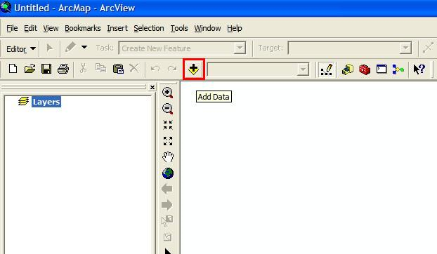

- ArcGIS will open the Load Data window and will ask you to point to which file(s) to load in to the current map. Since ArcGIS is NOT using the classic file manager interface of Windows software, you will recognize that you cannot select all the directories on your computer/desktop. In order to browse through the file folders on your computer click the “Connect to Folder” icon.
Once a folder is connected to ArcGIS, it will stay there.
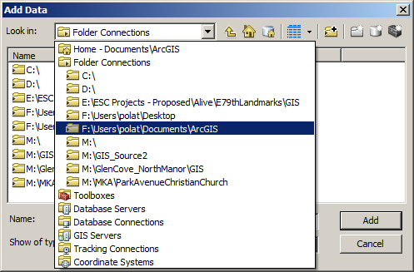

- Load all the datasets in the GIS Data topic 5 folder. You can load more than one shapefile at a time but you can only load the World_Counties.gdb at once. When it’s clicked, it will show you the contents of the geodatabase file. Please choose All_World_Countries to load. You should see a world map of counties with borders, major city locations as points and a grayscale gradient image with world map. Please note, the layers and their view order can be adjusted by dragging them up and down.
- Right-Click the All_World_Countries data and open the Attribute table. Inspect the table and make yourself familiar with the field names, we will be using multiple fields from this table to create thematic maps. Below is an explanation of attribute table fileds.
  - Y1-Y2008: GDP values by year in 1990 Geary Khamis dollars
  - Pop1600-Pop2030: Total Population
  - Lndarea20-Lndarea2010: Land area in KM2
  - CO2EM1960-CO2EM2008: CO2 Gas emission in Kilotons

- Right-Click climate raster image file (Evtempc ) and click properties. Go to the Symbology tab. This is where you will choose which data to visualize and how. You can do a symbology based on Stretched Colors and create a heat map of the yearly average temperature. Please choose the color scale that starts with red and gradients to a blue with yellow tomes at center. Make sure color tones red shows higher values whereas color tone blue shows lower value. If that is not the case, click the invert setting symbology tab.

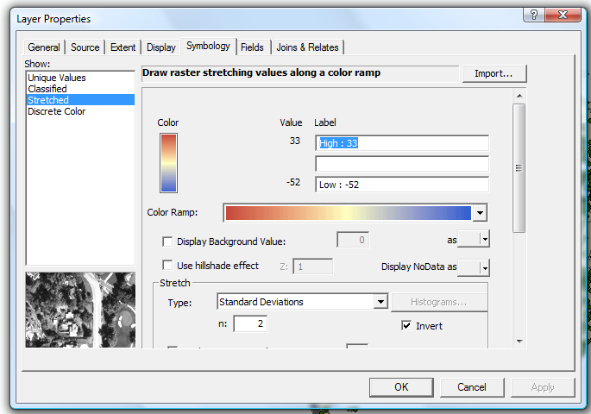

- Now right click the All World Counties layer and go to symbology again. Click the single default color symbol and use no color for fill color and use black for outline color. This will show just the country borders on the map. Now go to Labels tab and select label features in this layer. Make sure the text string for labels are set to name.
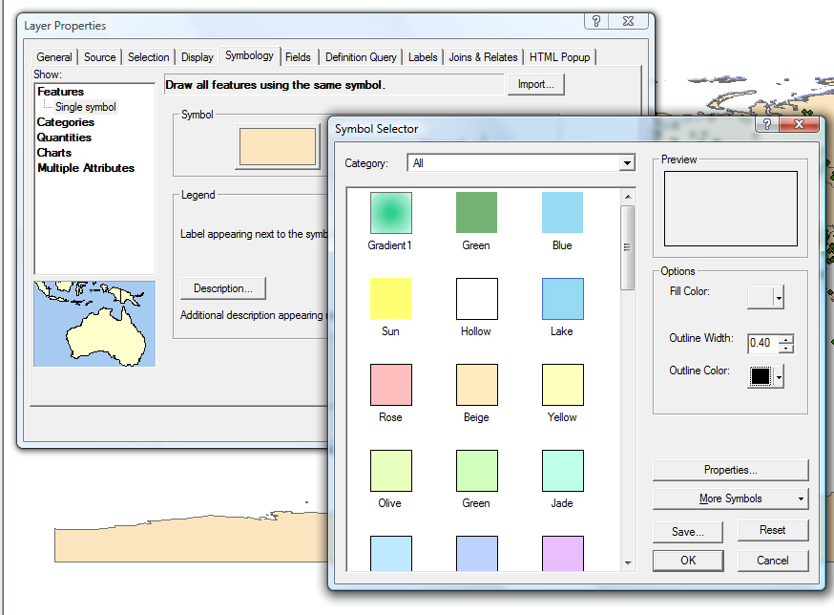
- Turn off the visibility of all layers except the city point layer. Turn on the labels for cities as well and find the city your assigned architectural piece. If your city is not listed in the cities file, just find the closest city. Select the city using the selection tool. Once you do the selection, you will see an outline around the selected city point. Now right-click the city point file and choose
Data>ExportData from the pop-up menu.
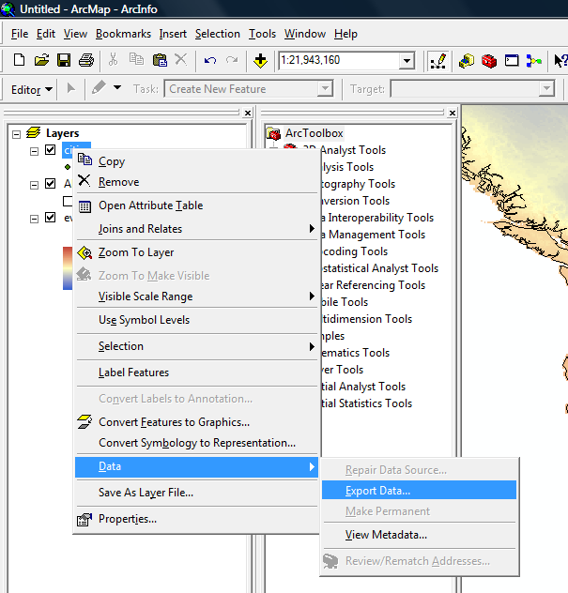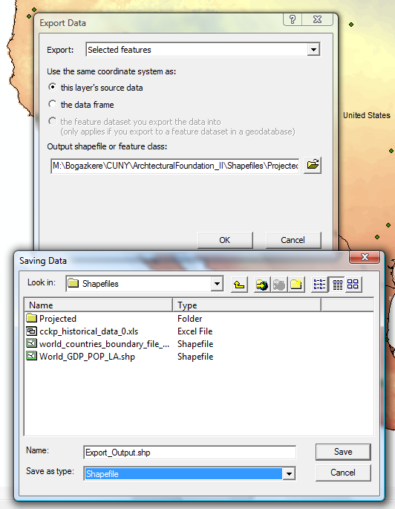

- In the export data dialog box, chose selected features and click the browse to choose a destination folder for the exported shapefile. Name it with the same name as your city and choose shapefile as the export file type, click save. Add the new layer to your map by saying yes on next screen.
- Turn off the cities layer and leave your city layer turned on. Turn back on the average temperature raster image and all world countries layers. They should be organized as the city layer being on top and average temperature raster being on bottom.
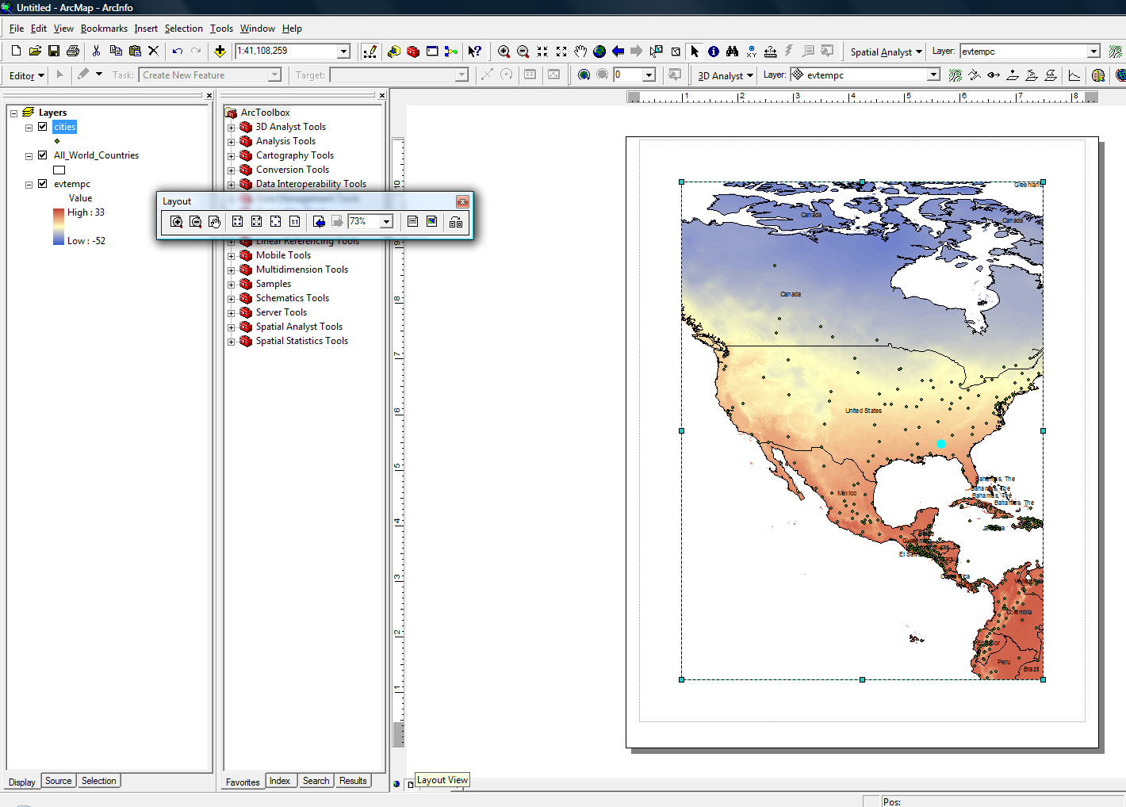
- Switch to Layout view by clicking the layout view button on the lower left corner of map screen. Now you should see your map on paper layout. Go to File>Page and Print Setup. Switch your paper size to 11 x 17 (tabloid), orientation to landscape and your printer to Adobe PDF. Drag your dataframe corner points to fit your dataframe to your paper. Once you are done with setting the dataframe to fit tabloid paper, change your scale to 1:20,000,000 and center your map on the page using pan tool. This will fit the map nicely to your paper showing the continent your analysis city resides and its proximity.
- Once you are done, go to bookmarks menu on top menubar and choose create. Name your bookmark as map1. This will save your map extent, scale and view. If you change your zoom level or your pan, you can always go to bookmarks and click the map1 to restore your view location. You can create unlimited number of bookmarks in a map file.
- You created the first part of our map. Now, we will insert another map to show the same data in world scale. Please click the Insert pull down menu and choose Data Frame. ArcGIS may pause for a brief time, this is normal while inserting a new dataframe. Once the new dataframe is created notice that you have a new layerset called new dataframe on the table of contents. Also you can see the highlighted new dataframe on your screen. Now drag the new dataframe to lower right corner of your paperscape. Align the bottom and right corners to your existing dataframe on screen. Resize the new dataframe by right clicking the new dataframe and hitting properties. Navigate to size and position tab and use 5.5 inches for width and 3.5 inches for height. We will use this new dataframe like a keymap to our main map.
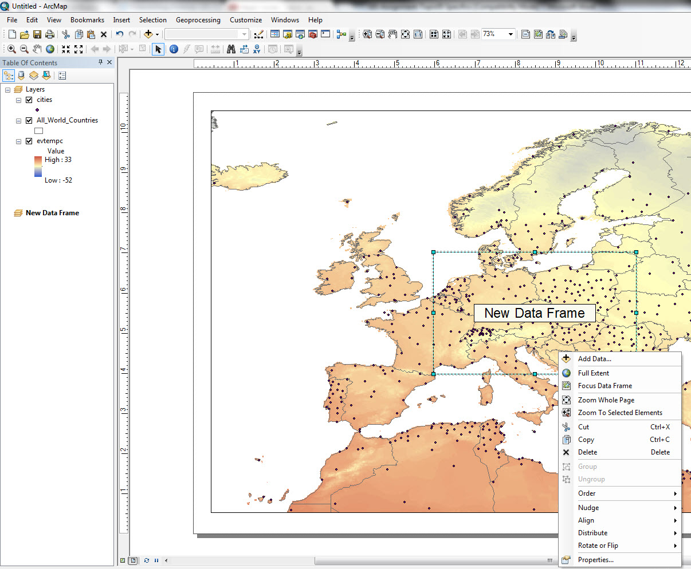
- Now right click on the new dataframe and go to properties. Open the frame tab and switch the frame color to white. Click Ok. This will create a solid white background so the new frame is not transparent anymore.
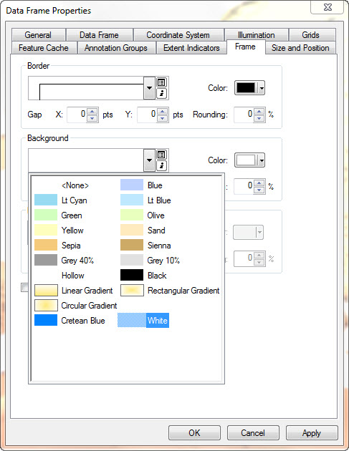
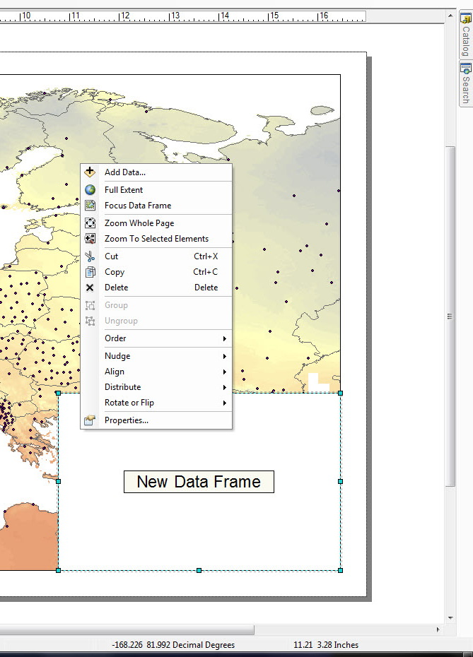
- Right click the new dataframe and choose add data. Load all the data that are on the main layout. Perform the same symbology to each layer as they exist on the main map layout. Then set the scale to
- The next step is to insert a title and a legend to your map. Click Insert pull down menu and choose title. Name your map “Average Annual Temperature in Celsius” and locate it to upper center portion of your map. Go to insert menu again and choose legend. In the legend wizard just keep the annual temperature raster layer on the right and everything else on the left. Choose style from the menu and click properties from the next window. Unclick show layer name and click ok. All you have to do is to add country names. Right click the All_World_Countries layer and choose properties. Go to Label tab and click label features in this layer, make sure your font type is Arial and font size is 11.
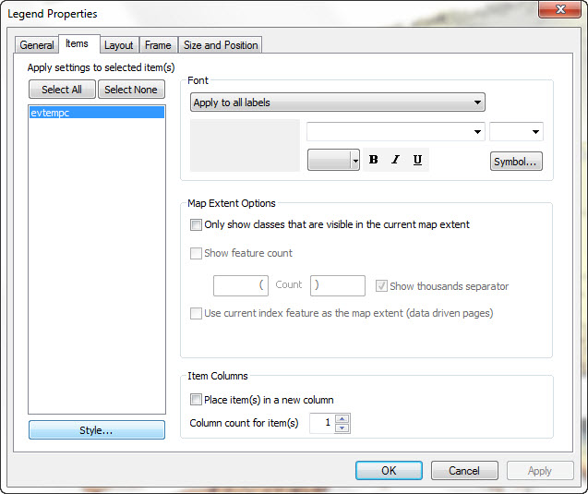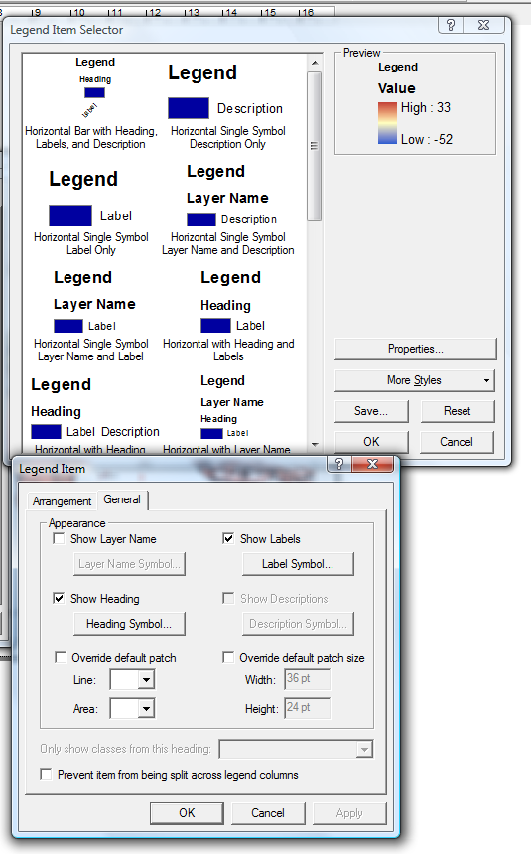
- Your map should look like the below. Now export your map to a PDF to be printed. Save your work and your first map is done.
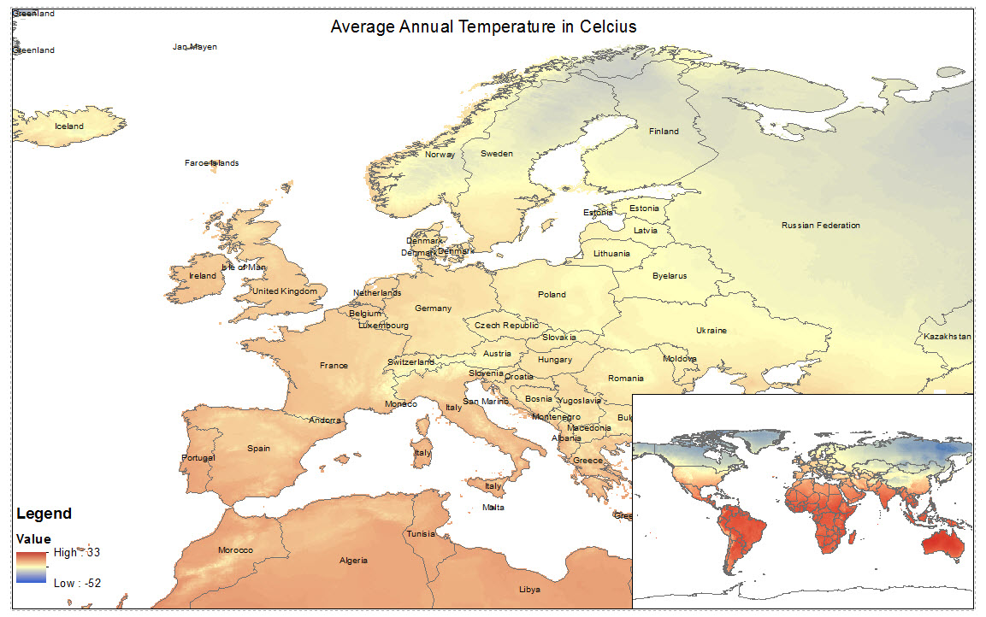
- Save your active map as a new file. We will make changes to symbology of layers and we do not want to lose the previous map. Switch back to data view using the icon next to layout view.
- Turn off the average temperature layer. Right click the All World Countries layer and go to symbology from properties. Choose quantities from the left panel of the menu and set the value to population in year your topic building is built. Choose the orange gradient from the available color ramps. Set the breaks to 10 and type 0 (number zero) to the first break value. Change the color of zero break value to a medium grey. We will call these as no data available. Click Ok and you should see a population map.
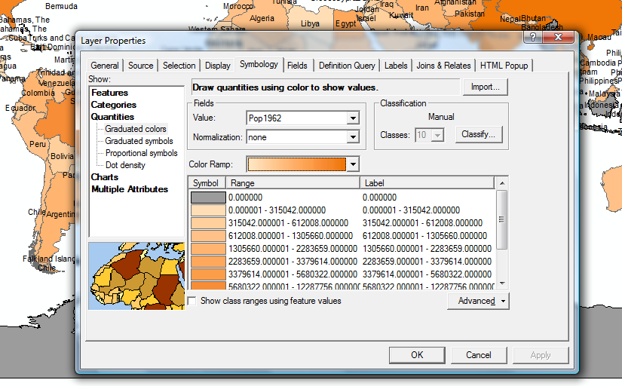

- Go to layout window no and choose insert>Data Frame from top menubar. This will insert another layout to the paper with blank layers. Right click anywhere on the new layout and add All World Countries layer to new dataframe. Use the same symbology properties but this time use year 2009 population value. Drag and locate the new dataframe to lower right of your layout paper view. Right click the new dataframe and choose properties. Go to frame tab and select your background as white Change the title to Total Population by Country and add your city layer to both layouts. You can use the menu on the right to access the second layouts table of contents.
- Hand in your pdf file and Process Folio update.
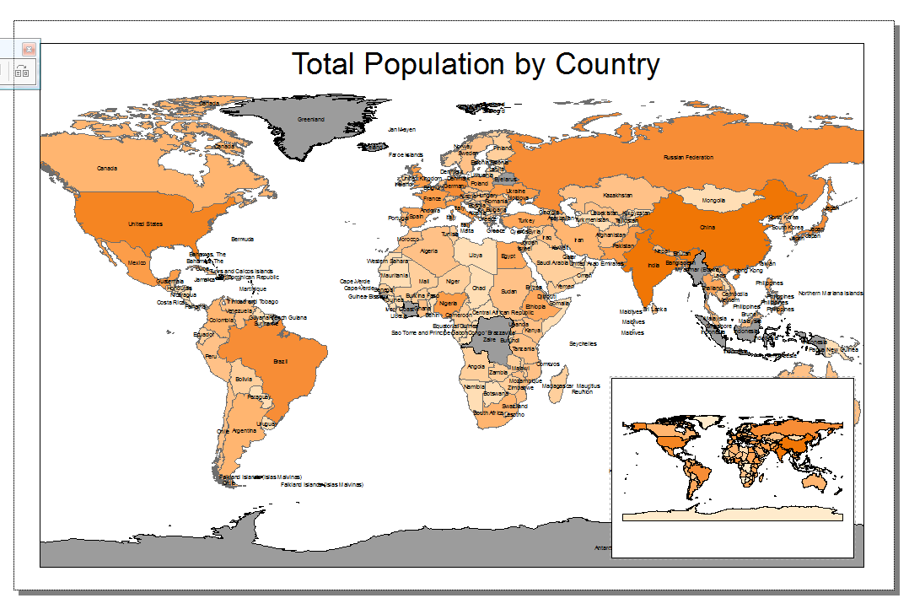

- Export your map as a PDF. Since all the data on these maps are vector based, you can control the colors and line thicknesses in Adobe Illustrator.

- When you have finished, please submit the digital file(s), named Professor’s Last Name_Sp13_Your Name_GIS I. Please print out your 11” x 17” maps.

- Do not forget to save all your files after completing the exercise. Make sure you copy your map files and your data files to your personal / USB drives.

There are some GDP values for certain countries that go back to 17th century. Since there is no record of indicators before the modern era, all the historic data is derived and calculated by using mathematical models. All the data after 1969 are derived directly from World Bank Yearly Reports.

