Visual Studies II: Arch 1291
Spring 2013

Assignment Number 6: Colorspace and Raster/Vector
Computer Program(s): Rhino, Photoshop, Illustrator

Student Learning Objectives:
To export vector and raster images from Rhino to be used as an underlay in other graphics packages.
To gain an understanding of RGB, HSB, additive/subtractive mixing.

Reading for the Coming Week:
Greg Lynn, The Protofunctional Potential of Diagrams in Architectural Design

Assessment:
The project will be assessed relative to the following learning objectives:
- Understanding of Rhino’s export functions
- Production of Munsell diagrams that demonstrate an understanding of the original color chart
- Generation of InDesign layouts that are complete and appropriate in architecture culture

Project Description:
Color is the way that human beings perceive the wavelengths of light between 400 (near ultraviolet) and 700 (near infrared) with different colors corresponding to different wavelengths in this range. The shorter the wavelength, the more energetic the light.

While it may not be crucial to understand the exact physics of light, we do need an understanding of how light works to understand color. Electronic displays, for instance, generate very specific wavelengths or colors of light. They “mix” these very precisely to create the image you see on screen. Displays that emit light often are called RGB, or red, green, blue displays. This is the case because the primary colors (the colors requires to generate every other visible color) for light are red, green, and blue. If you combine RG and B light, the result is white.

Inks, paints, and other physical media are subtractive methods. Unlike light, mixing these will yield a darker and darker result. You may remember the primary colors of physical media to be red, yellow, and blue. Scientifically the best “primary” colors for subtractive colors are cyan (a bright blue), yellow, and magenta. Mixing these colors gives you black, and a gamut of other possibilities. Printers generally use this color space.

You might have identified a potential problem: monitors use RGB colors, and printers use CMYK colors. Thankfully, our computers will translate, but we do have to be aware that some colors will not handle the shift well, and make adjustments.

Requirements
You will create a Munsell diagram applied to an array of 3D forms and also color your Pavillion, using the color theory work you have done in Design Foundation. The following description is oriented towards the former, but some of the concepts apply to the pavilion work.

You will create a digital model in Rhino that will become the base for a digital Munsell Color Chart. This chart will be exported as a vector file. You will then add color to this chart in Adobe Illustrator (vector version).

Process - Rhino

- Review the terms listed in the following pages to re-familiarize yourself with the important distinctions between the tools and concepts you will be using to complete the assignment. Review the Rhino Tutorial on pages 1-15 to re-familiarize yourself with the commands before beginning. Read the complete assignment before beginning!

- Create a new Rhino file using the “Small Objects, Inches” template.

- Create a 1” CUBE by selecting it from the SOLID dropdown menu. Make sure the cube is 1”x1”x1”

- Select your cube and type the command ARRAY.
Use the following setting for your array:
  - Number in X direction (7)
  - Number in Y direction (7)
  - Number in Z direction (7)
  - Unit Cell or X spacing (2) –this refers to the spacing between each cube
  - Unit Cell or Y spacing (2)
  - Unit Cell or Z spacing (2)
  - Hit enter to complete the command

- Use the command SHADE to hide the wireframe

- In your perspective viewport adjust your view to be able to see three sides of your cube, like the example below:

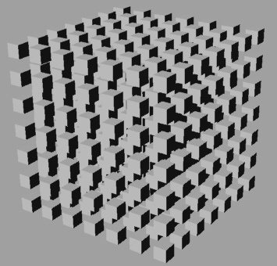

- Place the geometry on its own layer named “Munsell Volumes.”

- In your perspective viewport select all your objects and type MAKE2D in the command prompt. (make sure that you are in the perspective viewport when you use the command or it won’t work)

- Now you will notice that a 2d version of your cubes has appeared on the bottom of your model. Select only your 1” cube array and hide it by using the command HIDE. You should now only see the 2d perspective drawing of your cubes.

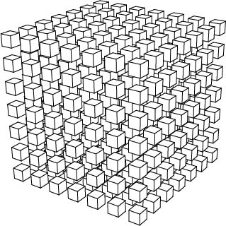

- Click in the “TOP” viewport. Select the objects you’ve created by pressing CTRL-A on your keyboard.
  - Go to File> Export Selected.. For “Save as type” choose Adobe Illustrator.
- Save your work. Name your file Professor_Last_Name_SP13_Project_Name_Student_Name_(Image Number))

Illustrator

- Open the file you exported in Illustrator.

- Scale the image by selecting everything and dragging the corners so that it fits your entire page.

- Select all of your geometry and set the stroke weight to .5pt. Set the stroke color to black. You can find the Stroke option on the top left of your screen.

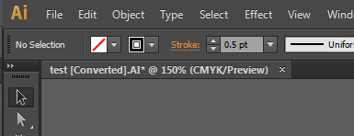

- Select your entire Geometry by selecting CTRL ALL

- With all of the geometry still selected, go to Object>Live Paint>Make.

- Using the “Live Paint Bucket” fill your objects with the proper Munsell Colors. After selecting “Live Paint Bucket” you will notice that the perimeter of the surface you are selecting turns red. This means that the surface is ready to be filled by the color of your choice.

- Finally to change the color of the fill, hold the SHIFT key and LEFT click on the location shown below.

InDesign

- Open your Portfolio document
- File>Place all your Munsell chart OR Pattern images into the document from 1210 and 1291.
- Include images that show the process of creating this piece. Labe and diagram to clearly show the steps taken.
- Review your use of text and change the text for this project that shows a greater knowledge of fonts used in architecture and that are suited to your design work.
- Save your file with the standard name (ie Professor’sName_Sp13_First-Last_AssignmentName).
- File>Package your document.

Submittal
Please submit to the project folder, by the beginning of next week’s class, your digital mode in Rhino, JPEG, Illustrator , and the InDesign portfolio.

P06.0: Rhino File (3DM)
P06.1: Illustrator File (AI)
P06.4: InDesign Package Folder

NAME __________________________________________________________________________

EVALUATION Your grade will be based on the care and craft of your digital diagrams, descriptions, and original image. Projects are evaluated based on their level of quality. A grade of “A” indicates an excellent level of quality. A grade of “A/B” and “B” indicate a good level of quality. A grade of “B/C” and “C” indicates a fair level of quality which is acceptable, but not notable. A grade of “D” indicates a poor level of quality which is unacceptable. A grade of “F” indicates a poor level of quality and an incomplete project.

PROJECT WEIGHT 6% of Final Grade

ON-TIME All Files Beginning of Class 5

CRAFT (60%) 4 3 2 1 0 Diagram Quality & Accuracy
All/Most/Some/None of the diagrams are accurate and complete

Diagrams show thoughtful use of drawing techniques
Descriptions are clear
Legend is communicative and clear

4 3 2 1 0 File Quality & Accuracy
All/Most/Some/None of the drawing elements have been placed on appropriate layers

InDesign master page has been utilized to set up title block for layout
Files have appropriate pixel density as called for in assignment

DESIGN (40%) 4 3 2 1 0 Meets Problem Constraints
All/Most/Some/None of the presentation is complete

Contains flow/hierarchy diagram
Contains color diagram
Contains original image
Contains student generated image
Contains descriptions

4 3 2 1 0 Achieves Design Excellence

Design decisions for student generated image are consistent with original image chosen
Graphic decisions create a clear visual hierarchy in each diagram
No/Some/Thorough understanding of color, geometry, and flow shown in diagrams through the use of drawing and representation techniques
Legend is well designed

A | A- | B+ | B | B- | C+ | C | D | F
4.0 | 3.7 | 3.3 | 3.0 | 2.7 | 2.3 | 2.0 | 1.0 | 0.0

