Visual Studies II: Arch 1291
Week 11, Spring 2013

Assignment Number 8 part II – Lattice Pavillion, part II [SEE PAGE 2 FOR PROCESS]
Digital Modeling Techniques: Patterning > Laser Form
Computer Program(s): Rhino, Laser Cutter, InDesign
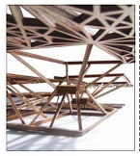

Student Learning Objectives:
To solidify 3d modeling techniques acquired thus far
To understand surface/solid creation/manipulation and laser cutter file preparation
To practice forming, and transforming techniques, including vertical and diagonal offsets in the digital space.
To understand how to manage large maulti-page files in InDesign

Assessment:
The students will be evaluated according to demonstration of skill of the following learning objectives:
- Understanding solid and surface modeling and creation
- Use of process documents/diagrams that show student’s understanding of the surface modeling processes
- Completeness of student generated InDesign layouts

Project Description:

Working first at the level of the component, a series of tracing and abstraction within Rhino yields a model shaped in a way that will help to formulate ideas about unit aggregates. Within these specific studies, the ideas of vertical and diagonal shifts emerge based on the number of bounding vertices.

INSTRUCTIONS
- The first part of the assignment involves taking part of your Paleontology house floor plan and extracting a pattern of rectangular shapes from it.
- The second part of the assignment is to create a 3D pattern from the original pattern and move/copy parts of the pattern in a vertical and diagonal shifting operation to create a new visual and spatial order. The new structure should be 2-3 levels tall.
- Using the slab command, create a 1/8” x 1/8” series of strips for the project.
- The parts will be Unrolled to bring the form back to 2D and allow laser cutting of the forms.
- Place your projects efficiently on the sheet stock to not waste material.
- Label the parts and Send the files to print on the laser cutter.
- Assemble the mode according to the 3D digital model

Requirements
- Drawings of pattern – both 2D and 3D [plan, elevation, 2 perspective views]
- Laser cut model from chipboard/bass wood [for 2nd week]
:

Process, Week II of Lattice Structure

- From top view create with the slab command a border of 1/8” by 1/8” for the hatched (large) rectangle..Copy this border slab in place.

- Offset the border curve from this large rectangle by 2 or 2.5 inches to the inside, and create a planar surface.

- Group all the elements but the planar surface and the copy of the large rectangle border

- Open four viewports layout, and move the Group to 10” above the ground plane. Next move the plane to 5” above the ground plane.

- Use the ExtrudeSrf command to create a 1/8” deep solid from the planar surface

- With only the end snaps on, draw 4 polylines that connect the three levels. Beginning at the bottom right corner, connect the bottom of the Border that remained on the ground plane with the corner of the extruded surface (5” above ground plane) and the corner of the rectangle border at 10”. Work your way around the four corners.

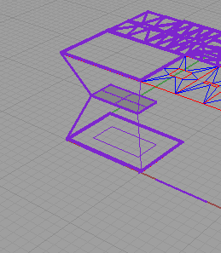

- Run the slab command on each line, and choose a .125” offset and height. Make sure these offset towards the center of the model. This can be aided by snapping to the opposite corner of the platform when asked for the direction of the extrusion (for the line on the right this would be the top left corner of the platform).

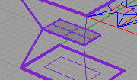

- You can work with the Control Points of the diagonal line to adjust the slabbed form and minimize the needed trimming. If trimming is needed, trim the tops/sides of the connecting diagonal pieces as needed by creating a plane (Cut Plane) that will be used to trim with (NOTE: the plane needs to extend beyond the edges of the polysurface on all sides) and then running the trim command.
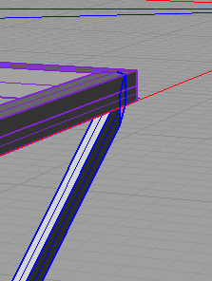
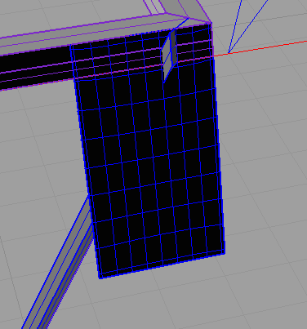
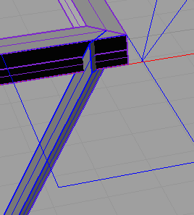

- Select the Unroll Srf command and choose one polysurface. For options choose Explode and no Label. Next find the unrolled surface on the groundplane in the Top view.

- Observe the two dimensionalized forms to understand which side relates to which part of the 3D diagonal form. Repeat the UnrollSrf for the polysurfaces at each corner.

- Set up the laser cutter file, with the diagonal strip outlines, the 2D traced form you created for the roof, the mid-level platform, and 2 copies of the bottom framework.

- Email your file to your professor for approval before laser cutting. We will be using some basswood for the project—we need to minimize cut repetition.

Submittal
Please submit within the first fifteen minutes of next week’s class to the project folder, in Drop Box or Blackboard. Please include a proper sample of how to format the files.
USE the correct NAMING FORMAT example: Professor’sName_S13_Somayeh-Ghorbani (P01.0) , and hand in 4 perspective view digital model files, and InDesign package Folder.

Vocabulary:
Vertices
Centroid
Abstraction

Example Project

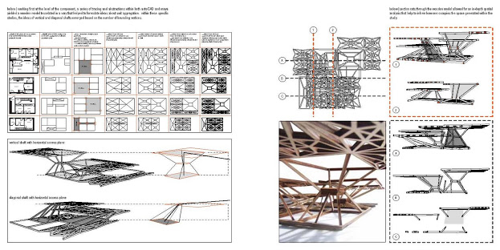
Evaluation: Form in Laser Cutting

Name: _______________________________

Evaluation is based on the standard project grading criteria described in the syllabus with the following specific issues emphasized.

Digital

0 5 10

Boolean Union model completed

Boolean union steps recorded in Word document

Boolean subtraction model completed

Boolean subtraction steps recorded in Word document

Surface model completed

Surface model steps recorded in Word document

Texture mapping model completed

Digital photos or scanned drawings properly cleaned up prior to mapping

InDesign layout is 8.5x11, no facing pages, packaged correctly

Digital Grade

Design

0 5 10

InDesign layout is clear and conveys relationship of models

Design Grade

