Visual Studies II: Arch 1291
Week 10, Spring 2013

Assignment Number 8 part I – Lattice Pavillion
Digital Modeling Techniques: Patterning > Laser Form
Computer Program(s): Rhino, Laser Cutter, InDesign
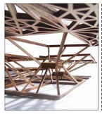

Student Learning Objectives:
To solidify 3d modeling techniques acquired thus far
To understand surface/solid creation and laser cutter file preparation
To practice forming, and transforming techniques, including vertical and diagonal offsets in the digital space.
To understand how to manage large maulti-page files in InDesign

Assessment:
The students will be evaluated according to demonstration of skill of the following learning objectives:
- Understanding solid and surface modeling and creation
- Use of process documents/diagrams that show student’s understanding of the surface modeling processes
- Completeness of student generated InDesign layouts

Project Description:

Working first at the level of the component, a series of tracing and abstraction wiithin Rhino yields a wooden model shaped in a way that will help to formulate ideas about unit aggregates. Within these specific studies, the ideas of vertical and diagonal shifts emerge based on the number of bounding vertices.

INSTRUCTIONS

- The first part of the assignment involves taking part of your Paleontology house floor plan and extracting a pattern of rectangular shapes from it.
- The second part of the assignment is to create a 3D pattern from the original pattern and move/copy parts of the pattern in a vertical and diagonal shifting operation to create a new visual and spatial order. The new structure should be 2-3 levels tall.
- Using the pipe command, create a 1/8” x 1/8” series of strips for the project.
- The parts will be Unrolled to bring the form back to 2D and allow laser cutting of the forms.
- Place your projects efficiently on the sheet stock to not waste material.
- Label the parts and Send the files to print on the laser cutter.
- Assemble the mode according to the 3D digital model

Requirements
- Drawings of mesh pattern – both 2D and 3D [plan, elevation, 2 perspective views]
- Laser cut model from bass wood [for 2nd week]
:

Process
- Open the floor plan of your Paleontology house (use a Le Corbusier rectangular house if your floor plan is organic/ has curved forms). Make sure it is scaled to fit within an 18” x 18” footprint as we will be outputting to the laser cutter, and it will need to fit within the size of the laser bed. (1.)
- On a new layer, named “Forms”, trace the principal forms in the plan, finding the underlying pattern logic (2.)
- Turn off the original floor plan layer, and continue to work the idea of pattern creation, refining the rectangular forms until the pattern is well designed (using principals learned in 1210 this semester). (3.)
- Define one dominant area that defines the space that will eventually serve as the base of your model (and covers at least 1/5 to ¼ of the overall area. See below). Shade this area with the hatch command. (4.)

1. 2. 3., 4.
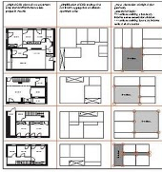

- Create a layer named “Framework”. On this layer, draw an X through all the rectangular units: this will help define the centroids [5]. On another new layer, “Pattern” use this center point to draw a small rectangle at the center of the rectangular units [6] (See figure below).

5 6 7
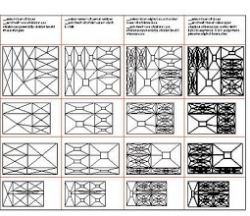

- Reconnect the vertices (points) of the outside rectangle edges to the vertices of the interior rectangles [6]. From here, except for the main rectangle you hatched earlier, create a pattern using the midpoints of the rectangle edges as you progress [7].. Create a design similar in density to the example. All these will be on the “Pattern” layer.

- Next, turn off the “Framework” layer, and create a new layer, “Subdivisions”, on which you will trace over each Subdivision triangle, with only the End Point snaps turned on so your triangle is a closed polyline. As you finish each subdivision, use the SLAB command. Click on the inside of the closed polyline for the offset side and choose a distance of .065” and then a height of .125”.

- You will notice that the edges of the piece are 1/16” while the center parts are 1/8”. Draw a single line along the inside of each of the thinner parts at the edge and then use the SLAB command on the line, using the offset and height dimensions as before to make the model uniformly of 1/8” width parts.

- Finally, create a new layer, “2D Laser Cutting” and on this layer carefully trace over the exposed edges using closed polygons. You will be defining the positive-negative space for the laser cutting—don’t choose the middle lines used to construct your digital model. All lines should be 1/8” thick. Turn off all layers except this “2D Laser Cutting” layer.

- The last step involves imagining the overall form as an open air pavilion: use the larger rectangle as the base [see the example photo] and decide if when the form becomes three-dimensional and the larger rectangle becomes the base, you’d like to move the patterned rectangles vertically or vertically and diagonally.

Submittal
Please submit within the first fifteen minutes of next week’s class to the project folder, in Drop Box or Blackboard. Please include a proper sample of how to format the files.
USE the correct NAMING FORMAT, for example: Professor’sName_S13_Somayeh-Ghorbani_LaserCutterI , and hand in 4 perspective view digital model files, and update your InDesign package Folder.

Vocabulary:
Vertices
Centroid
Abstraction

Example Project

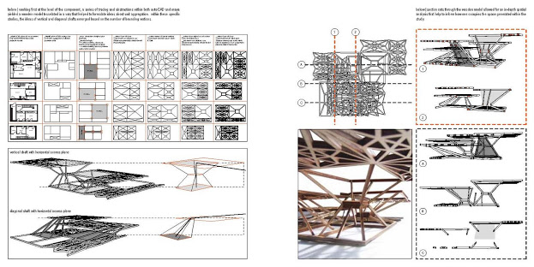
Evaluation: Form in Laser Cutting

Name: _______________________________

Evaluation is based on the standard project grading criteria described in the syllabus with the following specific issues emphasized.

Digital

0 5 10

Boolean Union model completed

Boolean union steps recorded in Word document

Boolean subtraction model completed

Boolean subtraction steps recorded in Word document

Surface model completed

Surface model steps recorded in Word document

Texture mapping model completed

Digital photos or scanned drawings properly cleaned up prior to mapping

InDesign layout is 8.5x11, no facing pages, packaged correctly

Digital Grade

Design

0 5 10

InDesign layout is clear and conveys relationship of models

Design Grade

