DRAFT

ARCH1291 – Visual Studies II
Week 8, Spring 2013
Assignment 7 GIS I
Prof. Alihan Polat

Visual Studies Exercise, Assignment 07 (Architectural Paleontology)
Geographic Information Systems (GIS), Part II

Medium: GIS
Concept: Basic Skills – Visualizing Data
Date: 01/22/13

Subject: Visualizing Data for Countries / 2

THIS IS THE SECOND PART OF THE GIS EXERCISE.

READING for the coming week: Manuel Delanda, Deleiuze, Diagrams, and the Genesis of Form

INTRODUCTION
This topic involves an analysis of historic data on country level, using the following indicators:
- GDP
- Climate (Average Annual Temperature)
- Population
- Land Area
- CO2 Emission Level
- Percentage of Urban Population

In this exercise you will work with a team of three to four people to explore a topic comparing how factors in the region where your house(s) are located potentially affect the local architecture. These could include urban to rural population ratios, wealth, climate, or other factors--whatever information you find in the data folder can be used. For this week’s analysis, you can use either current or historical data.
The indicators in the data folder are derived and joined from multiple datasets, with the goal begin that the classwork overall provides insights into the factors that may lead to variations in architecture across countries/regions.
Data inventory for this exercise:
- World_Counties.gdb: A geodatabase file with country borders and an attribute table for:
  - GDP (Data From 1600-2008)
  - Population (Data From 1600-2030 projected)
  - Land Area (Data from 1920-2010)
  - CO2 Emission Value (Data from 1960-2008)
  - Urban Population Percentage to Total Population (Data from 1960-2008)
- Cities.shp: A shapefile major city location points
- Evtempc: A Raster dataset that shows average temperature values from 1950-2010 in Degrees Celsius.

Part II Process

- Choose people to work with that have projects geographically close and contrasting to yours. For example, Finland and Mexico would make good contrasts looking at climate or population.

- At this point, you have two maps from the previous part of the exercise.
  - Climate (average Annual Temperature)
  - Population

- Load the last map file for which you created population maps.
- Save this map as a new map file.

- Choose the data you will be working with, and decide the thesis (premise) you will be exploring as well as how you intend to represent this (ie. What symbology (heat map or dot representations). This part of the assignment will be done in class. Communicate with your professor and get their feedback before proceeding.

You will meet with your group during the week to finish your representation, and come to class prepared to present your findings in ArcMap.

Some GIS pointers that may help you as you work:
- There is one easy way to copy the symbology from an existing layer. When you are in the symbology tab, you can click import and choose the source layer that this layers symbology will be based on. Usually this is easier and more efficient than doing it all over again.
- Your map extents should be the same as the previous maps. Make sure the display scales are consistent and other layers that show your topic’s city and country name labels are visible.

- Open your map. First thing to do is to modify the layout. In this round of the exercise, we will need to have two large maps with two small maps to compare two different subjects. Change the Page Layout to a landscape mode by clicking File>Page and Print Setup. Make sure the page size is tabloid and printer is set to PDF.
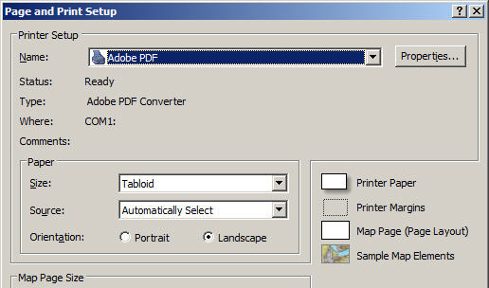
- Switch to Layout View and resize your layout window to square size that will fit to the first part of the page. It may not need to be a perfect square. Then copy and paste the layout window so you have an exact one on the left half of the page. Your layout should like something like the below.
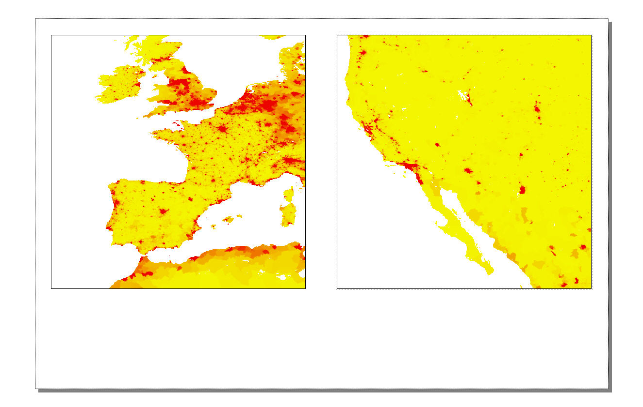
Resize
Then Copy and Paste
- Now you need to add the keymap as you did in the first part of the exercise. Insert a new Layout (Step 13 of the first part of exercise). Place it underneath the maps aligning with right side. Use the same scales on both larger maps and small map as in the first part of the exercise.

One option can be to use CO2 Emission data to create a comparable map.

- Right click to select All World Countries layer (the copy used to display the land area) and choose properties. Navigate to the symbology tab. Change the Value to CO2 Emission (CO2Em_##) of the year of your topic. Use10 for the classification.
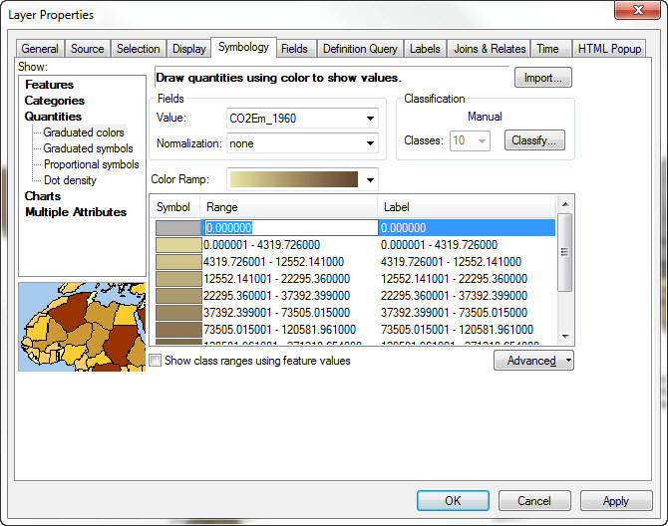

- Since the dates of two subjects will be different, use the most recent data available on both subjects. We will use 10 classes for classification of the data, we have to assign one flat color to value 0 which indicates there is no data. Go and click the first range field and type the number zero (0). This will be out no data class. Change its color to 30% grey.
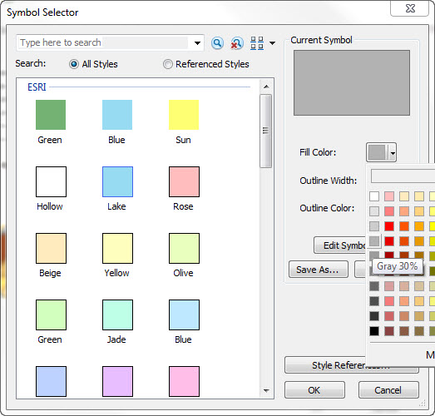

- Change the color ramp to brown gradient (as indicated on below image). Click Ok. (The CO2 Emission fields are in Kilo-Tons )
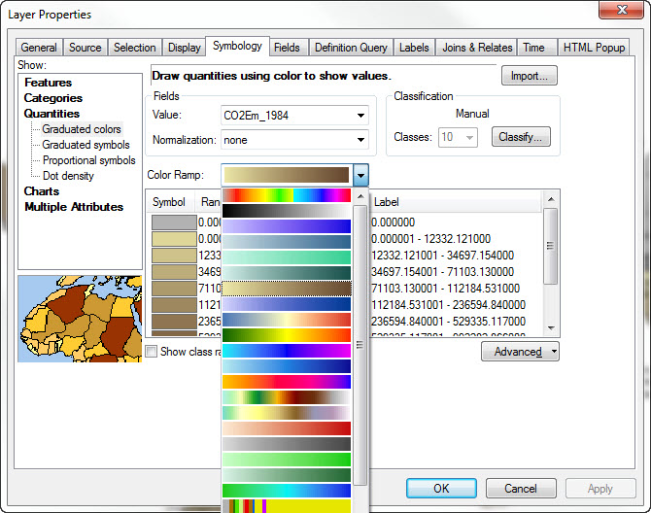

- Now do the same for the small key map that shows the world map. There is one easy way to copy the symbology from an existing layer. When you are in the symbology tab, you can click import and choose the source layer that this layers symbology will be based on. Usually this is easier and more efficient than doing it all over again.
- Change the title to “Comparison of CO2 Emission by Country (in Kilo-Tons ). Insert a north arrow and legend. The north arrow can be added from Insert menu / North Arrow. The legend wizard is an interactive tool. Please only show the elements of the map you compare in the legend.
- Your map extents should be the same as previous maps. Make sure the display scales are consistent and other layers that show your topic’s city and country name labels are visible. If not follow the steps in the previous exercise sheet to set the paper size and scales.
- Export your map as a PDF. Since all the data on these maps are vector based, you can control the colors and line thicknesses in Adobe Illustrator.

Using Urban Population data to create a comparable map

- Save your map as a new map file. We will use Urban Population data to create a new map. The Urban Population data is the percentage of population living in urban areas.
- Right click to click All World Countries layer and choose properties. Navigate to symbology tab. On the left panel of symbology tab, find and click Quantities, Dot Density. This will change our symbology to a dot density based map. Choose your field to Urban Population (URBPOP_####) of the year of your topic. Click the right arrow to use this field to activate in your map.
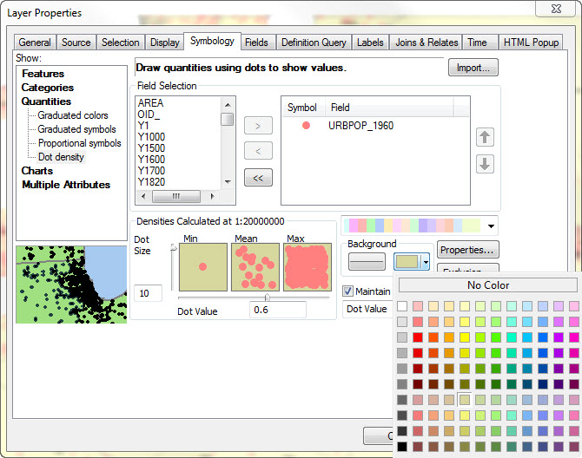

- Now double click the default point symbol right next to your active field (URBPOP_####). Change its color to medium coral light and click ok. This sets up our color symbology for dots. Click to background fill option now. It’s the button on the right underneath background panel. Change the background color to lime dust.
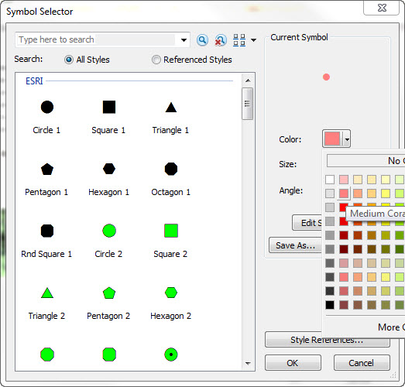
- Set the dot size to 10 and the dot value to 0.6. Dot size defines the default scale of each dot and dot value defines what each dot represents on your map. For example, if your dot value is set to 1, and your attribute table has a value of 30 for the field that you map, you will have 30 dots in that polygon. Click Ok and do the same thing for you’re the other layer that displays on your keymap. This time, set both dot size and dot value to 1. Use the same settings for background and dot colors. Your maps should look like the image below. Except you will have two large square maps side by side with the key map underneath them.
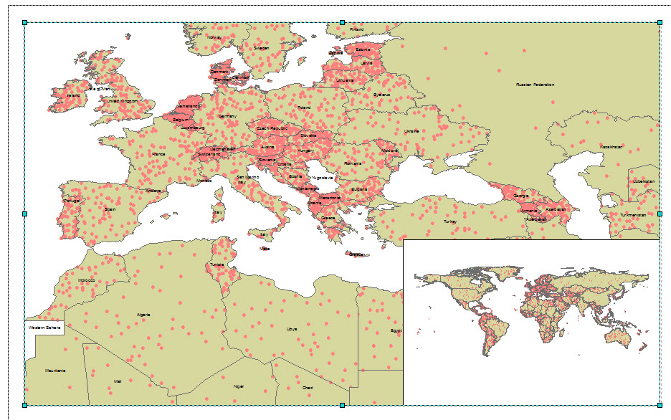

- Change the title to Percentage of Urban Population to Total Population by Country.
- Your map extents should be the same as previous maps. Make sure the display scales are consistent and other layers that show your topic’s city and country name labels are visible. If not follow the steps in the previous exercise sheet to set the paper size and scales.
- Export your map as a PDF. Since all the data on these maps are vector based, you can control the colors and line thicknesses in Adobe Illustrator.
- When you have finished, please submit the digital file(s), named Professor’s Last Name_FL12_Your Name_GIS . Please print out your 11” x 17” maps. Since you are creating multiple maps, please assign a number to your file name to indicate which map you are saving.

- Do not forget to save all your files after completing the exercise. Make sure you copy your map files and your data files to your personal / USB drives.

Using GDP data to create a comparable map

- Save your map as a new map file. We will use GDP data to create a new map. There are some GDP values for certain countries that go back to 17th century. Since there is no record of indicators before the modern era, all the historic data is derived and calculated by using models. All the data after 1969 are derived directly from World Bank Yearly Reports
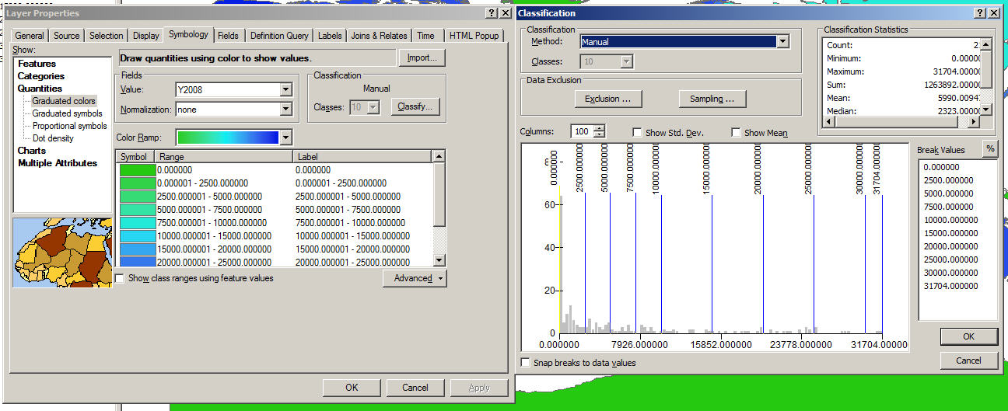
- Right click to click All World Countries layer and choose properties. Navigate to symbology tab. On the left panel of symbology tab, find and click Quantities, Graduated Colors. This will change our symbology to a heat based map. Choose your field to Y2008 (GDP values in year 2008). Click the right arrow to use this field to activate in your map. Choose the color ramp that goes from green to blue. Next is to classify the data. Choose 10 classes and then hit classify button.
- In classification menu use the custom Break Values and adjust them according to below figure. Notice we are making a custom classification based on user choice. Make yourself familiar with the classification methods to see how your data changes visually. Depending on the data range and what story you want to tell, different methods can be used in different maps. We are using a custom 10 class-method to show the GDP values on this map. Once you are done click Ok and go back to your Layer Properties.

- In your Layer Properties window Symbology tab, edit the names of the labels so they will show properly on legend. Make sure you have “No Data Available” set for 0. Use the same labeling method shown below. The first interval after 0 and the last intervals need to be names as up to $2,500 and more than $30,000.
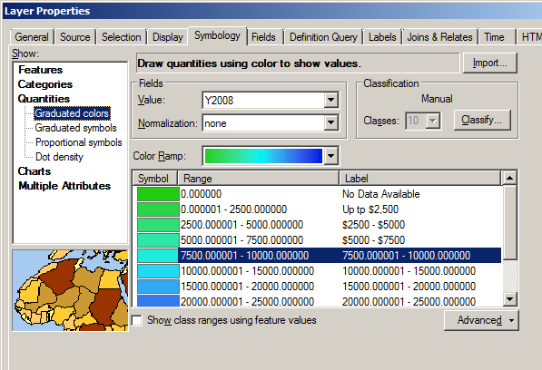

- Switch to the Layout View and change the title to GDP Value by Country (2008). Your overall layout should be similar to the one below with the appropriate title, legend and etc. Make sure you have the small key map inserted.
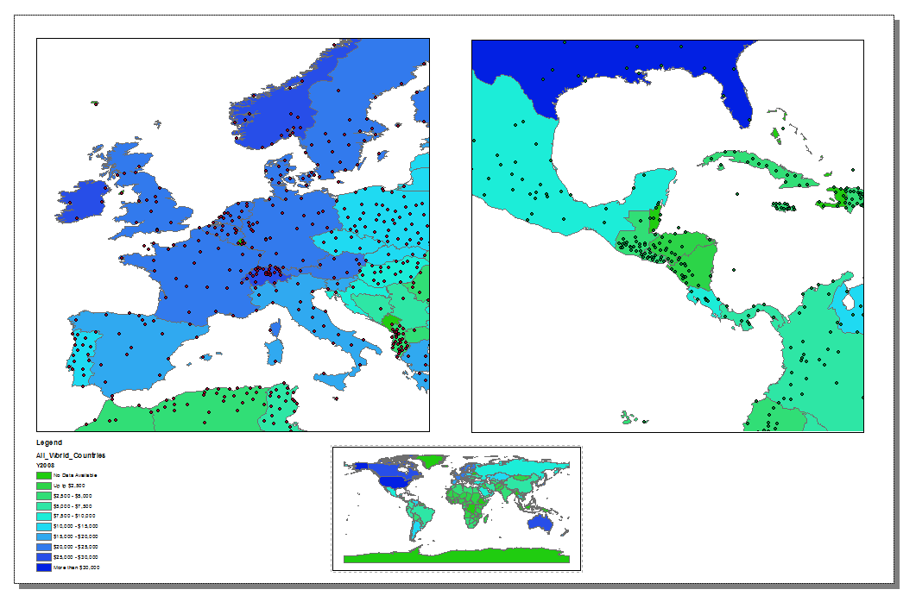
- Your map extents should be the same as previous maps. Make sure the display scales are consistent and other layers that show your topic’s city and country name labels are visible. If not follow the steps in the previous exercise sheet to set the paper size and scales.
- Export your map as a PDF. Since all the data on these maps are vector based, you can control the colors and line thicknesses in Adobe Illustrator.
- When you have finished, please submit the digital file(s), named Professor’s Last Name_FL12_Your Name_GIS . Please print out your 11” x 17” maps. Since you are creating multiple maps, please assign a number to your file name to indicate which map you are saving.

- Do not forget to save all your files after completing the exercise. Make sure you copy your map files and your data files to your personal / USB drives.

There are some GDP values for certain countries that go back to the 17th century. Since there is no record of indicators before the modern era, all the historic data is derived and calculated by using models. All the data after 1969 are derived directly from World Bank Yearly Reports.

