Haider
Jay
Michael

Wassup guys i hope yall are doing well, having a good day so far. As a former student of doctor Hall english class,she has a phd so she’s technically a doctor which also means she spent her entire life in school; talk about being a nerd, don’t tell her i called her a nerd. Anyway i want to welcome you guys to her class and start off with some tips on how to survive her class. First and foremost don’t be intimidated by the tattoos; doc hall is actually really kind and down to earth, feel free to talk to her about anything that may affect your performance in her class. Don’t be afraid to participate in class, the classroom is a judge free zone, your opinions and thoughts are valued here. Whatever your thoughts are on a topic speak on it and start a discussion there’s no right or wrong statements or any stupid questions in her class. Usually there will be discussions in class so get used to talking.

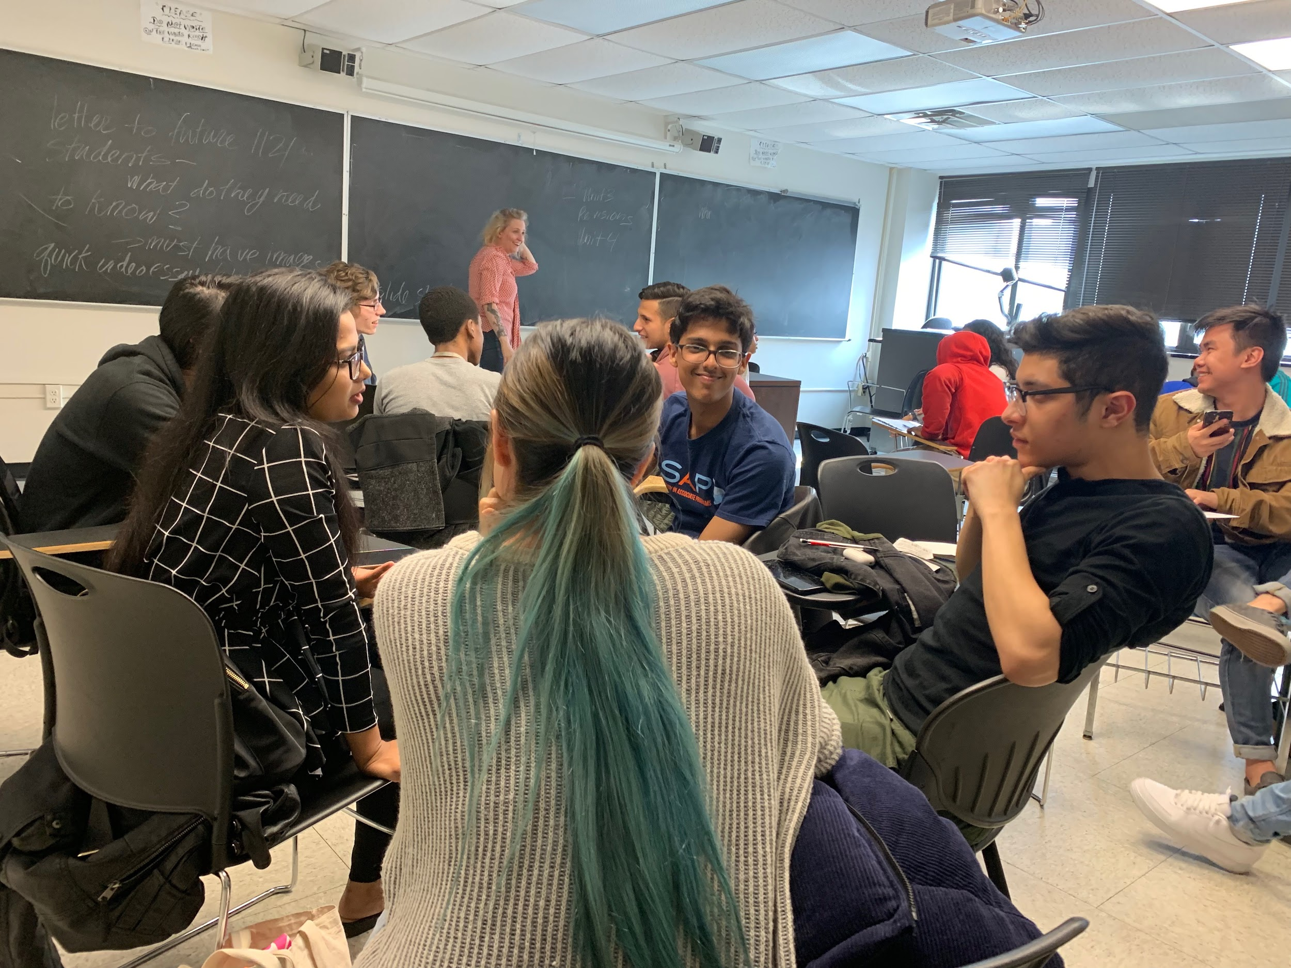
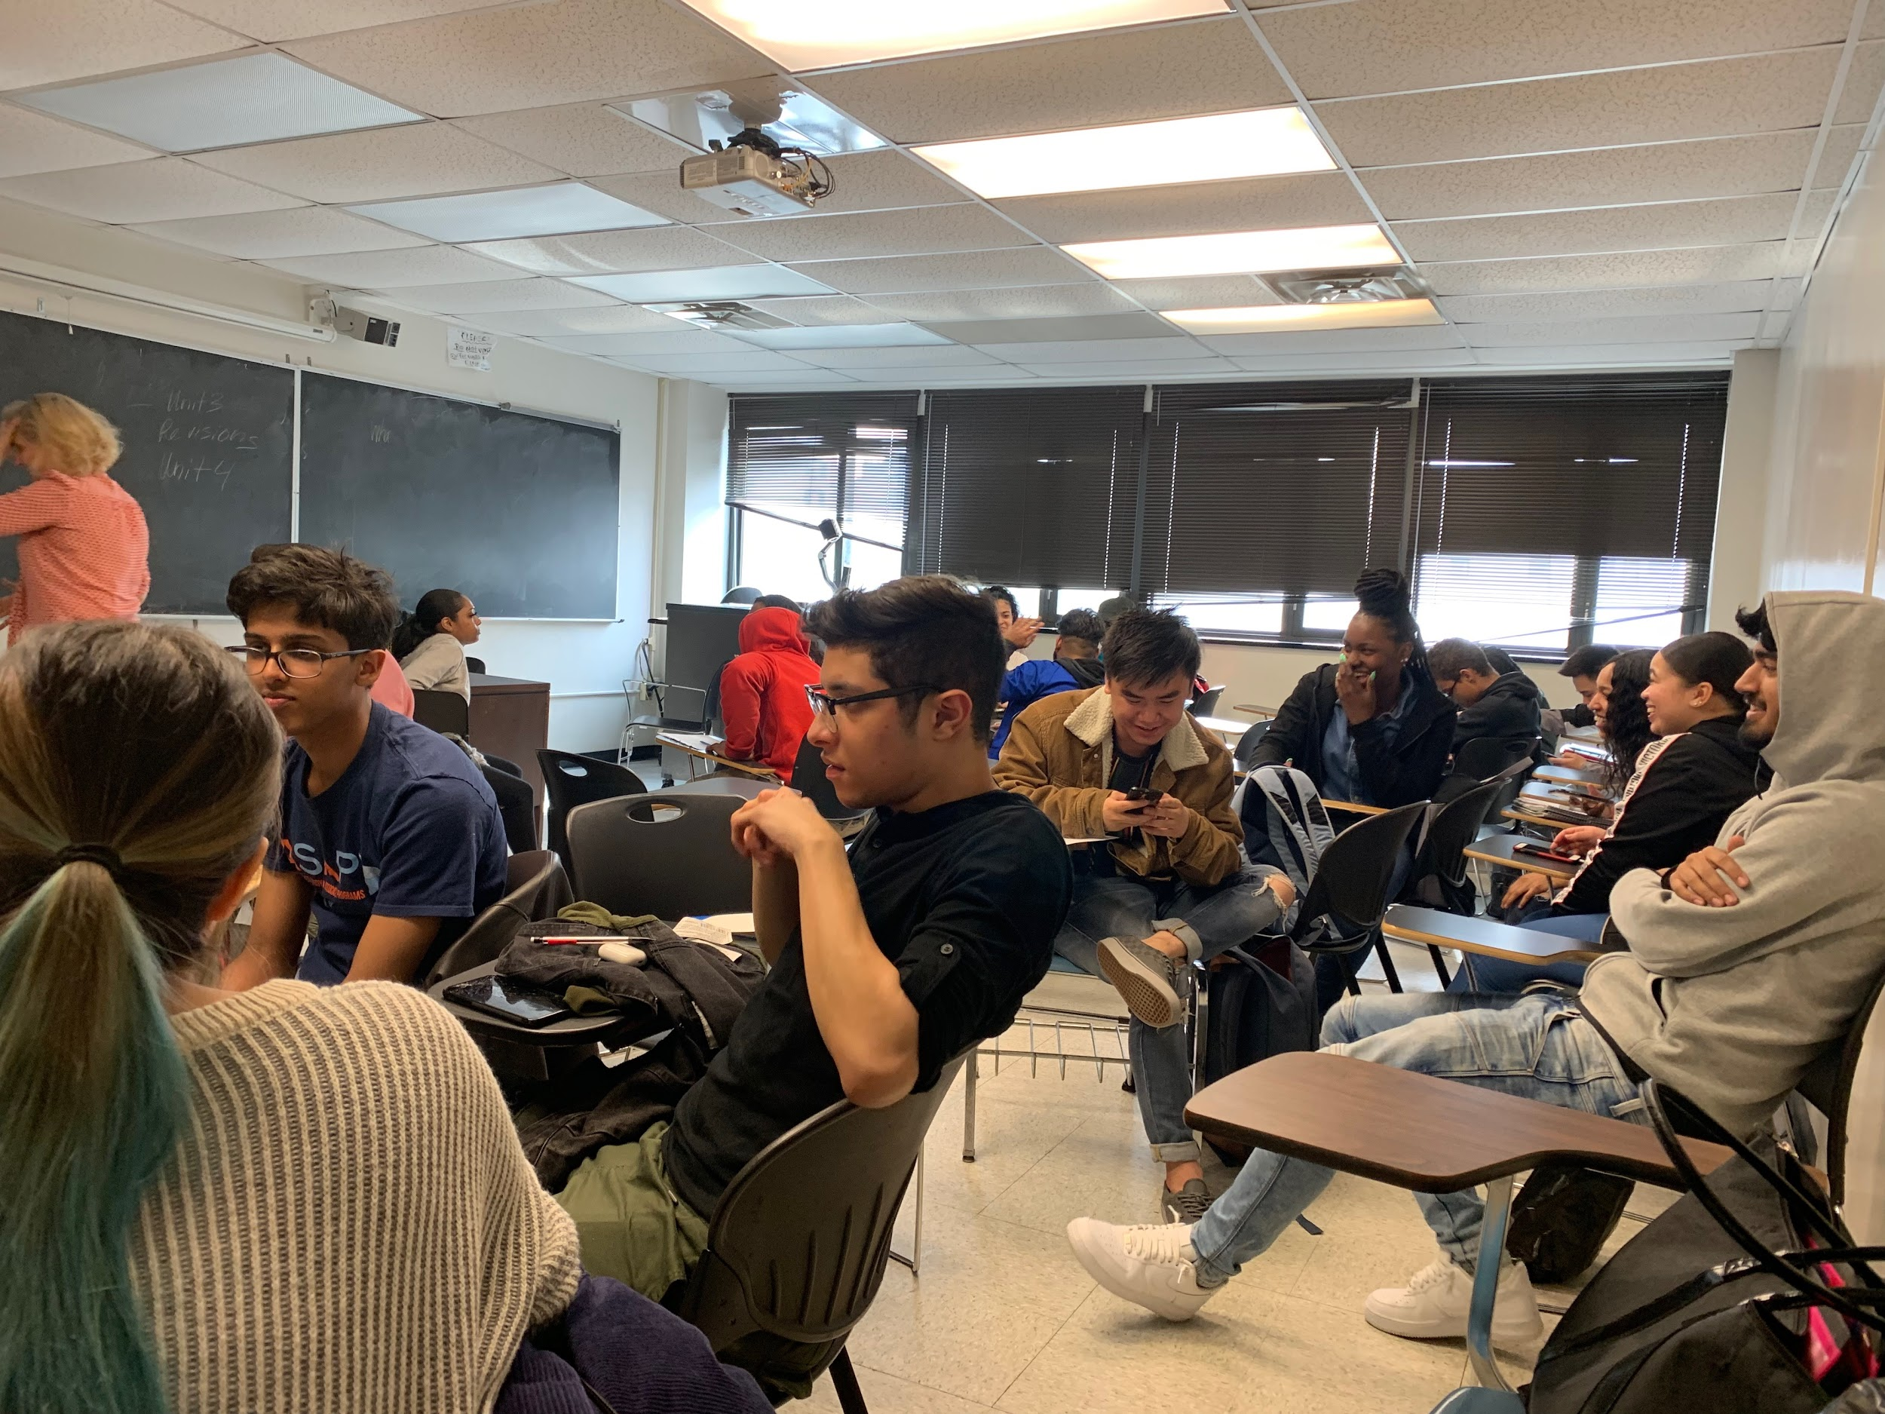
Don’t be afraid to be yourself. While in class feel free to make jokes and have a good time Doc hall appreciate jokes a lot. This will help to make the working environment easier to work and more comfortable. This goes without saying but have respect for eachother, you’re allowed to have some fun but it’s still a learning environment. Regarding the classwork; don’t worry. The topics you’ll be writing about are totally broad and interesting to write about. The work is also easy and doc hall gives efficient time for you to complete assignments. She doesn’t give long assignments like a 10 page paper; that’s not her drift. She like 4 page paper better. The thing about doc hall class is that it’s going to be one of your most chilled class and the whole point of her class is to help you get better at writing and have fun while doing so. So all in all come to class: be yourself, and have fun. Have a good semester guys.

