Santi Gill

“Alright” - From Dark to Light

Kendrick Lamar’s Alright was released on June 30, 2015. At the time, Black Lives Matter was thrusting themselves into the ongoing presidential campaigns, and two days prior, Kendrick had performed the song for the first time on BET. Famously, Geraldo Rivera of Fox News said of the live performance, “This is why I say that hip hop has done more damage to young African Americans in recent years”. This song came at a time of struggle, the African American community was fed up with the countless violence and wrongful punishments done to them by the police that was supposed to govern them.
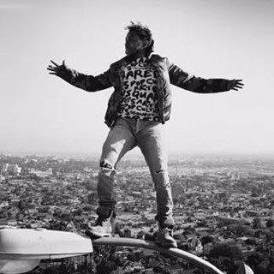
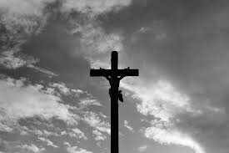

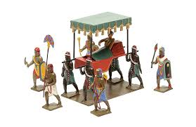
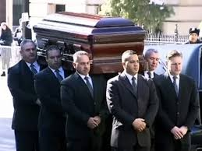
The video expresses the reality of this situation, the hope that Kendrick has for the community, and a story of a martyr. Colin Tilley, the director, describes the video in 3 stages, the first is a descent to madness. It begins with shots of the city in turmoil. M.A.A.D city was the name of one of Kendrick Lamar’s song on his previous record, Section .80, it stands for, “My Angels on Angel Dust” because of the fact that most times your friends are either dead or on drugs. A showcase of the madness and destruction of the city, torn apart by racial divide, prejudice cops, and high crime, and this is essentially that. The first shot we see of Kendrick is in a car with Schoolboy Q, Jay Rock, and Ab-Soul. The car they’re “riding” is being carried by four police officers. This can represent two things. Its is either a representation of royalty, as Kings and/or Queens would be lifted on a litter by subordinates, or death to represent the cops constant killing of Black people.
From here on, is a barrage of images of people dancing and Kendrick driving around, assuring everybody they will be Alright through the chorus sung by Pharell Williams.. This is the “Rally” stage of the video. The middle portion of the video, essentially the whole video, has Kendrick in the streets of California’s Bay Area, with the people, for the people. Colin Tilley said that he wanted to show how Kendrick is seen as a hero for the people, so Kendrick can be seen floating through the streets often. The dancers are essentially to enforce the positive outcome to all of this destruction. One location shows Kendrick in front of the Staples Center on a streetlight. In 2012, Kendrick had tweeted out an impromptu concert for free in front of the venue. There were too many people present at one time for it to be considered safe, so it was shut down after he performed about 4 songs. This might’ve been some retaliation from Lamar himself, telling the people that he’s still here, on the street light, literally way above where he was before. We notice this part of the video is much lighter in color as well compared to the beginning. As we go through the video as a whole, the video goes from Light to Dark. Colin said that he wanted to show this as a way for the audience to know that he is trying to bring light to the world, to see the brighter side of things, a supplement to the songs chorus in fact.

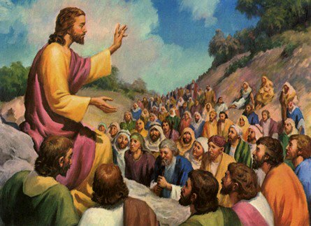

The final section is the “Sacrifice”. Kendrick is still dancing on a lightpole, but now we are in a hill far away from Downtown Los Angeles. This might be a biblical reference, as Jesus died on Calvary Hill on the cross. Kendrick is dancing away before a cop gestures a finger gun shooting him, which kills Lamar. The gesture and surrealistic nature of this shot shows that this video is essentially a bad dream. An accumulation of the fears and hopes he has in one. . One that he wakes up from, and still smiles.These people could possibly be in danger, and yet they dance away. Dreams are never often clear themselves, which is probably how Kendrick got to this other streetlamp in a snap.
Dreams are indeed a glimpse into the mind. A representation of what one is thinking and feeling. Nightmares are not particularly ones to inspire hope, but they do make you stop, think, and learn. Nightmares can make you stronger. Kendrick is saying that while the Black community may feel like this is a nightmare, that as long as you have hope, you’ll be “Alright”.

