My Love, My Life, My Fantasy

I sat and closed my eyes to enter my fantasy
Where all things are there just for me
A place where magic can flow
A place where there’s no where you can’t go
With creatures larger than the largest tree
Yet also creatures where the eye can barely see
A man can have the strength of a legion
Yet still frail enough to die for any reason
Women more beautiful than a daffodil
Yet hags trade it to kill at will
But regardless of what events occur
I never let it affect my composure
For when I look at the rising sun at dawn
Or the moon at stars with all clouds gone
This place will always be what I want it to be
For I made it just for me
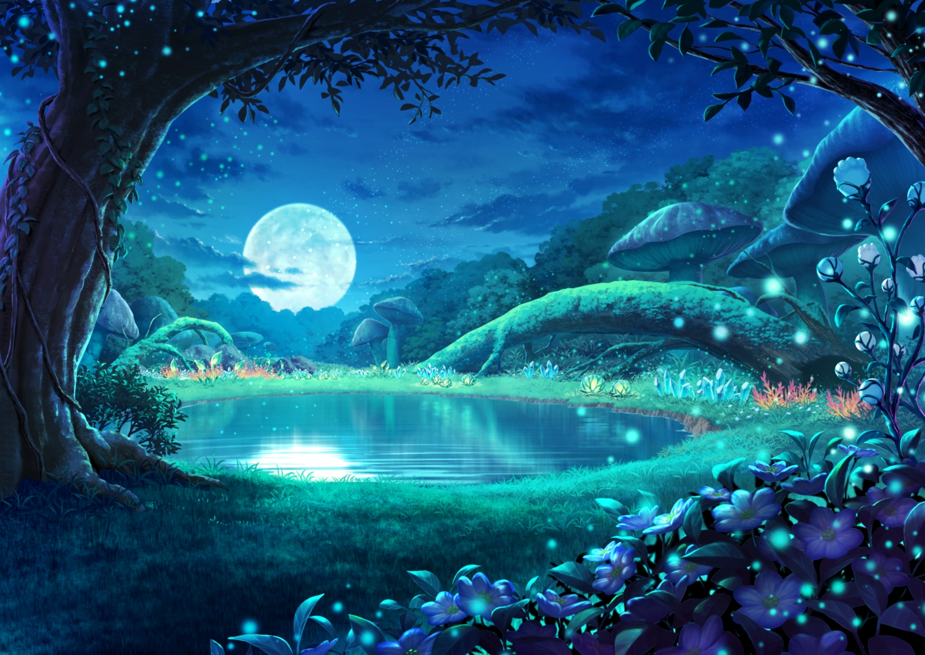

Whenever I enter this landscape
It is always my greatest escape
I get to meet up with my companions
I can see possibilities ranging into the billions
Maybe like finally confessing my love
And hope that there’s luck bestowed from above
So when she acknowledges my feelings with acceptance
I could feel like I’m experiencing a transcendence
She wouldn’t even have to be human fully
For even demihumans may make me feel unruly
Like cat girls with their pointed ears
Just rubbing their heads may erase my fears
And if we were to lay in bed
Her soft purrs may remove all dread
Pulling her close I run my hand down her bare skin
And just think of how this moment feels like i’ve earned a fortune
Resting my chin on top of her head
I forget the world and anything ever said
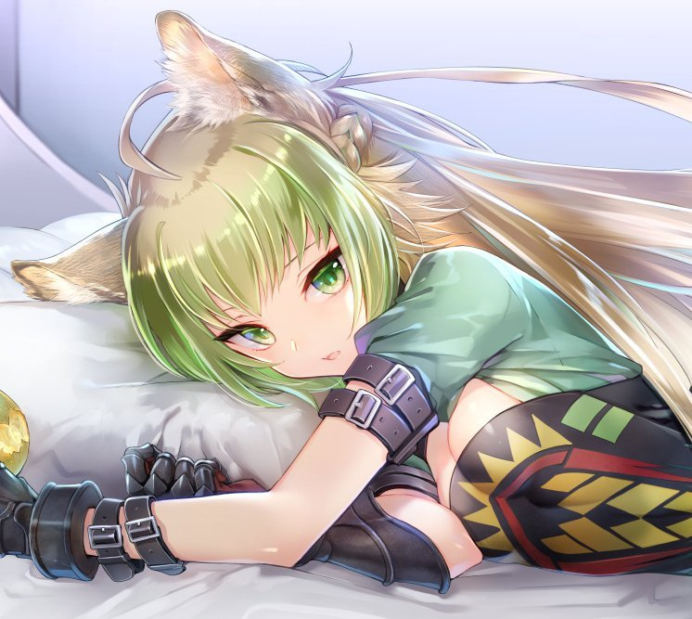
But each time I wake up in my actual bed
I keep getting washed over by a deep sense of dread
I just want to go back
Where I don’t have so many things to keep track
I want to just live in paradise
Where I don’t have to try to be lucky by rolling the dice
Because each day just continues as a chore
And the office is such a bore
And with each attempt that I try
I just burst into tears and cry
My throat begins to tighten
And yet I just keep fightin’
Because I know how important it is to have a life
Even more so for my dear wife
Yet my feelings I once had are dead
And my dreams are the things I truly wish to wed
For things in the world just feel so gloomy
It’s no wonder that I always feel moody
Whether it is slaving away after hours
I feel my compassion wilting away like flowers
For no matter how real I try to make it be
It was a place just for me
Maybe I should leave this world to enter my fantasy
