TRIGGERED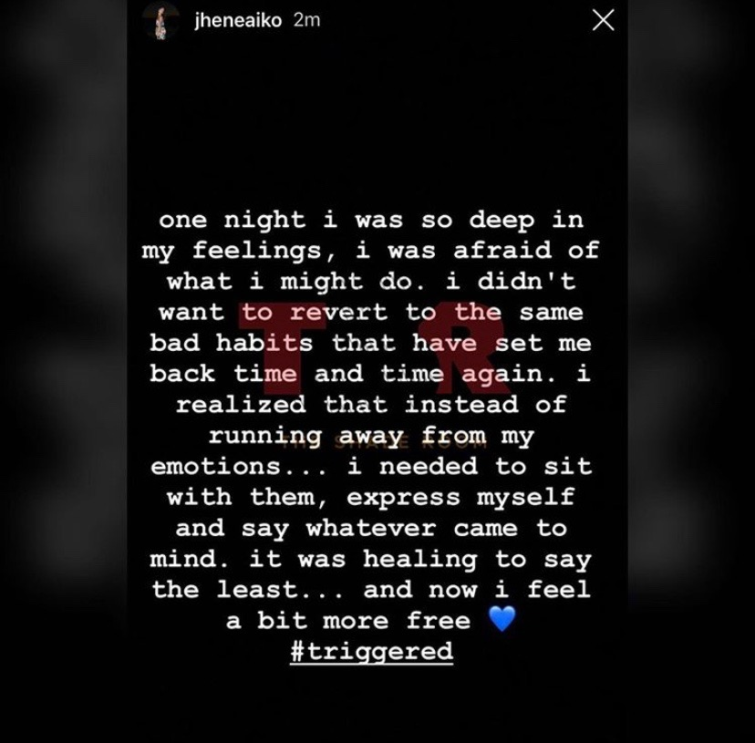
I’ve always wondered
What kind of mother I would be
Would I be strict?
Or would I be carefree?
I’ve always wondered
Would I love you to the moon and back?
Or will I be like my mom and dad
and lack
Certain qualities necessary to love a child?
Hmm.. nah, I never be that wild

Mom and Dad argued so much
When my sister and I came home from school
We never had much luck
I rarely seen them hug and kiss
They were just arguing mules
Days and years going of through this
I might as well have
Sunken myself into a deep abyss
Maybe I’ve said too much? Or maybe not
But you get the gist

In high school I got so many memories
Triggers and flashbacks of what used to be
And it made me act out
Not being the best student I that could be
Not pushing myself and seeing me at my best
My potential was there but I was just a mess
Hanging around the wrong crowd
Not caring about any consequence
But when I all came down,
I was on my own defense

I’ve always wondered
What kind of mother I would be
Would I be scared
because it’s all so new?
Would I be ecstatic after pushing you out
Enjoying my view?
A couple of my friends are new mothers
And sometimes I ask how it feels
They say it feels different than before
And sometimes they get the chills

One thing I do know
Is that you will be smart
You will not lack common sense
And you will have a heart
You are gonna look just like me
Beautiful eyes and curly hair
Oh, you never know the possibilities
Of what you and your siblings will look like
But one thing I do know
Is that you’ll definitely know how to ride a bike

Happiness was a facade
I still maintained decent grades
All thanks to God
When you want something
You’ll do anything to go after that dream
Nothing will stop you
No matter how hard it may seem
I know you will be a goal-getter
And no matter what
I will be there for the worse or the better

I’ve always wondered
What kind of mother I would be
I want to expand your intellect abundantly
I want to take you places I’ve never been
When I was I was five
Places in which it required you to dive
I want to be there for you
For every step that you take
I’d love you so much
Our bond would never break

What will you become when you grow up?
A doctor, lawyer, or nurse?
It really doesn’t matter
Because I will always put you first
And no matter what ever you become
I know you I won’t run you away from me
Because some things can’t be undone
I’m doing everything I can now
So you don’t have to worry
To you, that is my first vow

High school was complicated
I make some mistakes
I made friends with the wrong crowd
They were nothing but fakes
Mixed with peer pressure
I don’t regret anything in the past
It made me into the person I am today
While I’ll be in first, they’ll be in last
I wouldn’t change a thing
Just in case any one asked

I’ve always wondered
If my parents didn’t split
And I hadn’t been emotionally damaged
Would I have wanted to quit?
As a kid it was cute to act out
But as a teenager
That’s when really I had self-doubt
Could I really finish school?
Ditching classes and fighting
At the time, that’s what I thought was cool

You would be a smart little one
Yes, you would indeed
I believe that you will
Because we are of the same breed
You can do what you want willingly
And be of great success
You will be molded prolifically
And be nothing but the best
While handling grace with simplicity
You’ll be the complete opposite from the rest

Author’s note:
This poem is dedicated to my future child(ren). I include moments where I talk about what I went through as a child, as well as how it impacted me in the future. I explained that my parents did fail me in a way and I would never put that burden on my future children. This is a revision of Unit One, the educational essay. In said essay, I explained how my education and learning was impacted because my parents split when I wasabout six years old. In this poem, I am promising my future child or children that I won’t let history repeat itself.
The title “Triggered” was inspired by Jhené Aiko’s newest song “Triggered”. On May 7th, 2019, she took to Instagram her feelings on this song. To me, one of her themes is being free and letting all of her feelings out; which is exactly what I wanted to do. Not to mention, she is my favorite singer. I also named the poem “Triggered” because the moments with my parents were a gigantic trigger in my early educational years. It wasn’t easy, as a child, focusing on my school work with this occurrence in my life. This huge trigger bursted into smaller triggers, which is what I experienced throughout high school. By this, I am saying that the big trigger, my parents splitting, lead into smaller problems that expanded from the bigger one, such as cutting class, peer pressure, etc. This was my way of letting go and expressing myself.

THANK YOU, KENDRICK
One afternoon, while I was working as a hostess in a restaurant, I overheard a song by Kendrick Lamar on the speakers. I only heard about two minutes of this lengthy 12-minute song. But, within those two minutes, I knew it was a song that I had to constantly play. I adored the soothing tone of his voice, and that is what made me fall in love with this song. No, not a song, a story. “Sing About Me, I’m Dying of Thirst” is composed of two parts. The interesting fact about Part One, “Sing About Me” is that it is broken down into three points of view. Part Two “I’m Dying of Thirst” includes a skit and ties back into the lyrics of Part One. Kendrick not only raps about today’s social issues; he raps about the social issues he’s personally gone through, as well as his friends, and how he overcomes these trials and tribulations.
I love Kendrick Lamar as lyricist because he is cut from a different cloth than today’s rappers. In my opinion, he is undeniably one of the greatest hip hop artists of his generation. I say this because all of his music is a story. He is not the usual artist that you’ll hear on the radio rapping about having sex with women, smoking weed or drinking “lean”, finding himself in trouble with the law or getting to the money. At least, you’ll probably never hear him rapping about these topics as a means for fun; he’s actually mentioned these topics to tell his story to his listeners to make them aware of the everyday life of a Compton teenager, even though we may just listen for entertainment.

What makes “Sing About Me, I’m Dying of Thirst” so fascinating is one: it actually happened, two, this song ties into the whole album, which is a story line, and three, Kendrick wrote this song with three different points of view. In verse one, Kendrick is rapping, in his friend’s [named Dave] brother’s point of view. The brother’s name was never told; however, it is obvious he is speaking to Kendrick.
“Just promise me you’ll tell this story when you make it big…” ~ Verse One, Part I
He is telling Kendrick that he wants him to share his story with the world when he became famous. He tells the story of his brother getting shot right before him and his friends, including Kendrick. He also goes on to say how much he loved Kendrick for being a brother to his brother and for being there for him and his brother during the time of his death, as Kendrick is the one who held Dave in his arms as he was bleeding out. This verse was an example of a heavily common social issue, gun violence. Gun violence also corresponds with gang violence in this case. Kendrick raps:
“This Piru shit been in me forever
So forever I’ma push it, wherever, whenever…” ~Verse One, Part I
This clearly meant that Dave’s brother was gang-affiliated. This was more than common growing up in the 90’s and 2000’s in the wicked streets of Compton. Dave’s brother’s tone is angry and resentful towards the guys that killed his brother. It is also a tone of love admiration. As stated previously, Dave’s brother loved Kendrick as if Kendrick was his own brother. He says:
“I wonder if I’ll ever discover a passion like you and recover
The life that I knew as a youngin’;
In pajamas and dun-ta-duns” ~Verse One, Part I
This conveys that Dave’s brother’s wants to find “a way out” like Kendrick did with his music. Unfortunately, he never did. The verse ends with Kendrick rapping, and being interrupted by the sound of gunshots, indicating that Dave’s brother’s life was also cut short due to gun violence.
Verse two sums up the story of a teenage girl who follows in the footsteps of her older sister, Keisha. Again, the point of view is in that of Keisha’s younger sister but rapped by Kendrick Lamar. Unlike Dave’s brother, Keisha’s sister did not want Kendrick to sing about her. He starts the verse off by saying:
“You wrote a song about my sister on your tape
And called it Section. 80
The message resembled “Brenda’s Got A Baby” ~Verse Two, Part I
In Kendrick Lamar’s 2011 album “Section.80”, he wrote “Keisha’s Song (Her Pain)”, which was a story about a woman he knew, named Keisha. At the time, she was a 17-year-old prostitute. The message of the song was similar to Tupac Shakur’s “Brenda’s Got A Baby”, a story based on 12-year-old Brenda who got pregnant, became a prostitute for money and was slain. “Keisha’s Song” was a story that told the life of Keisha as a prostitute, with the same outcome as Brenda. The lines after this clearly show Keisha’s sister’s tone of disapproval after hearing the song about her very own sister. Keisha and her sister were prostitutes, and Kendrick did not mention that so abruptly; but there were parts of Verse two that hinted the profession of Keisha’s sister, which stood out to me:
“Even if I got to fuck, suck and swallow
In the parking lot, Gonzales Park, I’m followed
By a married man, and father of three
My titties bounce on the cadence of his tinklin’ keys
Matter of fact, he my favorite ’cause he tip me with E’s” ~Verse Two, Part I
This is one instance where a listener would find out that she’s a prostitute. Kendrick’s use of E’s is a homophone because this shows that he tips her easily because she’s a good prostitute and also tips her with ecstasy. Keisha’s sister is a teenager herself, and this is proved when she speaks upon running away from her foster home and not missing it; she believed that she was just another girl whose life was damaged by the system. She also shows a tone of slight regret and felt that if she was brought up by a family that actually loved and supported her, then maybe she would have learned to respect her body and become a woman, a leader.
Keisha’s sister’s tone of loathe is persistent throughout the verse. It became clear that her and Dave’s brother had opposing tones. Dave’s brother wanted Kendrick to tell their story when he made it big. It appeared that Keisha’s sister did not:
“…what point are you tryna gain
If you can’t fit the pumps I walk in?
I’ll wait… Your rebuttal a little too late
And if you have a album date, just make sure I’m not in the song…” ~Verse Two, Part I
Verse three is more centralized on Kendrick on verge of life and death. The tone of this verse is very unhappy, disgusted with himself as he stares into his reflection, and it becomes worse and worse every time he stares. It, more or less, becomes the rebuttal that Keisha’s sister claims (verse 2) was “late”. He reflects on both instances in verses one and two:
“And you’re right, your brother was a brother to me
And your sister’s situation was the one that pulled me
In a direction to speak on somethin’
That’s realer than the TV screen” ~Verse Three, Part I
The first line aimed at Dave’s brother, and corroborates verse one, which mentions that Dave’s brother sees Kendrick as a brother of his own. He is making sure that he’s telling Dave’s story and his because it is something that should be heard. The next three lines, and some after that, explain that Kendrick didn’t sing about Keisha to put her business out there and judging. It was instances like Dave’s and Keisha’s (and ultimately their brother’s and sister’s) that drove Kendrick to focus on his music, and not the sad life of the Compton streets. Kendrick hopes that one day, when he dies or retires, that someone will rap about his legendary days as a rapper, just as people do now with BIG and Tupac:
“…And hope that at least one of you sing about me when I’m gone
Am I worth it? Did I put enough work in?” ~Verse Three, Part I
At this point in the song, Part one’s (Sing About Me) beat is simmering down and the skit is arising. In the skit, Dave had just been killed due to gun violence, and Kendrick and friends are trying to figure out if they want revenge or to run. Dave’s brother concludes the skit by fumingly yelling that he’s tired of running. Kendrick starts off Part two (I’m Dying of Thirst) by stating:
“Tired of runnin’, tired of huntin’
My own kind, but retirin’ nothin’” ~Verse One, Part II
This is a never-ending cycle of violence in the black community; this is black-on-black violence that he partakes in because of the death of his friend. “Retirin’ nothin’” is in reference to not losing anything of value (besides involved loved-ones) after this is all said and done. Essentially, nothing is gained from violence.
Part two more so shows Kendrick’s relationship with God.
“My momma say “See, a pastor give me a promise
What if today was the rapture and you completely tarnished?
The truth will set you free, so to me be completely honest
You dyin’ of thirst, you dyin’ of thirst
So, hop in that water, and pray that it works.”
This is in reference to holy water. Kendrick is seeking salvation; he is talking about being baptized with the spirit of the Lord. The tone of Part two is reflective, and Kendrick just wants forgiveness from God.
I enjoyed listening to this song the first time; and I felt exactly the same way after dozens of listens. What I learned about Kendrick Lamar, and more so on this song, is that it ties into the whole album. Kendrick Lamar is very descriptive, and I believe that is what drew me into this song out of millions I could have chosen from. Not only did he tell a story of four people he deeply cared about, he made people aware of their situation of gun/gang violence and prostitution. I love music; however, I don’t listen to a lot of songs that will tell the story of the person rapping it. I will never have that problem with Kendrick Lamar.

MOTHER TONGUE
Reading this piece of literature gave me an outlook on the English language that I’ve never has before. In the text, the author/narrator explains that her mother’s “broken” English had an effect on limiting her possibilities. I grew up in a home that speaks English as our first language, and I don’t believe that has ever had any boundaries on my capabilities. Many people doubted the author, and often pushed her away from studying English. She began writing stories pertaining the different Englishes she grew up with; ironically, her mother said that it was “easy to read”. I don’t think people such as Mrs. Tan, the mother, should be treated differently just because their version of English is not what yours is. As a student who wants to better her writing, this text proves that you do not need to be an American born with English as your native language to express your stories and ideas.

FINAL REFLECTION
Me as a Writer
I’ve always loved writing, but my professor made it possible for me to love it even more after taking her class. Before this English class, I never knew my purpose as a writer, and I never knew if I was a good one. I was always comfortable with what I already knew as far as genres. After this class, I can say I’ve written a great poem and a prolific lyrical analysis. These are two genres I never imagined I can write with passion. Now, what drives me to write is the fact that I can write about anything and be comfortable enough to broaden my horizon (because creating writing was my favorite form of writing). Through my writing, I’ve been able to become more descriptive to a reader’s liking, making instances in my writing imaginable. Being in Dr. Hall’s class has made me want to write in my free time. Writing for myself became therapeutic. Two pieces of writing that have made me a better writer this semester is “Thank You, Kendrick” and “Triggered”.
Both “Triggered” and “Thank You, Kendrick” has made me a splendid writer. In “Triggered,” my audience were my future children. I’ve had a lot of ups and downs as a child and teenager and I made that known in the poem. For example, I wrote:
“In high school I got so many memories
Triggers and flashbacks of what used to be
And it made me act out
Not being the best student I that could be
Not pushing myself and seeing me at my best
My potential was there but I was just a mess…”
This practically means that my education was impacted because of my childhood and experiencing my parents splitting up. It means that I was not motivated enough, although I wanted to be the best student that I can be. I included this quote in my poem because I felt that it was important for my audience, my future children, to know what I’ve undergone in the past, so that history does not repeat itself. This poem stands for a lot. It is a promise, and it is closure. This piece of writing changed the way I wrote because I, myself, didn’t think that I had the feelings to write this poem, and I didn’t think I had what a true writer had to write A POEM. This poem has made me a better writer.
The second piece of writing that stood out to me this semester was “Thank You, Kendrick.” This work was distinguishable from my other pieces of work because it is the first time that I wrote a lyrical analysis. The essay is composed of an analysis of Kendrick Lamar’s song “Sing About Me, I’m Dying of Thirst,” which takes on two perspectives of people that he knows—one positive and one negative. Then, he shares his own perspective on growing up in Compton and explains how people in this urban ghetto survive. The first one uses vengeance and turns it into violence and the second one sells herself for money. In “Thank You Kendrick,” I wrote: “In my opinion, he is undeniably one of the greatest hip hop artists of his generation. I say this because all of his music is a story”. This means exactly what it says. A lot of rappers today do not rap about what Kendrick raps about. He tells his stories from growing up through rap, regardless if they are good or bad. This inspires me because he is an absolute wonderful lyricist, and all of his work has meaning behind it, it has passion. This piece of writing also changed me as a writer. It made me become more open about writing different pieces of genre, as I’ve never written a lyrical analysis before.
The last piece of writing was a response to “Mother Tongue,” a short excerpt I read earlier in the semester. My response to that included: “As a student who wants to better her writing, this text proves that you do not need to be an American born with English as your native language to express your stories and ideas”. By this, I meant that writing is an art that can be expressed in many different conducts. One should not be doubted of their efforts and skills because of their language. This also, discreetly, made an impactful effect on me as a writer because it gave me more insight on my own “mother tongue”. Throughout this semester, my writing has changed, but for the better. I’ve become more open as a writer; I’ve been able to express more. From my unit one educational essay to my unit four, I’ve been more descriptive in the work that I create, and although I am a great writer, I am always progressing my work each and every time.

