Noise Pollution  Noise pollution or sound pollution refers to the presence of excessive and disturbing noise (from machines, transportation systems, aircrafts, trains) in the environment that is very harmful to the physical and mental health of the living beings on earth.  - Industrial Causes  Everyone knows the feeling of waking up to the sound of a hammer drill. Not exactly the serene start of your day you were hoping for. There’s a reason why workers in factories and industry wear earplugs. Residents in areas neighboring industries or manufacturing facilities report intense sound levels that can damage hearing ability. | How to control it!  Engineering Controls  Engineering controls modify the equipment or the work area to make it quieter. Examples of engineering controls are: substituting existing equipment with quieter equipment; retro-fitting existing equipment with damping materials, mufflers, or enclosures; erecting barriers; and maintenance.  Administrative Controls  These are management decisions on work activities, work rotation and work load to reduce workers’ exposure to high noise levels. Typical management decisions that reduce worker exposures to noise are: moving workers away from the noise source; restricting access to areas; rotating workers performing noisy tasks; and shutting down noisy equipment when not needed. | Cost-Effective way to reduce noise  A cost-effective way to reduce noise at a construction worksite is to buy quiet equipment. When buying equipment always ask if there is a quieter way of doing the job. All things being equal most contractors would choose a quieter machine or process. Quieter machines or processes can cost more. Manufacturing tolerances are tighter, gears mesh better, quieter cooling fans are used, etc. Because of this, when contractors buy quieter equipment the final determination often depends on whether the noise reduction justifies the extra expense. Looking at this decision another way, if the quieter machine costs $100 more and is 5 dB quieter, the extra cost of $20 per decibel reduced can be considered cheap noise control when compared to cost of establishing a hearing conservation program or medical cost associated with noise induced hearing loss.
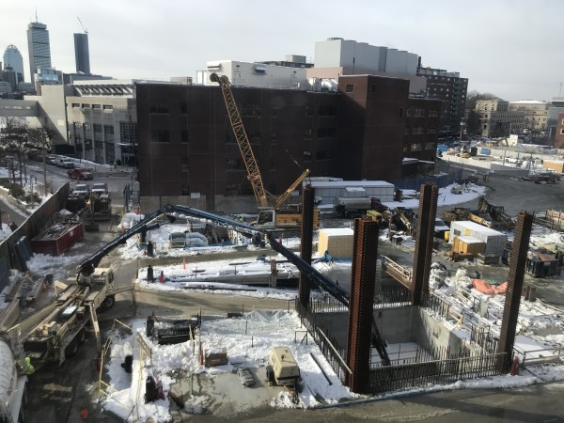  Loud construction site.  Construction sites can be quieter.  Some ways for a worker to reduce noise.  • Sometimes a quieter process can be used. For example: Pile driving is very loud. Boring is a much quieter way to do the same work. | New equipment is generally much quieter than old equipment. Some equipment manufacturers have gone to great lengths to make their equipment quieter. Ask equipment manufactures about the noise levels of their equipment and consider these levels when making your purchase. For example, noise-reducing saw blades can cut noise levels in half when cutting masonry blocks.  Old equipment can be made quieter by simple modifications, such as adding new mufflers or sound absorbing materials.  Tell the others the ways!!  Get the exact results you want  Share with your boss and company the ideas that I listed in this brochure. Make them understand why it is important for your health and the others to reduce noise!! | “Too much noise!!”  Bystander exposure to worksite noise is common in construction. Workers are as likely to be exposed from noise generated by other workers or trades, as they are to be exposed to noise generated by their own work.  Personal Protective Equipment  Earplugs are the typical PPE given to workers to reduce their exposure to noise. Earplugs are the control of last resort and should only be provided when other means of noise controls are infeasible. As a general rule, workers should be using earplugs whenever they are exposed to noise levels of 85 dB (A) or when they have to shout in order to communicate.

