- There’s an organization called Sounds of New York City, aka SONYC, who are currently working on addressing noise pollution in New York City
  - Founded by NYU in 2016
  - Schools involved
    - NYU Center for Urban Science and Progress (CUSP);
    - NYU Tandon School of Engineering;
    - NYU Steinhardt School of Culture, Education, and Human Development;
    - The Ohio State University.
  - Have received $4.6 million dollar grant
  - Their Main goal is to create the opportunity to track, analyze, and address noise pollution
- 9 out of 10 people are exposed to harmful sounds in New York (Estimated)
- Traffic and Transit are the primary causes (of course)
- Manhattan has the worse noise pollution
- Early morning and evening are when noise pollution is at its worse (When most people go to work and come home from work)
- An average New Yorker (City resident) spends on average between 485 and 540 hours on the streets. (About 6% of time in a year)
- Noise pollution is higher during the weekdays
- 8 AM and 2 PM are the two highest peaks on average
- Quality microphones for tracking noise throughout the city can be as cheap at 10$
- On the map below, anything that is pink go past the recommended 70 decibels range.
- New York city already has a code that requires the standardization of certain things such as:
  - Construction sites must have a noise mitigation plan prior to beginning construction, and must have said plan on site at all times.
  - An air conditioner shouldn’t be making 42 decibels of noise measured from a distance of 3 feet.
  - Businesses must keep music and other sounds quiet from the sidewalk during night time.
  - Sounds should not exceed more than 35 decibels into the neighboring building.
  - Garbage trucks can not exceed 80 decibels, especially at night
  - There are common courtesy policies to the New York City Noise code.

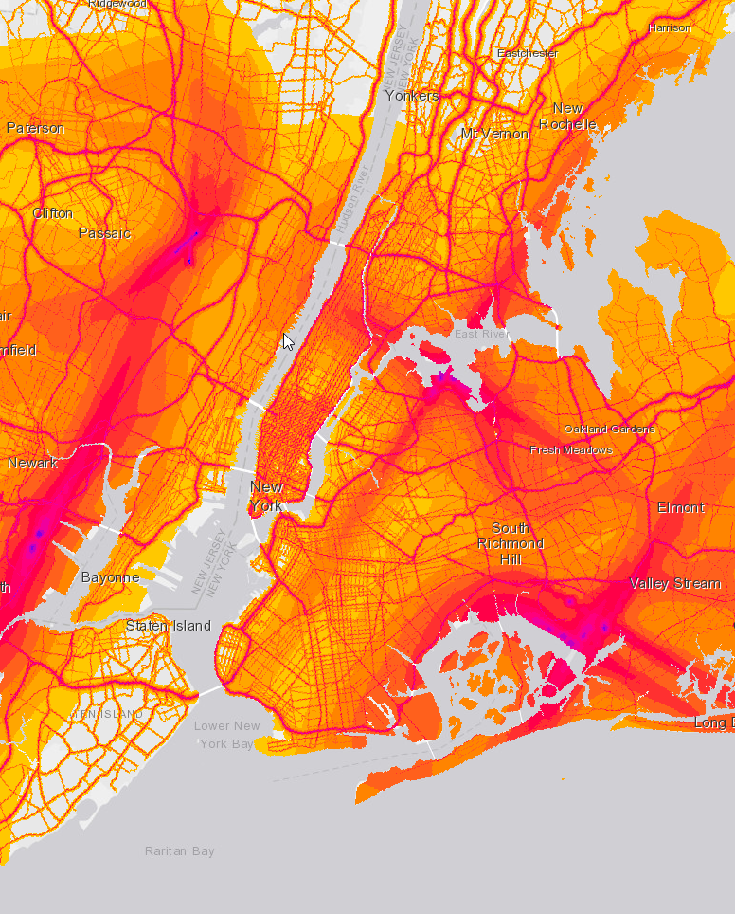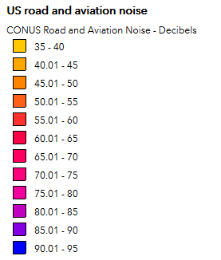 National Transportation Noise Map

