How It Begins…  The homeless are the same people as us, the only difference is that they have been through some unfortunate events bringing them to this point at which they were driven out of the same lifestyle as us…  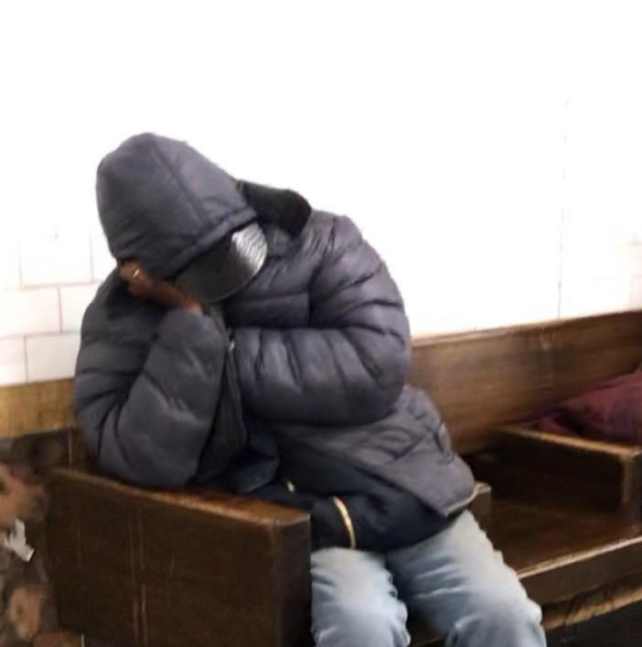 | The Truth...  We see Homeless people everywhere. Either on the street, in subway stations, outside subway stations and even in the train and by now we have seen it so much that we are not even surprised. We are at this point at which it would be wrong to say that we are ignoring their existence because of our busy schedules and life.  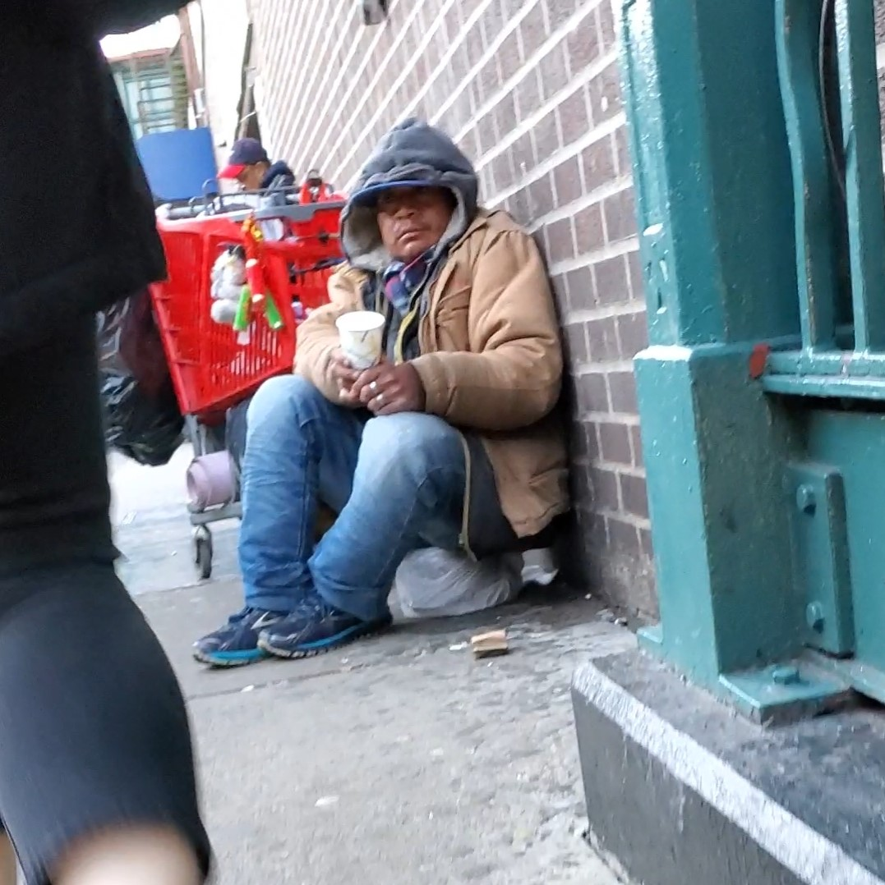 | Homelessness  in NYC  The facts,  and how to help solve it

How To Solve It…  We are sending you this message to ask you to help us help these people by donating anything you want to, to some homeless shelters.  To help, contact:  CALL : 0900-786-01  INSTAGRAM : mpnyc_ | What Happens Next…  - The reasons for family homelessness are recognised as being different to those for single homelessness, with families more likely to be homeless because of structural factors and many families more likely to be ‘hidden homeless’ (such as staying with relatives), not seeking out formal support until they have been homeless for some time.  What causes homelessness and rough  sleeping ? Impact News Service, April 9,  2019 Tuesday.  Eventually They Do End Up Completely Homeless  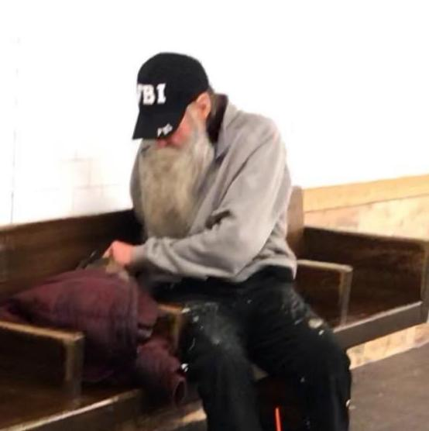 | There are many reasons for this occurrence from which some of them are:  - High Rent:  The nation's most populous city also has the nation's largest homeless population, with 75,000, and like other high-rent cities, it has not been able to move the dispossessed to permanent housing nearly as fast as people are becoming homeless.  GEOFF MULVIHILL The Associated Press. New York City offers homeless insights. Telegraph Herald (Dubuque, IA), November 23, 2017 Thursday.  - Low-Wage/Unemployment:  The new report, Early Intervention to Prevent Persistent Homelessness, presents screening tools for two groups that become homeless: Low-wage workers who lose their jobs and youth who get public assistance. While a majority of people in each of the groups are able to get out of homelessness quickly, 8 percent of each group stay homeless, researchers said.  Elizabeth Chou, , @reporterliz on Twitter. Group outlines homeless chances; Researchers say early intervention helps keep people off the streets. The Daily News of Los Angeles, March 21, 2019 Thursday.

