Reading Strategies

- Read the title, which can often provide important clues to the author’s focus.

- Read the passage once.
a. Circle any words you don’t understand.
b. Star or checkmark things that seem important.
c. Look up unfamiliar words.

- Read the article a second time for more thorough understanding.
a. Underline what you think are the most important points.
b. In the margin, write comments, questions, and any connections you can make to the author’s points.
c. Insert “quotations” around phrases or sentences you might want to quote (these will be things that really stand out).
d. If you don’t understand a certain sentence or phrase, look up unfamiliar words and try to piece together the author’s meaning.

- Next to each paragraph, write the main idea in your own words.

5. At the top of the page, write down what you think are the central ideas of the reading. Note: there may or may not be a thesis—the biggest central idea of a passage—depending on the genre of the text.

By the end of this process, the passage should be completely marked up. You should have underlined or circled important ideas, highlighted significant quotations, and recorded the author’s main points in your own words, as well as your own comments and questions, in the margins.

Here is a sample passage:

Excerpted from “Whose Feet Are Those? Negotiating Air-Travel Etiquette” by Stephanie Rosenbloom 10/29/13 The New York Times

Forget paying extra for more legroom seats. These days I’d pay to sit next to someone who keeps his socks on. On recent flights I’ve had bare feet beside me, on the back of my armrest, on the bulkhead in front of me.

Yet barefoot flying is merely one example of how public space, especially in airports and on airplanes, is rapidly transforming into more personal and intimate territory. From the hoodies and pajama bottoms we wear on board to the magazines, gadgets, creams and eye masks with which we litter our seats, the airplane has become Everyman’s bedroom.

With the holiday travel season approaching, when patience will be as essential as a passport, the time seems right to seek some understanding about why we behave the way we do on airplanes. Can we chalk it up to a global spike in thoughtlessness? We’re living in an age when smartphones and tablets allow us to have our most personal conversations in extremely communal places. Centuries-old walls between what’s considered private and what’s considered public are crumbling.

While this phenomenon is happening everywhere — in parks, restaurants, shopping malls —it’s exaggerated when we travel. One could argue that at a time when flying is an exercise in contortionism, filling a seat pocket with your paraphernalia and putting your feet up is an attempt to create what the environmental psychologist John B. Calhoun referred to in the 1940s as “defensible space” — public territory that you try to turn into personal space to gain some measure of cognitive control.

“The gurus say we’re cocooning,” said Setha M. Low, director of the Public Space Research Group at the City University of New York Graduate Center. “You take your private, personal world with you.”

Here is what a passage looks like after reading strategies are employed:

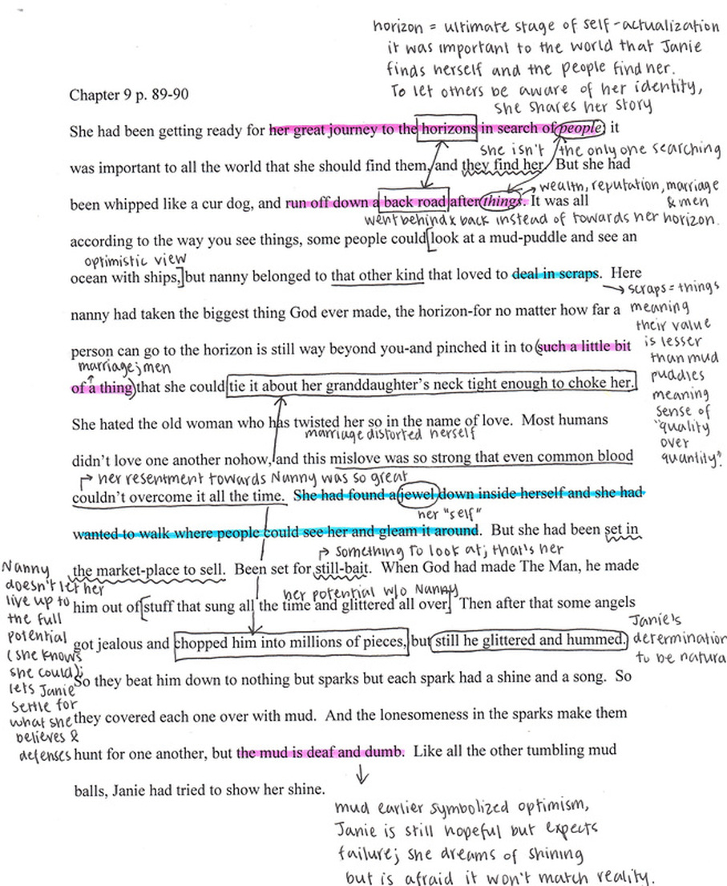
Even from a distance we can see how the student took notes throughout the passage, circled and underlined key words and phrases, and wrote the main ideas on the bottom, in her own words.

