ARIZONA’S INTESTATE SUCCESSION AND WILLS
The main reason people should have a Will is to insure their assets will go to the people they desire. If a person died intestate (without a will), the state will divide their assets and distribute them to the closest relatives. The State of Arizona has two types of properties: community property and separate property. Separate property acquired by single spouse before the marriage and community property acquired by both partners in a marriage.
If there is a surviving spouse:
Ariz. Rev. Stat. Ann. § 14-2102 Statute sets forth that both separate property and the one-half of community property that belongs to the decedent, passes to the surviving spouse.
If there is no surviving issue or if there are surviving issue all of whom are issue of the surviving spouse also, the entire intestate estate.
If there are surviving issue all of whom are not issue of the surviving spouse, ½ of the separate property and no interest in the ½ of the community property that belonged to the decedent.
If there is no surviving spouse:
Ariz. Rev. Stat. Ann. § 14-2103 Statute sets forth that any asset or property not passing to the decedents spouse under previous statute 14-2102, passes to the other family relative who survive the decedent.
Issue of the decedent gets everything by representation.
If there is no surviving issue, to the decedent’s parents.
In The State of New York the laws are quite differ: N.Y. Est. Powers and Trust Law § 4-1.1 If the decedent is survived by spouse and issue: the spouse receives the first Fifty Thousand Dollars ($50,000.00) and one-half of the remainder of the decedent’s estate. The issue collects the rest by representation. If a decedent doesn’t not have a spouse or issue, decedent surviving parents receive his assets.

Ariz. Rev. Stat. Ann. § 14-2503
Holographic Wills- whether witnessed or not must be in testators handwriting.
Nuncupative Wills-are not permitted in Arizona at all.
In New York pursuant to N.Y. Est. Powers and Trust Law section 3-2.2 holographic and nuncupative wills permits three groups of people to validly make these types of wills. Members of the armed forces, on active military duty during a war or other armed conflict, civilians who accompanying the armed forces during a war and mariners.
(Explanation of what these wills mean: Holographic Wills-entirely handwritten by the testator but is not properly signed and witnessed. Nuncupative Wills-is an oral will, with at least 2 witnesses who hear the testator speak his will.)

Ariz. Rev. Stat. Ann. § 14-2505 any competent person may be a witness to a will. The signing ceremony by an interested person doesn’t automatically invalidate the will. The will requires two witnesses.
In New York State N.Y. Est. Powers and Trust Law section 3-2.1, at least two witnesses are required. Although lawyers prefer three.
The second most populated city in Arizona is Tucson with a population approximately of 524,295 according to U.S. Census Quick Facts website (http://quickfacts.census.gov/qfd/states/04/0477000.html)

VALENTINE & VALENTINE, PC This is how the firm represents themselves: “You have worked hard all your life to accumulate personal assets and we want to ensure that you pass on your legacy to your family at the right time and in the manner you desire, rather than have your hard-earned assets be consumed by estate taxes, creditors, predators and probate expenses. Our goal is to ensure that you have a solid plan to protect your family, wealth and legacy”. They specialize in specialties are in wills & trusts, estate planning, asset protection, probates, conservatorship, guardianship, real estate, business law, prenuptials and ant nuptials. (http://valentineandvalentine.com/)
WOOD LAW FIRM, PLLC This is how the firm represent themselves: “We are committed to providing affordable legal services including estate planning, wills, probate, guardianship, conservatorship and elder law matters to those in Tucson and the surrounding community”. (http://www.woodlegal.com/)
TUCSON REAL ESTATE APPRAISER, Founded in 1986, Tucson Real Estate Appraisal is a leading provider of real estate valuations and consulting services. We take pride in offering world-class appraisal customer service, quick turnaround times, and only the highest quality appraisals. Our valuations are supported by primary market research, objective analysis, and seasoned judgment to better guide our clients in their property evaluation needs. Our reports are prepared with the precision that the industry demands. Best of all, our appraisal services are competitively priced. Call Jeffrey C. Patch, MAI, SRA at (520) 326-6066
(http://tucsonrealestateappraisal.com/home/)
http://www.sc.pima.gov/ Arizona Superior Court in Pima County probates wills in Tucson, Arizona. The address of the Arizona Superior Court in Pima County is at 110 W. Congress St., Tucson, AZ 85701. Phone number: (520) 724-4200.
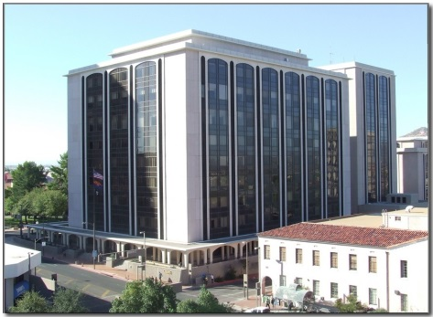

A student can become a paralegal or legal assistant, title examiner, trust officer, contract clerk, legal investigator or law firm administrator from attending Pima Community College. http://www.pima.edu/ , which is not an ABA accredited program. Program requires completing 66 credits in order to receive an Associate degree. College offers Financial Aide and Scholarships, and other payment plans. Here, you can find how much it cost: http://www.pima.edu/paying-for-school/costs/2015-tuition-in-state.html
Here you can find all the courses you must take to receive your Associate of Paralegal Studies:
http://www.pima.edu/programs-courses/credit-programs-degrees/business-careers/paralegal/paralegal-aas.html

