By: Anthony Browne
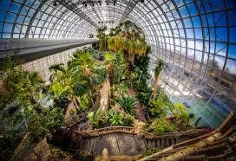
Park Slope is an affluent neighborhood in central Brooklyn. Park Slope is roughly bounded by Prospect Park West to the east, Fourth Avenue to the west, Flatbush Avenue to the north, and Prospect Expressway to the south. Park Slope features historic buildings, top-rated restaurants, bars, and shops, as well as proximity to , the Brooklyn Academy of Music, the Brooklyn Botanic Garden, the Broseum, the Brooklyn Conservatory of Music, and the Central Library of the Brooklyn Public Library system. The amount of community events or to numerous to list, everything from bike tours to concerts are available all year round.

Park Slope is in two different Community School Districts - District 13 and District 15. Students are zoned to schools for Elementary School; both District 13 and District 15 place students in Middle School based on the student's ranking of acceptable Middle Schools. There are three high schools in Park Slope, the Secondary Schools for Law, Journalism and Research (formerly John Jay High School) though students from Park Slope attend high schools throughout the city, to which they must apply.
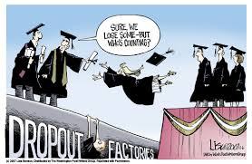
In spite of its rich history and various cultural and entertainment offerings, Park Slope lacks diversity. While a cultural mix marks so many Brooklyn neighborhoods, Park Slope is pretty much just white. Non-Hispanic white people make up almost 70 percent of the population, while the percentages of African American and Hispanic residents decreased by 12.1% and 22.7% respectively between the 2000 and 2010 census. The immigrant population also dwindled, but there was a minor uptick in Guyanese, Korean, Russian and Ukrainian residents. There is a significant Jewish population in Park Slope, allowing for a number of synagogues along the religious spectrum. In addition, there are a few congregations that meet less regularly, and have house of worship of their own. In addition to a number of synagogues, there is an Eruv, sponsored by Congregation B'nai Jacob, that surrounds Park Slope.
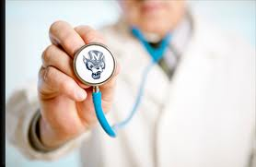
Park Slope has comprehensive health services, one of which is Methodist Hospital. The other is Park Slope Family Health Center and affiliate of Lutheran Hospital. Both of these organization offer head to toe comprehensive care.
By Kate Idowa
Most of these 65,047 residents are made up of young childless professionals who came from Manhattan or Brooklyn heights as a result of increase in rent in these neighborhoods.
Park Slope is made up of beautiful preserved land marks of row-houses, brownstones, queen Anne, Renaissance revival and Romanesque mansions located by the magnificent Prospect park with its wonderful gardens and scenery.
Due to the significant Jewish population of park slope, Beth Elohim, which is the largest reform Jewish synagogue and the longest running congregation in Brooklyn is located there. Park Slope is not only a home to a wide variety of religious institutions but also houses of worship and churches which date back to decades. Park slope remain the magnificent historic city in the heart of Brooklyn.
By: Chuchana Paul
POLICE
The police station that services the area is the 78th precinct, it is located on 65 6th Avenue, Brooklyn, NY, 11217 their contact number is (718) 636-641. They service the park slope and prospect park area.
The Precinct community council is a non-partisan group which meets with police officials to exchange mutual views and seek ways to solve local problems. The 78th Precinct community council meets the last Tuesday of every month at 7:30 P.M. at the 78th Precinct; their president is Pauline Blake.
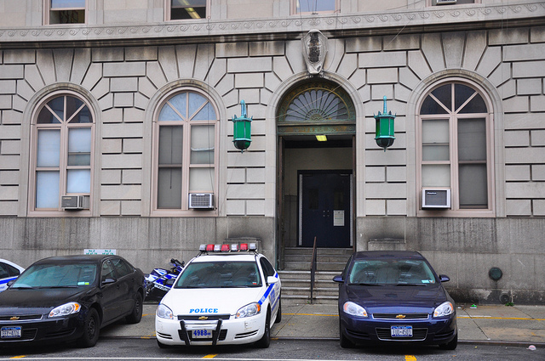
FIRE SERVICE
There are three fire stations that respond to fires in Park slope the first is FDNY Engine 220/Ladder 122. They provide Fire protection and emergency medical services their address is 530 11th Street, Brooklyn, NY 11215.
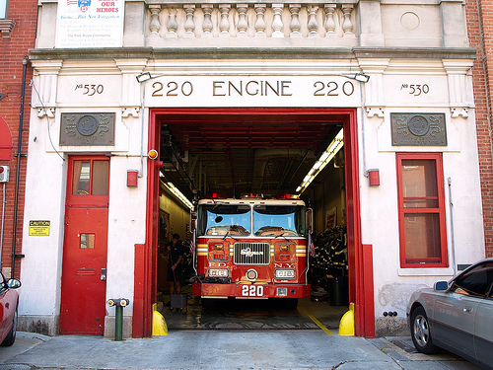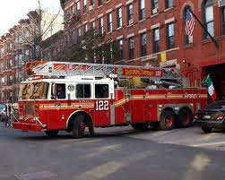

The second is FDNY Engine 239 provides Fire protection and emergency medical services, their address is 395 4th Avenue, Brooklyn, NY 11215.
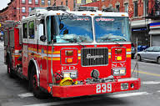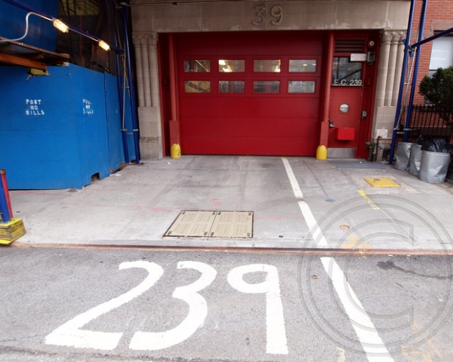

Lastly there is FDNY Squad 1 is one of seven Squads in the FDNY Special Operations Command. Squad 1 responds to fires and other emergencies throughout New York City, operating primarily in Brooklyn from their station in the Park Slope at 788 Union Street
Brooklyn, NY 11215
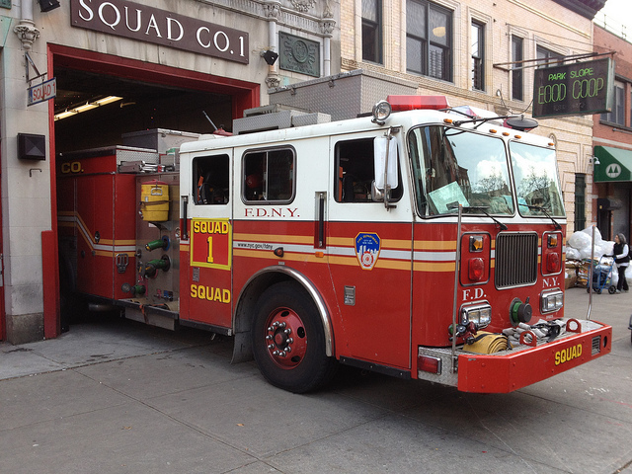

AMBULANCE
PARK SLOPE VOLUNTEER AMBULANCE CORPS (PSVAC)
The Park Slope Volunteer Ambulance Corps (PSVAC) is a volunteer organization providing free emergency medical care and rescue services in Brooklyn, New York. Since 1992, members have responded to over ten thousand calls for help. In light of recent events our country and the New York City area has faced, resources like PSVAC have become increasingly more important to the safety, security, and health of our community. PSVAC provides BLS (basic life support) emergency medical response, rescue operations, patient assessment, treatment, and transport, regardless of ability to pay. PSVAC also provides a presence at community events and performs educational outreach with regard to safety and first aid for schools and other organizations. They are located at 453 Bergen Street, Brooklyn, NY 11217.

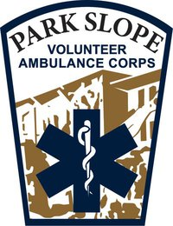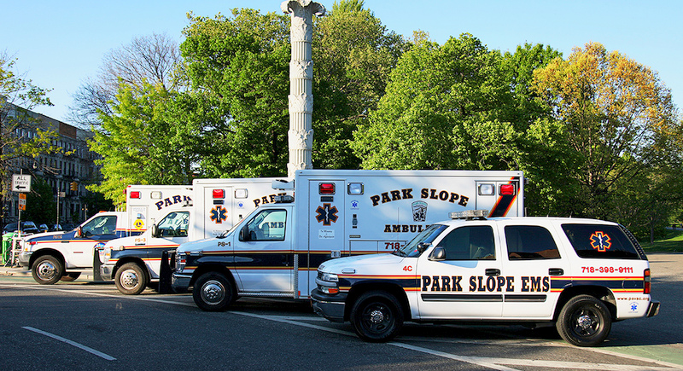

Park Slope Shopping:
Park Slope is filled with boutiques and independent stores, making it a popular Brooklyn shopping destination. A walk down Fifth Avenue or Seventh Avenue will turn up all sorts of shopping gems.
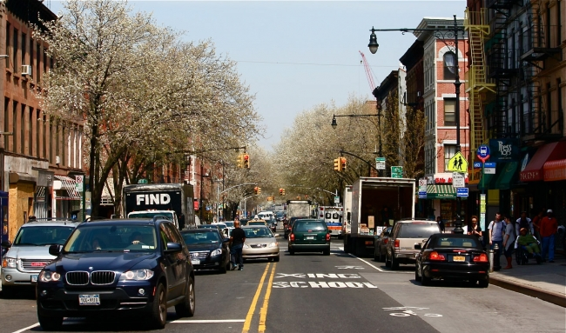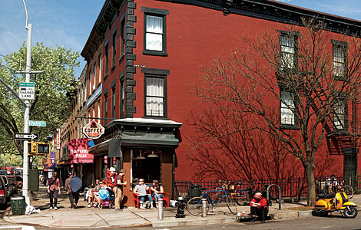
Park slope is known for its Flea market located on seventh ave, between 1st and 2nd Sts., Brooklyn, NY hosted by P.S 321
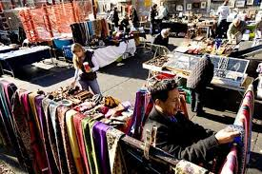
Stores like “Cog & Pearl," sells handcrafted jewelry, bags, art, and more, much of which is produced by local designers.
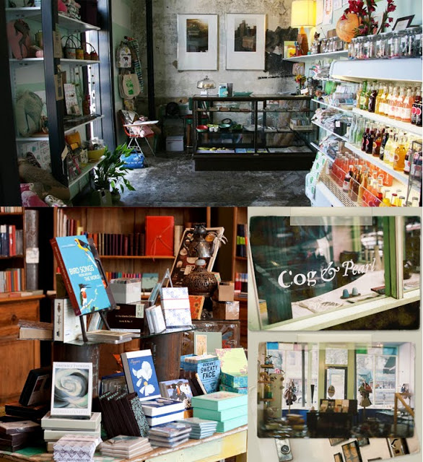

Another store that seemed to be popular is "Beacon's Closet". They buy and sell thrift items; therefore the items are vintage and affordable. They are located at located at 92 5th avenue at the intersection of Warren Street. Stores like "Goldy + Mac" for trendy women's fashions, and "Bird," which sells coveted high-end brands like Stella McCartney and A.P.C.
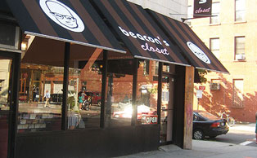
Park Slope Bars & Restaurants:
Park Slope is home to some of Brooklyn's best restaurants. "Al di la," an award-winning Italian restaurant on Fifth Avenue, is a top pick. Also popular is "Franny's" for pizza and wine on Flatbush Avenue and "Palo Santo" for Latin American fare. The restaurants are mostly Italian and Asian cuisines; some are very affordable while others are on the high end of the pricing. When night approaches the locals migrate to bars and lounges to have drinks and eat a meal.
Park Slope Activities & Attractions:
Park Slope's main attraction is, of course, the park: Prospect Park's 585 acres offer up everything from a Farmers' Market and free concerts in warmer months to ice skating and sledding in the winter. Park Slope also boasts a central location to many other Brooklyn attractions, such as the Brooklyn Botanic Garden and the Brooklyn Museum.

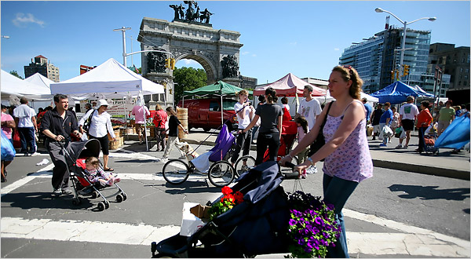

Pavilion Theater

Opened in 1928, the Pavilion is a serviceable neighborhood movie theater. It's been reconfigured more than once, and carved into many smaller theaters, so while it's not elegant, there's plenty of choice. They offer specials on Tuesdays regularly priced movie tickets are cut from $12.00 to$8.00 for all patrons. On Wednesday they offer $7.00 tickets for students all day. It is located at188 Prospect Park West across for prospect park.

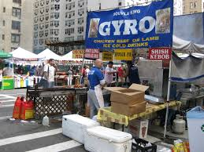
Fabulous Fifth Avenue Fair
For more than 20 years, the merchants along Fifth Avenue have been sponsored the Fabulous Fifth Avenue Fair. Like many New York City street fairs, this event is known for its great food and music. What really sets it apart from the other street fairs, though, is the heavy participation of local merchants along the avenue, who use it as an opportunity to introduce fair-goers to their goods. The Park Slope 5th Avenue Business Improvement District took over management of the fair in 2009 and will continue and expand this rich tradition in the years to come. While park slope might be known for its peaceful, well-kept and affluent community; there are still lots of activities and entertainment to keep the residents active and enjoying their community.
By: T mills
Park Slope is an affluent neighborhood in central Brooklyn. It stretches north from 15th Street to Flatbush Avenue and is bordered on the east by Prospect Park. Transportation wise, the neighborhood is well served by the New york City Subway. Several train lines, ad buses have stops in Park Slope. The F and G trains run along 9th Street, which is a main shopping street, stopping at fourth avenue, seventh avenue and 15th street.(Prospect Park/Prospect Park West. The 2,3,4,and 5 trains, which are the Eastern Parkway Lines, runs under Flatbush Avenue. The fourth avenue line, includes the D,N, and R train lines. They make stops at Prospect Avenue, Ninth Street, Union Street, and Atlantic Avenue- Barclays Center. The Brighton Lines, which includes the B and Q trains, also passes through the neighborhood under Flatbush Avenue making stops at Atlantic Avenue- Barclays Center, and Seventh Avenue. All three stations at Atlantic Avenue are connected with passageways to allow free transfers between the numerous subway services there. Five bus lines also serve the area, the B63, B67, B69, B71, and B41.
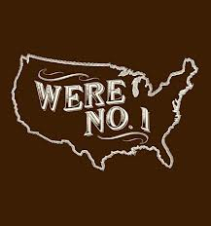
Park Slope in 2007, was named one of America's top 10 neighborhood. It is known for its beautiful tree-lined streets and historic brownstones and is home, too, to a diverse range of popular restaurants and bars In 2010, New York Magazine ranked the neighborhood number one in New York. It's strong qualities include public schools, dining, nightlife, shopping, access to public transit, green space, safety, and creative capital, among other aspects. The American Planning Association named it one of the "Greatest Neighborhoods in America", for its architectural and historical features and its diverse mix of residents and businesses, all of which are supported and preserved by its active and involved citizenry. In December 2006, Natural home magazine named Park Slope one of America's ten best neighborhoods based on criteria including parks, green spaces and neighborhood gathering spaces; farmer’s markets and community gardens; public transportation and locally owned businesses; and environmental and social policy.
BY: Jeneta Ramdat
Areas of strength and weakness
The Park Slope area consist of many strengths and weaknesses. Some of the various strengths of this neighborhood include that it is very family oriented. It is also a very close knit community. There are lots of activities to engage in. The community is also very diverse and multi cultural. Park Slope is a very child friendly neighborhood as there are many children here. There is lots to offer including dining, nightlife, community events and shopping options. Park Slope is known for its beautiful, historic architecture, especially the brownstones. The neighborhood consist of good public schools and lots of public transportation options. Another advantage to living in Park Slope is that the crime rate is very low. There is also a lot of greenery in the area for example Prospect Park and roof top gardens. Despite the many strengths of the neighborhood there are minimal weaknesses. Some of the weaknesses include the cost of living. Parking is difficult to find and there are limited private driveways for residents. To rent or own is also becoming much more expensive due to new development close by for example the Barclay's Center.
In the Park Slope community, two ways in which the role of the Community Health Nurse can help to maximize care includes:
1) holding community health fairs for residents for screening and health information in the community for example in Prospect Park.
2) provide home visits for seniors in the community and support for pregnant women pre and post birth.

