**Final project**

**Anne Menmou**

**EMT1111: Logic and problem solving**

**Topic: COMPOUND INTEREST**

The objective is to apply compound interest formulas to financial situations to find the value of the investment after a period of time.

The purpose is to calculate the amount in a saving account after a giving number of years, knowing the initial amount, the interest rate percentage and the time period i.e the number of time the interest is compound per year.

According to the book “Contemporary Pre-Calculus – The Graphing Approach” by Thomas W. Hungerford and Douglas J. Shaw, The compound interest formula is :

If **P dollars is invested at interest rate r per time period (expresses as a decimal), then the amount A after t periods is A=P(1+r)t**

When the interest is compounded unlimited time per year, we say that the interest is **compound continuously**.

**If P dollars is invested at interest rate r , compounded continuously, then the amount A after t years is A=Pert**

I am taking the math class MAT1375 : Pre-calculus.

I have learned the notion of compound interest in that class. I have used that formula in a Python program to solve a financial problem I have chosen.

The flowchart of my program is in the following page.

**FLOWCHART**

**Start program**

Display statement to user to enter the initial value, the interest rate percentage and the number of years. Read inputs and store values respectively in “init_amount”, “int_rate” and “nbe_year”

Read Input info from user

Set “time_period” equal to **0**. This value will not affect computation of the total amount

Is input

“compound_choice”

=”y?

Ask user if the interest is compound continuously. Read inputs and store value in “compound_choice”,

Read Input info from user

Decision based on input info from user

**True**

**False**

Display statement to user to enter the time interest. Read input and store value in the variable “time_period”.

Is input choice”=”y”?

**True**

**False**

Set “total_amount” equal to **“initial_amount” multiplied by (eint_rate*nbe_year)**

Set “total_amount” equal to **“initial_amount” multiplied by (1+(int_rate/time_period))time_period*nbe_year**

Display value of “total_amount” to user

Ask user if he wants to calculate again. Read input and store value in “choice”,

Is input

“compound_choice”=”n”?

**True**

**False**

**End program**

**The screen shot of the result is :**

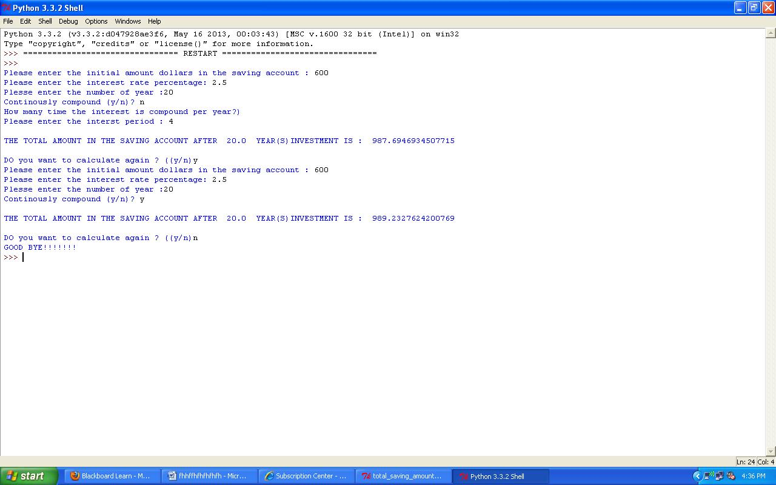

In this example, I have choose :

The initial amount of $600

The interest rate of 2.5%

The number of years 20

The time period 4 i.e the interest is compound quarterly

The result amount after 20 years is ~$987.695

The second time I have used the same inputs but the interest is compound continuously. This time the result was ~$989.230, who is greater than the first result.

In conclusion, this program is used to evaluate the amount in a saving account after a giving number of years, knowing the initial amount, the interest rate percentage and the time period i.e the number of time the interest is compound per year.

We can also use this program to estimate the population after a certain number of years knowing the increasing rate percentage. If the population is decreasing, we can modify the program to incorporate this situation.

We can also modify the program to estimate when the amount in the saving account would rich a certain amount for example.