Report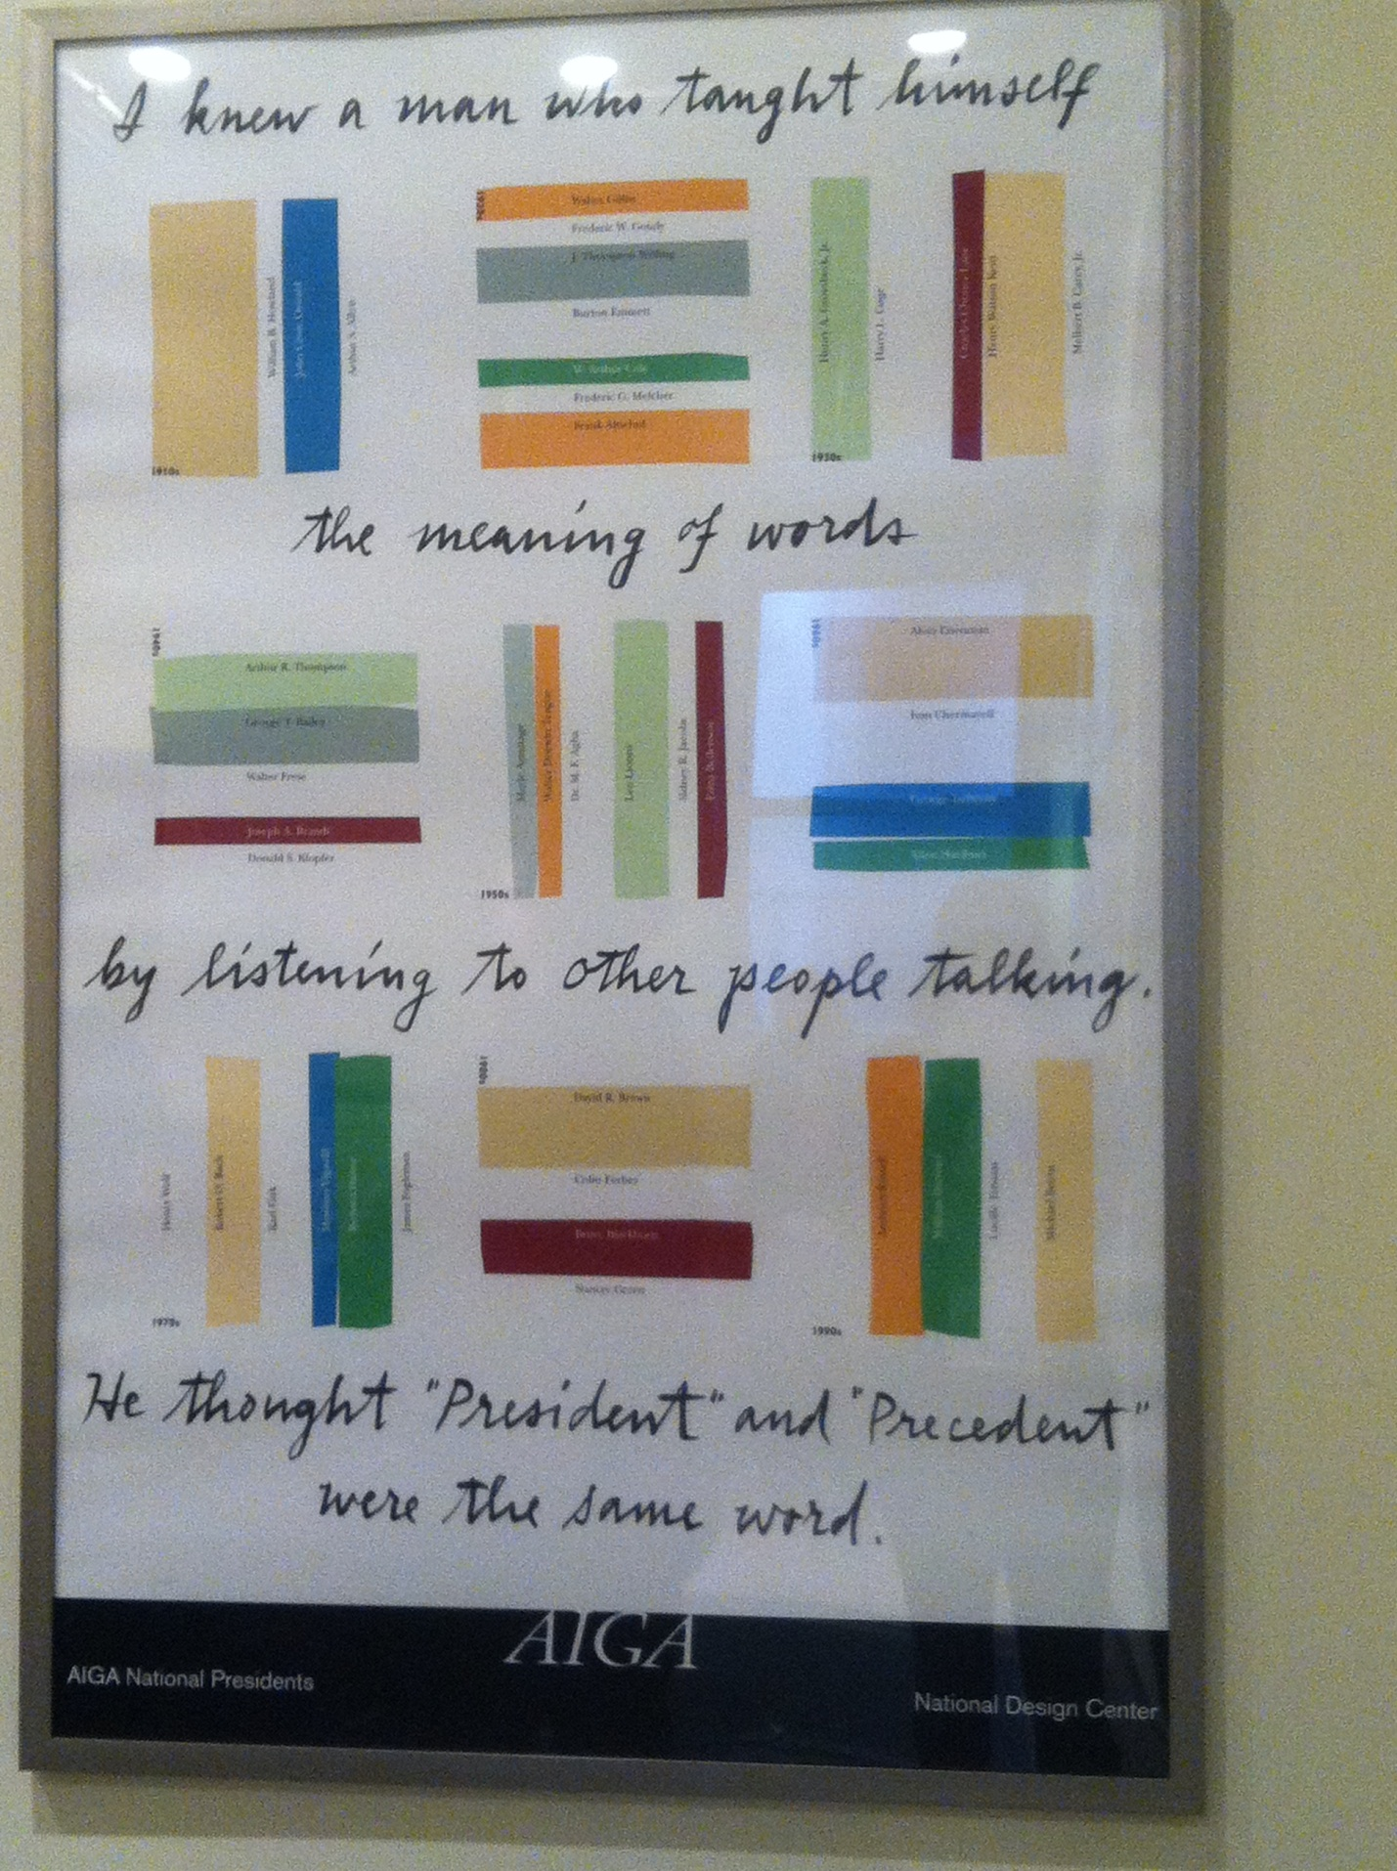
I found this picture on the third floor offices. I found it particularly interesting to me, because it sounds like it could be political, but I believe it falls more under the category of the intricacies and ambiguity of language, specifically English. Precedent meaning, “a legal decision or form of proceeding serving as an authoritative rule,” is, in some cases, pronounced exactly as president, which means someone appointed to be the highest position of authority in a democratic government. These two terms, while similar, do not necessarily mean the same thing, yet can be used interjectionally. For example, in the sentence:
“They are about to announce the president/precedent.”
Without text or clues, it would be difficult to ascertain who or what exactly the speaker was referring to. He/she could be talking mentioning either the arrival or annexation of the President of some sort of organization, or perhaps a court ruling. The almost exact pronunciation of these two words could render a statement ambiguous.

This piece by Dylan Lanthrop, called Energy, represents annual global energy consumption vs. annual available global energy sources. I also believe it represents the negligence of utilizing alternative power/energy sources. It is no secret that there is extensive evidence and support of using alternative fuel sources for energy, such as solar energy, wind and ocean waves, leaving much room for potential energy that never transforms into kinetic energy.

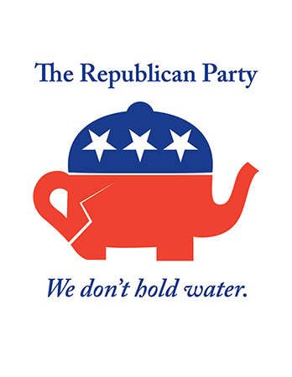
This is a piece done by Milton Glaser called Crackpot Party, which provides a blatant attack on the Republican Party. The idiom, “won’t hold water,” basically means that something is inadequate. So, to say that, for example, a defenses case in a court trial holds water, means that they have a solid case to plead. Here, Glaser took the Republican logo and turned it into a teapot looking shape, and by saying the Republican Party doesn’t hold water, means that he believes them to be politically ill-conceived.

