New York City College of Technology



Group members:

Zayira Vasquez

Lucy Lin

Frantz St Valliere

CET4711

Computer Control System Design

Final Lab Project

Due date: December 19, 2012

Submission date: December 19, 2012

Submitted To:

Professor Mendoza

**Table of Contents:**

**Tools and parts required……………………………………………. 3**

**Abstract……………………………………………………………..... 4**

**Procedure…………………………………………………………….. 5**

**Project Description…………………………………………………... 7**

**Schematic Wave Shield ……………………………………………… 10**

**Project Management………………………………………………….. 11**

**References…………………………………………………………....... 13**

**Tools and parts required:**

* Computer (WinXP or 7)
* Marking pen
* Phillips screwdriver
* SD memory card adapter
* SD slot
* Scissors
* Sewing needle
* Solder
* Soldering iron
* USB programming cable
* Wire cutter/stripper
* Stuffed toy
* Arduino microcontroller
* Wave Shield
* Parallax RFID Reader
* RFID tags
* Speaker
* Connector header
* Velcro

**Abstract:**

Our project is based on a bear which talks when it is near an object. The way this will work is by using an RFID reader, Arduino and a windshield. When the RFID reader in the bear is near an object, which has an RFID tag, it will talk. We programmed the Arduino to identify each tag differently using an RFID reader, so that the bear has something specific to say.

The windshield that was soldered together has an SD card slot. The SD card slot has sounds we inserted. It is connected to the RFID reader and the windshield is what has the sounds for each RFID tag. The program we have used to insert the sound is called Audacity. The arduino is connected to a battery holder that contains 8 AA batteries.

**Procedure:**

1. Assembly of the Waveshield:

Solder the Wave Shield together, following the instructions at http://ladyada.net/make/waveshield. At the step where you screw the plastic volume dial onto the housing, just insert the screw without the plastic dial, and turn it to maximum volume level. Cut and strip 4 wires about 6"–8" long, and solder them to the 4-pin connector, leaving the other ends bare. Mark the connector positions Vcc, Enable, S Out, and GND, to match the RFID reader’s serial header, and connect red and black wires to voltage and ground, respectively. If your battery holder has wire leads, solder its red wire to the inner terminal of the barrel connector (power plug) and its black wire to the outer terminal. (If it has a 9V connector, solder the wires from a 9V battery snap.) Screw the housing onto the plug and wrap the wires with electrical tape if needed to hold things firm. Solder the wires to the 9V battery clip and insulate with more tape. The lengths of the wires is not critical, but leave enough room to place the RFID sensor in the bear’s chest and have the wires come out the back to reach the rest of the electronics.

1. RFID tag preparations:

Solder two 6" wires to the speaker if it doesn’t already have leads connected. Solder the speaker wires to the 2 holes on the Wave Shield right next to capacitor C9, behind the headphone jack. Either wire can go in either hole. From your 4-wire RFID connector cable, attach the red and black wires to the Wave Shield’s +5V and GND holes, respectively, and solder the S Out wire to digital I/O pin 0 and Enable wire to pin 7.

*Vin to +5v*

*GND to GND*

*Enable to Pin7*

*S Out to Pin0*

To complete the electronics, just plug the Wave Shield onto the Arduino, connect the 4-wire cable to the RFID reader (make sure it goes the right way around), and plug the battery power plug into the Arduino.

1. RFID Tags identification:

Unplug the RFID reader. Open the RFID program and upload to the Arduino using a USB cable. Open the Serial Monitor to see what the RFID reader is seeing, then plug the RFID reader back in. Bring each one of your RFID tags close to the reader. The 10-digit hexadecimal tag IDs should print out in the Serial Monitor. Use a permanent marker to label each tag with its tag ID. You won’t need to do this again until you get a new batch of tags.

1. Audio editing:

For each tag, record your audio or otherwise obtain a sound file you want to use. Download and install Audacity — free, open source software for recording and editing sounds. We are going to use Audacity to convert your audio files into the correct format: 16-bit sample size, PCM encoding, and a sample rate of 22 kHz or less. These conversions might be the trickiest part of the whole project. Name each sound file with the first 8 hexadecimal digits of the RFID tag you want to associate with it. (It’s extremely unlikely that you’ll have duplicates.) Copy the sound files in the root directory of the SD memory card. Since these filenames don’t say anything about the sounds they contain, be sure to note somewhere which sound goes with which tag.

1. Test the code:

Unplug the RFID reader and load the tedbear.pde sketch into the Arduino. Plug the RFID reader back in, and see if bringing a tag near starts a sound playing.

**Project description:**

The purpose of the project of the project is to test the usage of RFID tags (RFID stands for radio frequency identification) with toys. We wanted to use this mechanism to stage a scene in class. To accomplish this we need to have a pre-recorded voice using a recorder program on the computer. We also need an SD card to save the sound files. Now before we go on to that, most importantly, what is connected above the Arduino is the Arduino Waveshield. The Waveshield connects directly to the pins of the Arduino to read sounds clips saved on to the SD card. The Waveshield had an SD card reader component to read off sound samples saved. In order to hear the sound, we have to include a speaker good enough for the user to hear. Optionally we can use headphones but however we do need a speaker for this project. The teddy bear will playback depending on the RFID tag identified. The wave shield must be assembled to allow the speaker to work with the Arduino connected below the wave shield.

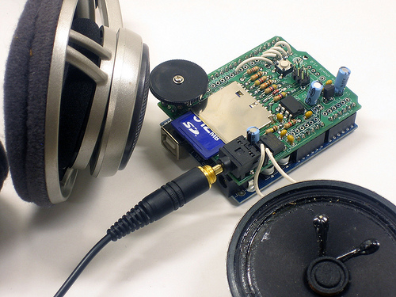

*Wave shield on top of the Arduino*

The programming piece to the project requires two programs to be applied. The Arduino can only run one program at a time. That is not a problem because one program is only for testing and the other program needs to run at all times. One program is to identify the frequency of each tag and the other program is used to run the teddy bear. The RFID program is a test program to monitor the tags so we can label the tag and the audio files to the right tag. The Arduino environment has a serial monitor to detect the frequency to displays the tag ID. Each tag is different so we can have different options of audio playback. If the RFID tag displays for example “2100D82331” as one of the tags, we can then mark the tag with that ID as well as the audio file. Notice that the tag is in fact hexadecimal. The audio file name must correspond to the tag ID to keep consistency as well for it to run in the program correct. So the RFID only task is to identify each tag since the tag is not initially labeled from the manufactures.

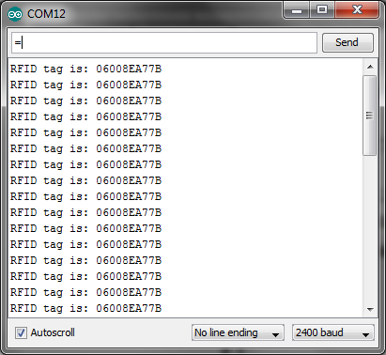

*RFID Tag identification using Serial Monitor and Results*

Now to record audio we will use Audacity which is a free open source programs for sound recording and editing. The wave shield can only read certain audio formats. We need to convert all audio files to the proper format which states that the sample size must be 16-bit; PCM encoded, and has a sample rate of 22 kHz or less. Since we are using voice only we can use 8 kHz but the audio quality will suffer. We have to name each sound corresponding to the RFID tags values. It will be highly unlikely that there will be a pair of tags with the same hexadecimal value. After checking the tags, it is time to load the main program to run the teddy bear. The program requires a wave shield library to run the wave shield. This can be found easily since the code for the wave shield is unique and difficult to write on your own. Stuff the electronic devices inside the teddy bear to use and it is ready to go.

**Schematic: Wave Shield**

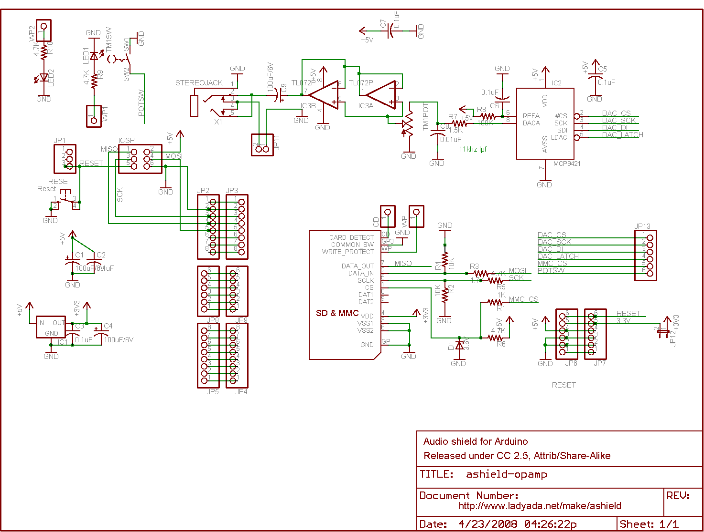

**Project Management:**

*Research Project:* Deciding a project well suited for this class, by going through vary of projects and all agreeing on the same project. We finalized and agreed on the teddy bear project because it was challenging, yet accomplishable with in the time period that was required. After deciding the project we have to find the correct items and parts we needed to complete the project. When we have found all the items and parts needed we purchased the times as soon as possible, so we can have the parts in hand to start the procedure to building the prototype. There was a slight delay on the parts because we accidentally ordered the wrong part and realized it pretty late, so we needed to reorder another part. During the wait process we began what we could putting all the pieces together, soldering all the parts together.

*Planning Project build:* Selecting the roles that are divided equally among each other. Frantz agreed on the technical drawings so all the schematics, so the building process can begin. Zaiyra worked on the power point presentation so the presentation can finish as soon as possible. Then the final part is the paper left for Lucy, putting everything into words.

*Build Prototype:* Continue the building process while doing all the other individual parts and still work together. After prototype is built, we needed to finalize the prototype but there was a slight delay because of the parts that was mistaken. After receiving the part that we needed we finally finalized the prototype.

*Test:* After finalizing the prototype we began to test prototype to figure out what is working and what isn’t working. There was some simple problems during the testing which required us to trouble shoot a couple more time to make sure it meets the requirements. When the prototype was finally up to the requirements we filmed/recorded the prototype to put a video into our presentation.

*Finalize:* We all checked the project requirements that has to be put together by the due date that was given to us. We made sure the presentation is done and the paper is finalized and match what is needed. Then make sure there would not be any more problems with prototype so during our presentation nothing would go wrong. Then we prepare all the equipment needed for the presentation and prepare ourselves to present.

**References:**

"Audio Shield for Arduino." *Ladyadanet Blog*. N.p., n.d. Web. 19 Dec. 2012.

"Audio Shield for Arduino." *Ladyadanet Blog RSS*. N.p., n.d. Web. 19 Dec. 2012.