CET471
Microcomputer Controlled System
Final project report
Huan Yang
Zhiyong Rong
Wai Tso

Objective:
In our final project, we are working on Missile launcher controller. To control the missile launcher, first we need to study on the Arduino which is a microcontroller that designed to make the process of using electronics in multidisciplinary projects more accessible. We will use the Arduino to control the power source in the circuit which is the second part for our project. Second, we need to build a circuit which is receive the power source, and transfer the power source to the motors. Finally, we have to figure out the control system which the motor has two different directions.
Equipments:
Computer
USB Missile Launcher
Arduino Uno Rev3
Resistor: three 120k-ohms
Transistor: 2N4402
Diode
Switches: five STDP
wires

Procedures:
First, we were going to down the Arduino code from the internet and follow the tutorial to control the missile launcher, however we realized the missile launcher we bought is different to the tutorial, therefore the code did not work for our missile launcher. And then, we have to change our plan.
Second, we were trying to use a PS3 controller to control the USB Missile Launcher, however, there are too many levels of difficulty. First of all, the USB host shield library didn’t work with our board. We couldn’t interface the controller with Arduino board.
So that we decided to use switches instead. And we were able to use 5 SPDT switched to control the Missile Launcher. Because of the DC motor is high current load, Arduino Board can’t provide enough power for it. We have to use transistor and extra 5 volt from the Arduino board.

Transistor and motor connection:
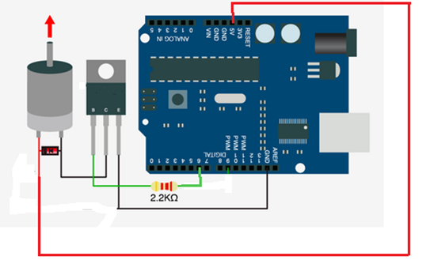
Circuit:
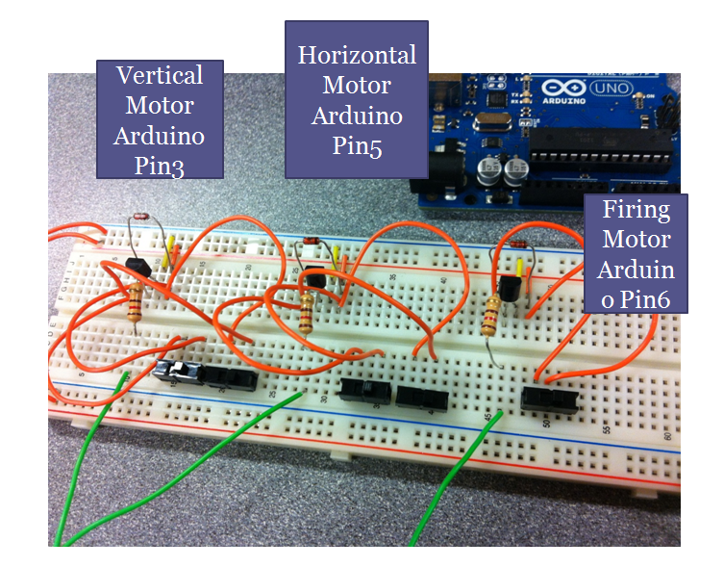
Block diagram:
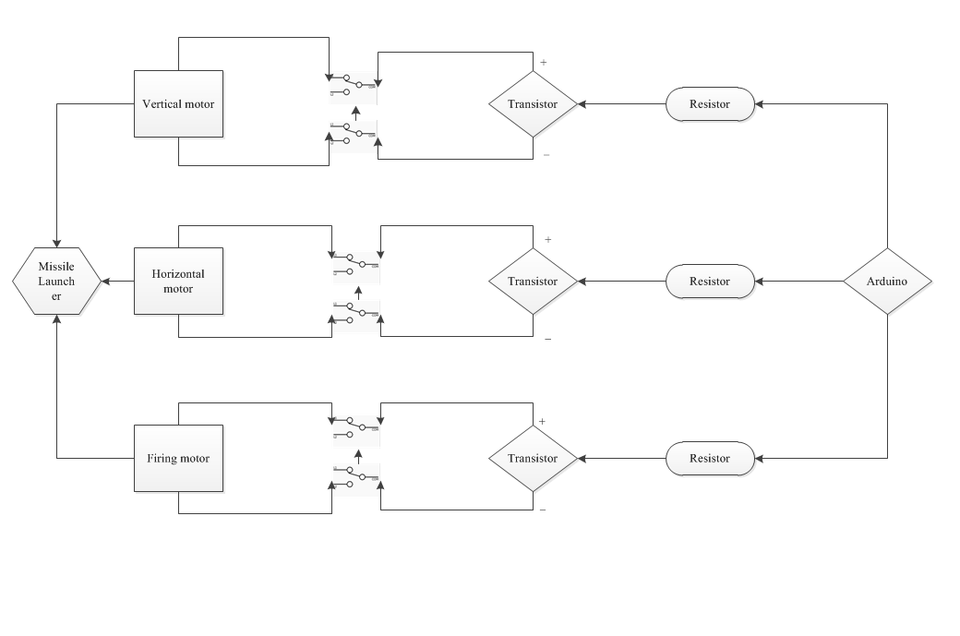
Arduino code:
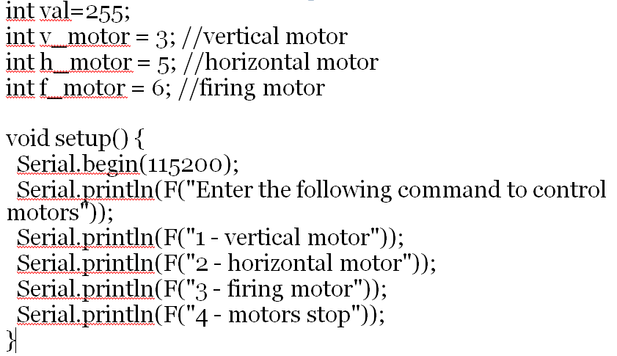

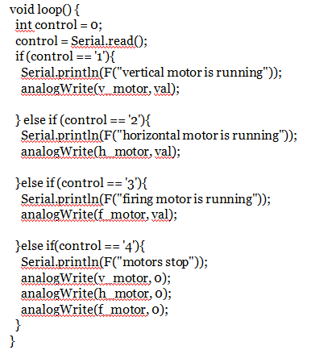
Gantt chart:
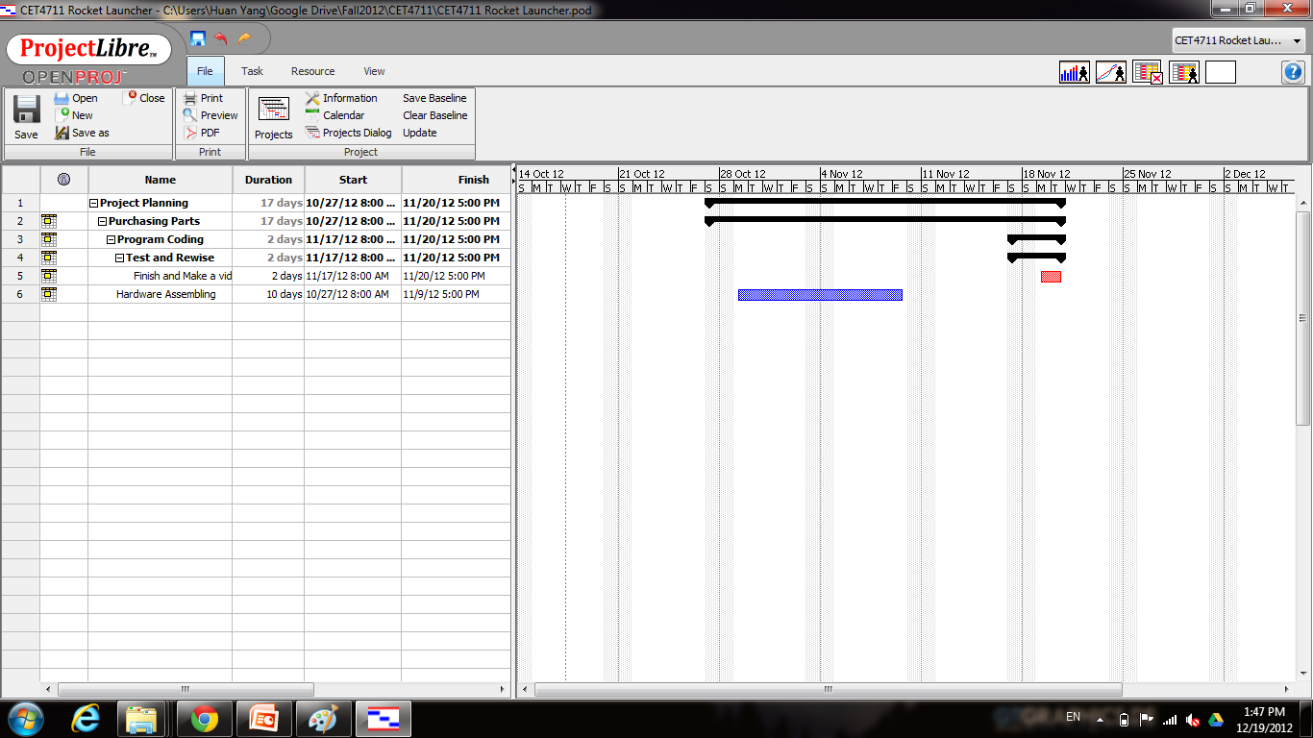

Conclusion:
After this project, we have learn many acknowledge in different realms, such as Arduino library, to provide the power source to control DC motor, the control the DC motor's direction by using Switches. And during this project, we had encountered so many problem, we had change our plan three times. This is because we do not have enough time and equipments to construct our original plan. However we have succeed our main purpose which control the missile launcher, even it is neither by Arduino library or PS3 controller.

