David Winnick

PHYS 1117

EUROPA

Europa is one of the Galilean moons to the most massive planet in our solar system Jupiter. Galileo Galilei on January 7 1610 discovered through his hand built telescope, Jupiter along with 4 of Jupiter’s largest moons. These included Io, Europa, Ganymede, and Callisto. I think that Europa is an interesting Moon, because of its Ice, and Water contents. If we proved that we could actually survive on Europa or a planet similar to it, we can have an expansion of the human race.

Europa is unique in accordance to the other Galilean satellites (moons). Europa is made up of mostly water ice. It is believed that it could potentially have twice the amount of water that earth holds. Astrobiologists have been very intrigued by Europa. They believe that it could be a potential “habitable zone” due to its similarities to earth. The curious moon could be a vital component to understanding life on different planets and how to create habitable environments for either ourselves in the future or other endeavors. It could also prove that there could be life beyond our solar system and somewhere else in the cosmos. Europa has a layer of ice that is that acts like a “crust” (for lack of better terms) and underneath this layer of ice is Europa’s ocean, which engulfs the entire planet. The reason for the ice on the moon for not melting is because it is so far away from the sun, that the temperature doesn’t rise to a point where the ice could actually melt. If Europa did get closer to the sun to where the ice did in fact begin to melt, then the plant would be a giant salt water filled moon. So if humans were to travel to Europa successfully, we would have to adapt to the cold conditions, the lesser pull of gravity, as well as the longer day on Europa. It takes Europa approximately 3.5 Earth days to orbit the massive planet of Jupiter. The intricate patterns on Europa’s surface are all cracks and crannies on the ice. Probes that have been sent there must be careful to not crack the ice too much or else they will be lost to the salty ocean that lies underneath the icy surface.

Though there are no complex organisms (that we know of) living on Europa, there is evidence that simple organisms could have a potential of surviving on the icy moon. *“The warmth of Europa's liquid ocean could prove critical to the survival of simple organisms within the ocean, if they exist.” 1* If they prove that simple organisms can live and thrive on the moon, then the study of complex organisms can commence. This could possibly mean the survival of the human race. Europa has characteristics in order to allow life to thrive. *“Europa is the only other place in the Solar System, aside from Earth, for which there is very strong evidence suggesting a liquid water ocean is present today and is in contact with rock. This is important because life as we know it requires three key basic "ingredients": liquid water, an energy source, and organic compounds to use as the building blocks for biological processes. Europa could have all three of these ingredients. Moreover, and its ocean may have existed for the whole age of the Solar System, giving life a chance the time to begin and evolve there.”2*. Though there is some evidence of certain characteristics that Europa *could* have potential, it doesn’t necessarily mean it does have these things. We haven’t had enough missions to the moon to verify all of these things for sure. There is still many things we must find out about Europa to be sure of anything about it. For example, a Frequently Asked Question on the NASA website is *“Is Europa's ocean like Earth's oceans? “*. NASA replies to it with this, “*We don't really know, but we certainly think it is briny, with salts and minerals dissolved in it, like Earth's oceans. This hypothesis is based on theories for planet formation, which predict that Europa's water came from primordial material that is similar to some asteroids. The extraction of water from what is now Europa's rocky mantle would also have extracted minerals and salts from these rocks. Measurements by the Galileo orbiter support the likelihood of a salty ocean, because salt water is the most likely conductive material for generating Europa's induced magnetic field”3*. So even though we hope that this moon could possibly open many doors that could help unlock answers to the universe that we share, there is the possibility that we could hit a dead end with it.

The possibility of sending human beings to Europa would be a very difficult task. Besides the fact that it would take many decades to get there even if they made it to the moon, they would not be able to work safely there. *“The giant magnetic field of Jupiter traps belts of atomic particles that move at high speed and with great energy. Europa orbits Jupiter within these radiation belts, making it impractical (or perhaps impossible) for astronauts to safely work there without some very advanced form of shielding.”4*. So the theory of Europa containing the possibility of life on it is very nice and hopeful. But, it would be almost impossible (at the moment ) to send humans there because of a couple of things. One, being the lack of technology to get there and survive for a long period of time and then being able to get back to Earth safely. Two, by the time we figure out everything we need to know about Europa, it is very well possible that we could discover a safer planet, or moon that we can travel to, and perform the same experiments on it that we would have done to Europa.

Although there are some pro’s and con’s about Europa, there was a discovery recently. On November 16th 2011, A probe sent by NASA found Europa’s evidence for water. The picture shown here is what the probe found.

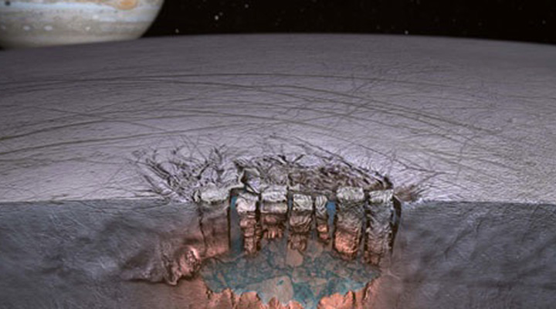

In and article posted on the Nasa website states, “*Data from a NASA planetary mission have provided scientists evidence of what appears to be a body of liquid water, equal in volume to the North American Great Lakes, beneath the icy surface of Jupiter's moon, Europa.* *The data suggest there is significant exchange between Europa's icy shell and the ocean beneath. This information could bolster arguments that Europa's global subsurface ocean represents a potential habitat for life elsewhere in our solar system.”5.* . This discovery alone should give us hope to that it could be very well possible to survive on Europa.

Europa has enlightened me in many ways. The new discoveries that Nasa is making on it is actually very exciting. Many planets and satellite’s that surround us have the evidence that there could have been water, or life etc. On Europa, the evidence has been proven to be reality and to me that is amazing. It has become a big interest to me now because of the recent discovery of Europa having water. Now it is something I will be following more diligently, rather than gazing right over the topic. This moon means a lot to the discovery of many other things in the universe, and therefore we should all treat it as such.