Erick Matos
PHYS 1118/3450
Prof. Acquaviva
December 3, 2012
Mars Curiosity Rover

Mars is described as the “Red Planet” and is in fact the smallest planet in the solar system. However, did you know that if you were driving 60mph in a car it would take 271 years and 221 days to get to mars from earth? Also that Mars is the only planet to have earth like seasons and did you know that Mars is the highest known mountain of the solar system. These are pretty interesting facts about Mars that might’ve lead NASA scientist and physicists to the Mars Curiosity landing mission. The Mars Curiosity rover’s mission is to find any type of life whether from the past or present.
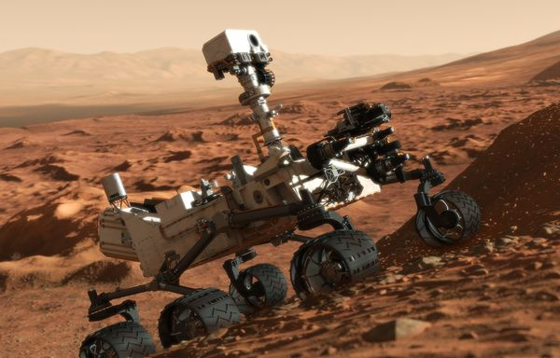
The Mars Curiosity Rover is a car-size craft which took up to two years of preparation and eight and a half month journey to land. A journey of which is 352 million miles long. The mission is believed to be the new era of exploration that could bring evidence that the “red planet” once had the necessary ingredients for life. So it can be said that we are on the search of the capacity of growth, reproduction, and functional activity on another planet. Moreover, the rover is supposed to search and collect rocks and soil sample that hold up clues to past water activity on Mars. The craft is equipped with a laser beam that is used to vaporize dirt around it to do a spectroscopy examination. It also includes a geology lab and plenty of cameras.
The Curiosity is about ten feet long, nine feet wide and 3 meters long and weighs about 900 kilograms. It might sound like a car but certain parts that compose curiosity can be similar to any living creature on Earth. For example, the brain of curiosity will be the computer, the head will be all the cameras it has, the hands is the extended part it has to reach and collect the rocks that will later on be used for study by scientist, the wheels are in charge to help his mobility I can say those are the “legs” and its mode of communication will be through antennas. According to NASA this mission “will last about 23 months”. This will help scientist know whether that environment is condition to life.
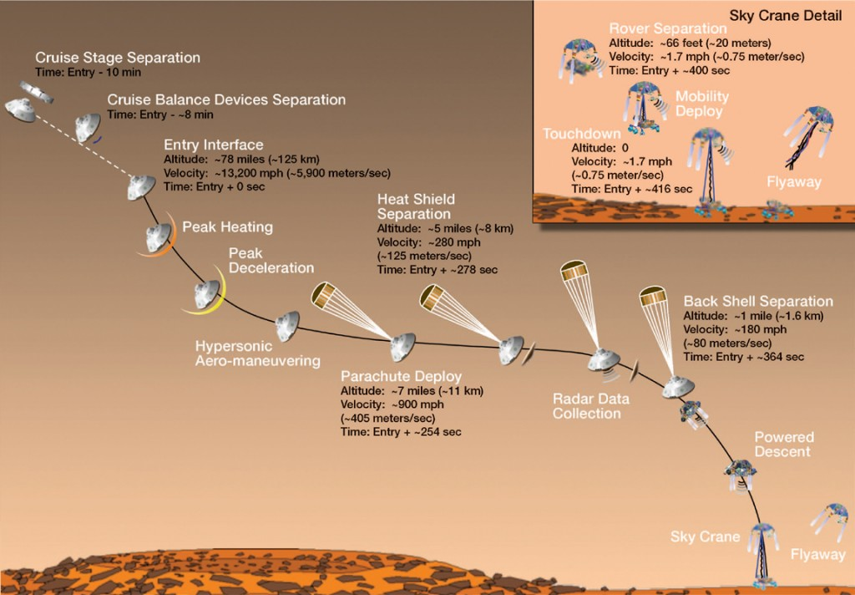
“Touchdown Confirmed” were the words the NASA scientist uttered when Curiosity landed on the Gale Crater, a moment of pure joy for all the NASA staff and enthusiasts alike. The landing of the most sophisticated rover created by man occurred on Sunday August 5, 2012 at 1:31am eastern time. The Curiosity rover was helped land by a looking parachute and a sky crane which is a device to that assisted the landing/touchdown. Although the 2.5 billion dollar project gave us “seven minutes of terror”, which was known as the time it took for it to land successfully and 14 minutes for us at base to receive the signal of a successful landing.
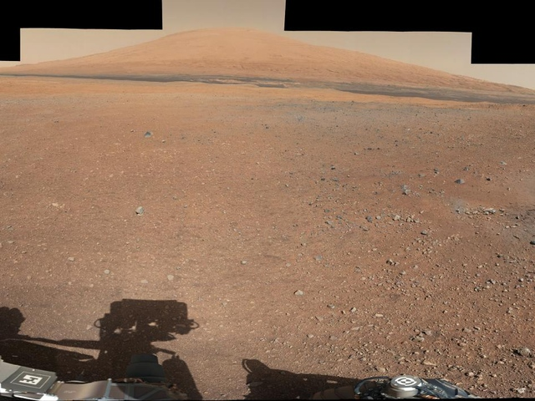
According to the NY Times “the United States remains the center of the universe for space, ahead of Russia, Europe and China, and for NASA, it was a chance to parry accusations of being slow, bloated and rudderless.” this in fact was one of the grates achievements for NASA. This mission has brought a lot of expectations to many to find a trace of life. There is access to all the video, photos, and maps of the landing of curiosity on the internet, more specifically NASA’s website.
Curiosity has definitely captured the public’s imagination and has impacted science in many positive ways. For scientist it has brought moments of joy and a feeling of a monumental achievement in mankind’s history and engineering science followed by its success. According to NASA this mission took eight years of pure dedication and preparation, it was challenging but a great achievement. Perhaps the results of this mission may be positive or negative, but one thing that is guarantee is a lot of learning and knowledge of new things for the entire world. In addition the Mars Curiosity mission is already a part of history. Moreover, our most up to date technology and engineering skills did a lot to help for this mission. I would imagine that if it had been done during the 1950’s none of this would have been done to this success. Also thanks to our advances in technology we can be updated from curiosity from every move it makes. Curiosity even has its own twitter account with over one million followers.
Now we wait for a “concrete” answer. That is, was there or is there life on Mars. Can future generations successfully live on this planet? Only time will tell and Curiosity’s data gathering can help us, at the moment!

References:
1. New York Times Magazine/Website
2. NASE.gov
3. Wikipedia.org

