Danny Chen

Life Cycle of Stars

Just like human beings, stars have a life cycle. Stars are born, and they go through different stages where they will eventually die. By understanding stars I believe we can understand more of what is out there in our vast outer space. Understanding the stars life cycle is important because it will help us learn and understand more about stars. It's also a great idea to understand the stars, especially when located within the center of our solar system is a star, the sun. All stars go through a complex transformation throughout its life.

The life cycle of a star is determined by the size of its mass. If the star has a larger mass, the life cycle of the star would be shorter than a star with less mass. The mass of a star is determined within the nebula. The amount of matter in the nebula leads to whether the life cycle of the star is long or not. The nebula is a giant cloud of gas and dust composed mostly of hydrogen and helium. The nebula is the rightful birthplace of stars because dust and gas is what makes up the form of stars. Eventually the hydrogen gas in the nebula is pulled and moved around by gravity and begins to spin. The hydrogen gas mixes with the dust and heats up. As the gas and dust rotate and spin faster, it heats up and becomes a protostar. The protostar is basically the baby form of the star as it has just formed. The protostar is in its early development phase, just like a fetus for human beings.

After the protostar phase there are two options. The first option is that eventually the temperature of the protostar reaches 15,000,000 degree Celsius. Once reached, a nuclear fusion happens in the nebula's core. The nebula will start to glow brightly and become smaller due to the nebula starting to contract and shrink. Then after the nebula contracts the core of the nebula becomes docile and more stable. This phase changes the protostar into a main sequence star. Main sequence stars will remain in this stage, shining for millions to billions of years. Our sun is currently in the main sequence stage, so it is quite young. Also, the sun is a low mass star. The second option is if the protostar does not reach the right temperature required to evolve then it becomes a brown dwarf star, which is a star with little gas, dust, mass, light, and is bigger than a planet but smaller than the regular star.

The main sequence star gets older as it glows. Hydrogen in the core is converted into helium due to the nuclear fusion which is still active. Eventually the hydrogen supply in the core starts to deplete. The core will start to become unstable, wild, and will contract by becoming smaller. The outer layer of the star which is still made mostly of hydrogen starts to expand. By expanding the outer layer of the star, the star cools, become less hot and begins to glow red.

The star has now reached the stage called the red giant phase. The star is red because it is cooler and less hot than the main sequence star phase and has become a giant due to the expanding of the outer layer. All stars grow and evolve the same way up to the red giant phase. The life cycle after the red giant phase is judged and determined by the amount of mass the star has received while it was forming in the nebula.

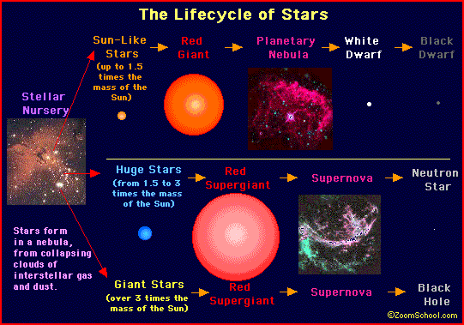 (A)

Low mass stars become medium sized to massive stars after the red giant phase. In the red giant phase, the hydrogen gas of the lower mass stars continues to burn in the outer layer and the temperature in the core of the star continues to increase and rise. Once the temperature of 200,000,000 degrees Celsius is reached, the helium atoms in the core become carbon atoms. The last of the hydrogen gas in the outer layer of the star is blown away to form a ring shape around the core. This ring around the core is called a planetary nebula. Once the last of the helium atoms become carbon atoms, the medium sized star begins to die. The rest of the star's matter and mass begins to collapse together and compact firmly due to gravity. At this stage the medium sized star becomes what is called a white dwarf star phase. In this phase, the white dwarf star's matter is very dense. White dwarf stars shine and emit a white hot light. The white dwarf star will eventually run out of energy and will no longer emit light.

By not emitting anymore light, the white dwarf star becomes a black dwarf star. Black dwarf stars usually have temperatures near absolute zero, and have diameters similar to that of terrestrial planets such as Earth and Venus. In this stage, the black dwarf star will remain forever emitting no light. That is the end of the low mass medium sized stars.

When stars formed with a large mass, also known as super massive stars, reach the red giant phase, the temperature in the core increases and rise as carbon atoms are created from the fusion of helium atoms. Gravity will continue to move carbon atoms together as the temperature increases resulting in the creation of oxygen, nitrogen, and iron. Once the star reaches this state, the fusion of the carbon atoms stop and the iron atoms start to absorb all the energy. The energy absorbed by the iron atoms is eventually released in a large powerful explosion called a supernova. A supernova can light up the sky for several days to weeks. Within the supernova, temperatures can reach 1,000,000,000 degrees Celsius.

After the supernova explosion, the core of the massive star that is 4 to 8 times as massive as our Sun becomes a neutron star. Neutron stars are small stars with the mass of about 1.4 times our sun and with a diameter of about 20 kilometer. This shows that neutron stars are very dense. Rotating neutron stars are called pulsars. Pulsars release radio waves while spinning rapidly. Neutron stars are one of the possible endings for a massive star.

The cores of massive stars with more than 8 times the mass of the sun remains and stay massive after the explosion of the supernova. There is no nuclear fusion or combining of any elements to support and fuel the core, so eventually the star is swallowed by its own gravity. This result in the phase called the black hole. The black hole attracts any matter and energy that comes near it. Black holes are so massive that their own gravity consumes everything in its vicinity such as stars, planets, and even light cannot escape. Black holes cannot be seen thus making them not visible. Scientist can only observe what's around the black holes. Black holes can however be detected by x-rays due to the matter and energy being absorbed and consumed. Black holes are the end of massive stars. Black holes are very brutal and are not a pleasant way for a star to end its life cycle.

Basically the life cycle of a star revolves around first having gravity pull hydrogen gas together to create a cloud. Within the cloud a process called the nuclear fusion starts which causes the star to start to glow and emit light. Eventually a main sequence star, which can live for millions or billions of years start to form. When the hydrogen level in the star begins to drop, a red giant star is formed. Later on, iron which absorbs and acts like a sponge, forms within the star. Once everything is absorbed to a certain point depending on the star and mass, a supernova occurs. After the supernova, depending on the mass of the star determines the fate of the star. If the star was a medium sized star to massive sized, a neutron star will form. If the star was a super massive star, then a black hole is formed after the supernova and starts to consume and absorb all matter around it.

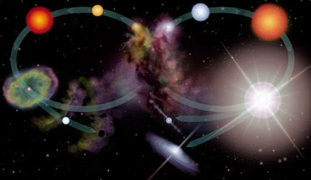 (B)

(Low mass star life cycle on left and a high mass star on the right.)

By understanding the stars are we able to gain more knowledge about what's out there in space. I was able to find out that the sun is a main sequence star and is currently quite young. That means we don't have to worry about the sun dying anytime soon. I was surprised of what the stars were made out off and how different amounts of mass determined the fate of the stars. By depending on its mass, a star will either end its life in a planetary nebula or a supernova. This will result in the core being left behind which becomes a white dwarf star, neutron star, or a black hole. By understanding and studying stars will we be able to understand the rest of our universe.

Citations:

1. "Background: Life Cycles of Stars." *Background: Life Cycles of Stars*. NASA, n.d. Web. 01 Dec. 2012. <http://imagine.gsfc.nasa.gov/docs/teachers/lessons/xray_spectra/background-lifecycles.html>
2. Kornreich, Dave. "What Is the Life Cycle of a Star?" *Curious About Astronomy:*. Cornell, n.d. Web. 01 Dec. 2012. <http://curious.astro.cornell.edu/question.php?number=38>
3. "Life Cycle of a Star." *Life Cycle of a Star*. N.p., n.d. Web. 01 Dec. 2012. <http://aspire.cosmic-ray.org/labs/star_life/starlife_main.html>

Pictures:

1. http://3.bp.blogspot.com/-0rFFa98mcOA/TsGysCU1bvI/AAAAAAAAAC4/EtsIrIS2M2c/s1600/Starlifecycle.GIF
2. http://imagine.gsfc.nasa.gov/docs/teachers/lessons/xray_spectra/images/life_cycles.jpg