Sussy Dilone
“A Journey to Jupiter”
Astronomy 1117
Professor Acquaviva
New York City College of Technology
December 1, 2012

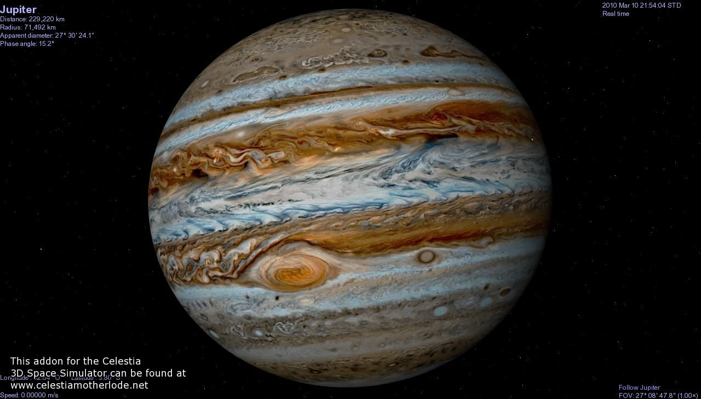

“A Journey to Jupiter”
What does trigger our curiosity? First of all, since we are born, we want to discover and get to understand the world around us. The more we explore, the more our desire to learn grows. Our nature to wonder has reached the exploration of outer space; a place that seemed impossible for us to visit when we got to think that the sky was our limit. Even though we have recorded history of the observation of space for past astronomers of ancient times that have contributed to the knowledge of the solar system and its creation today, there are questions about our origin, that yet we have to discover. The largest planet in our solar system, the one we thought to be born first, the planet that can provide us with the information that will help us determine how the solar system was made and how our existence came to be, is our famous guardian planet: Jupiter.
Named by the Romans, after their king of gods, Jupiter is a planet that symbolizes power and mystery. However, thanks to the early discoveries of scientist Galileo Galilei, the nature of Jupiter was revealing to us. While observing the celestial bodies in space through his telescope in early1600’s, he discovered the four Moons of Jupiter. Galileo observed that the moons were orbiting around the planet meaning that our planet Earth was not the only one with satellites orbit. His observation did not correspond to the geocentric system which suggested that every planet orbits around Earth. Therefore, Galileo reinforced his belief of the Copernican Theory that supports all planets including Earth revolve around the Sun. In addition, finding the four Galilean Moons, helped to understand Earth role in the Solar System. Because of the eagerness of learning more about the unknown, the National Aeronautics and Space Administration best known as NASA was established.
NASA is “a United States government agency that is responsible for science and technology related to air and space. The agency was created in 1958 to oversee U.S space exploration and aeronautics research.” Subsequently with the development of technology more and more spacecraft probes were created with telescopes and other materials to be sent outer space with the purpose of exploring space by orbiting the planets, landing or flying by. One of the famous probes is Voyager 1 that launched into space in September 1977. It was the first space probe to take images of Jupiter remarkable self. The pictures showed the swirling clouds which allowed us to learn that Jupiter is a massive ball of gas with a Great Red Spot which is a hurricane double the size of Earth that has been around for more than three hundred years. Having theories of Jupiter composition, NASA sent a space probe to visit the giant in 1990.
When Galileo spacecraft, named after the great astronomer Galileo Galilei, visited Jupiter, it discovered unexpected elements such as: Carbon, nitrogen, sulfur, argon, krypton and xenon. Chemicals that form in extremely low temperatures mixed with materials that formed in warmer temperatures. The probe also revealed that Jupiter has no surface. Later, in 1995, Cassini-Huygens spacecraft passed by Jupiter’s’ gravity during an orbit to Saturn and studied Jupiter’s atmosphere. The largest atmosphere in the Solar System mostly made of hydrogen and helium. Other amounts found were methane, ammonia, hydrogen sulfide and water. Water is a source of life. Every life on Earth needs water to survive. However, we do not know from where our water comes from. Acquiring the knowledge of how Jupiter got its water, will give us clues of how we came to have it as well.
This mysterious planet will help us to learn how Earth and life itself was formed. The secrets that Jupiter conceals are the ones scientists want to unravel and for the purpose of achieving this, NASA next mission to Jupiter; Juno,-named after Jupiter’s wife in Roman mythology, was created. Juno was launched in August 2011 and its mission is to search for evidences that will answer our questions regarding the early days of the solar system. “Because whatever was in Jupiter at the beginning — more than 4.5 billion years ago, when the solar system was formed — is still there, scientists say, hiding in a mysterious gas giant made up of dust and gas left over by the Sun.” Juno is expected to arrive to Jupiter by July 4, 2016. Juno is having a journey to Jupiter that will last five years. The cost of this trip is $1.1 billion dollars. It is a luxurious journey that discoveries will help human beings to comprehend Jupiter’s true nature and consequently, ours.
Juno Mission has several objectives but the first purpose is to understand the origin of Jupiter. Finding answers of its formation and the role it plays in the solar system are significantly important for us. Other prominent goals of Juno are to study the source of water in Jupiter, to discover if it has a solid heavy core underneath its beautiful stripes swirling clouds and to determine its structure. Juno will accomplish its goals by “measuring the strength of the microwaves radiating from Jupiter. To make the measurements, Juno will travel along squashed elliptical orbit, swooping to within 3,100 miles of the cloud tops. Over the course of 33 orbits during the mission, Juno will get a global view of the interior.” NASA has prepared Juno to survive the conditions of being near the giant planet field of gravity.
Juno has a titanium vault that without it, the radiation will destroy the electronics and the spacecraft will be sent crashing the planet or sent outer the Solar System. Jupiter’s magnetic field is the most powerful in our Solar System. It is 14 times as strong as the Earth magnetic field and contains 20,000 times much energy. Jupiter’s magnetosphere extends seven million kilometers towards the Sun and the edge of Saturn’s orbit. Because of this magnetic field, Jupiter is known as our cosmic protector. Most of the comets and asteroids flying near Jupiter are constantly absorbed by its powerful magnetic field, keeping them away from colliding with our Earth. Jupiter’s nickname is “vacuum cleaner of the solar system” because of its role of being like a protective parent of the inner planets. Juno Mission will survive the intense radiation around Jupiter due to the materials it was made. Scientists are positive that Juno will continue with its journey and successfully discover Jupiter’s nature.
Being witnesses of the fascinating feature of Jupiter‘s auroras is a side goal to Juno Mission. Juno trajectory through Jupiter’s North and South Pole will study Jupiter’s auroras, the most powerful auroras in the Solar System. Aurora is a natural light spectacle in the sky production of the collision of the solar wind and a magnetosphere field such us the Earth auroras in the atmosphere. However, Jupiter’s auroras happen a little bit differently. Jupiter’s rotation of 10 hours drags its planetary magnetic field around with it; producing 10 million volts around its poles. Furthermore, Jupiter’s aurora is a relation between its extraordinary speed rotation and its magnetic waves and the size of those auroras are greater than our entire planet Earth. Jupiter is an interesting planet.
The beautiful and ambitious project Juno, which was put together by hardworking people of the National Aeronautics and Space Administration, will soon provide us with the pieces to finish the puzzle that will let us know our origin. It is true that for obtaining evidences of the early creation of the Solar System Juno’s journey through Jupiter has to spend five long years. Nevertheless, the time for us is not so far from the near future. The hopes of discovering Jupiter as a whole are beyond the altitudes of Earth. Juno’s discoveries might or might not relate to Jupiter’s theories of creation. One of Jupiter’s theories is that it has a heavy metallic core which explains the strong magnetic fields. In other hand, Juno can discover whether it has a core or not and depending of Juno’s research, scientists will have to find new theories to explain Jupiter’s nature and Earths.
By having wonderful minds full of curiosity that eventually drive them to be creative and get to explore to discover what is unknown to us, it is the best definition to describe humankind. Thanks to those brilliant people that dedicated themselves in the fascinating world of science, a world that acquire knowledge and explanation of the universe, because of the evidence obtained that predicts the formation of our Solar System, is due to those past famous scientists that today we can organize and study Jupiter; the giant planet that conceals the answers of our planet’s formation. With the development of Juno spacecraft by NASA, the structure, composition, interiors and Jupiter’s source of water will be studied. In conclusion, the thrilling journey Juno is pursuing at the present, is the key to learn everything we need to know about us.

