“I’ve loved the stars too fondly to be fearful of the night,” Galileo Galilei once said. I have always admired this quote and it has always been an inspiration to me. It has reminded me to not be afraid of the darkness because that is where (we) stars shine the brightest. Everyone in life has their hardships to face and I hope that in times of darkness, you too can remember this quote and let it guide you to finding your way.
Ever since I was a young girl I have always had an obsession with our starry, starry night and would dream of the cosmos. I wondered about the universe and how exactly did I fit into something so much bigger than myself. Now that I am older, I am able to understand more than I ever could (compared to then) at such a young age. I am aware that there is still so much more for me to inquire, as well as for humanity to discover, but with each day will be as eager to learn as much as I possibly can.
The one place that I have been absolutely enchanted by is the Custer Observatory. It is a place that has helped me see and have a better understanding of what is exactly in the night sky. You can explore the universe and see for yourself the wonders that it holds. It is at that point that you will be forever blown away and will keep returning there for as many of their events as you possibly can.
Custer Observatory is located in Southold, Long Island (1115 Main Bayview Road.) It is the oldest observatory that is in Long Island and was officially constructed in 1939 by an amateur astronomer as well as scientist, Charles W. Elmer and his friends, who were also (amateur) astronomers. Pre-construction, (of Custer observatory itself,) they would all meet every weekend at Elmer’s house in Cedar Beach.
The group (and observatory) was named Custer, due to Elmer’s wife, “May, whose maiden name was Custer, was the Grand Niece of General George Armstrong Custer.” The new founded group believed it would be a courtesy to name their group and building after her because she welcomed them ever so happily into her home every week.
According to Custerobservatory.org/history, the new found group of friends and Astronomers bought some land in 1938 and began constructing the Main (northern) building.” The new building was completed in 1939 and they held their first meeting there during that spring.
It was shortly after that in 1945 when they built the second building which could accommodate 100 guests. With the expansion of the building, they also expanded their services to the public by scheduling more astronomy related services.
Even sooner following the second addition was the construction of the three-story tower and dome. The place of which was my favorite due to the narrow stair-cases and wrap-around library’s that smelled something like history to me.
In 1954 Elmer had passed away and that is when Custer had a new addition, three sliding roof observatories which is called the shed. Not much had gone on since then until one event happened that would change Custer and local followers for a long time to come.
It was now 2006 when Custer was topped with the 22 foot steel dome where Custer would soon give Laser shows. The only setback being that you can only have 15 people at a time due to its smaller size. If you are waiting to go into the dome you can use other equipment from Custer or fellow astronomers. One of the times when I was waiting I met a man who built his own telescope out of a cardboard barrel and was able to use it right there on the spot, and it was awesome!
Shortly after the dome was placed atop the building in 2008, came the “Obsession Telescope.” The obsession telescope was bestowed on loan to Custer in October of 2008 and was from Suffolk County Community College located in Riverhead (not too far from Custer.)
The Obsession Telescope is 25 inches (3175mm focal length) and is a reflecting telescope. The height of the telescope is 11 feet tall and according to Custer, is the largest telescope available to the public that is on Long Island. It is one of the many pieces of equipment Custer has and is absolutely amazing! When I looked through the lens I was completely blown away. I observed the moon like never before. When looking at the impact craters and Maria I couldn’t help but feel like I was almost inside of them.
I have also viewed Jupiter and some of its Galilean moons through the Obsession Telescope. I was astounded to see how vivid the colors of Jupiter’s belts and zones were. You see pictures of the planets and think they are amazing but when you’re seeing it with your own eyes and perfectly clear, you can’t help but feel as if you were right there in space.
Another time that I was overwhelmed with what I was seeing was during the Perseids meteor shower. This is the most active meteor shower of the entire year and produces 60 meteors per hour. It is also favorable because the moon isn’t full and allows you to view a dark sky, the perfect condition for a shower.
At Custer Observatory is not only one, but two astronomy clubs. Much like the one for NYC, the ASLI – Astronomical Society of Long Island as well as the AOS – Amateur Observers’ Society of New York, which both host events with and thorough Custer during the weekends and special event week nights. Both clubs also host other events though the club and if you were interested in joining could find more information on their websites as followed. They host many events year round, especially parties on nights when there are said meteor showers. During these parties they try to make it most enjoyable by having bands, refreshments and education videos.
If you wish to visit Custer Observatory or become a member you can do that as well on the link to follow. When becoming a member you will be notified about all events and will also receive their newsletters. There is no entrance fee at Custer but donations are highly accepted, any little bit will help to keep it up and running and ongoing!
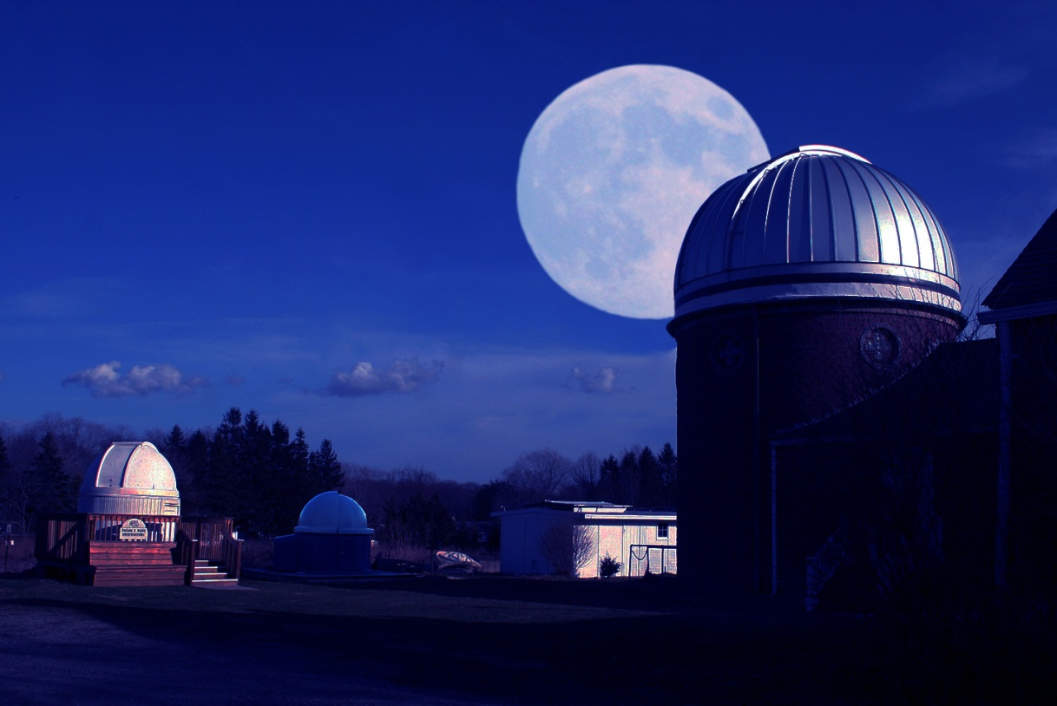
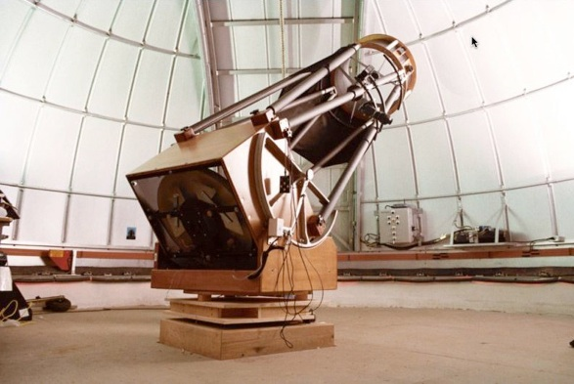
This is the 25” obsession Telescope, located in the Dome atop Custer Observatory! It is also the largest found in any public Observatory on the East coast.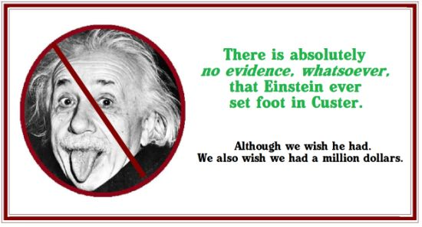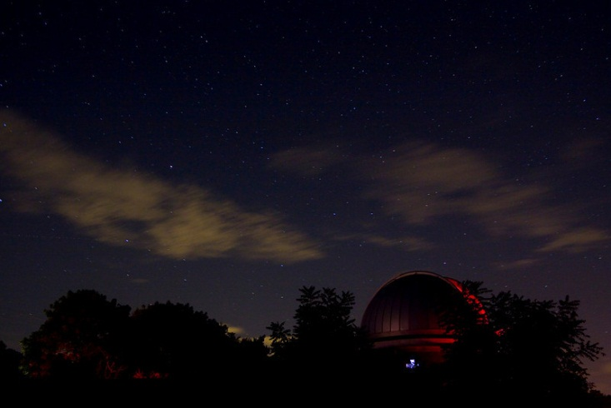 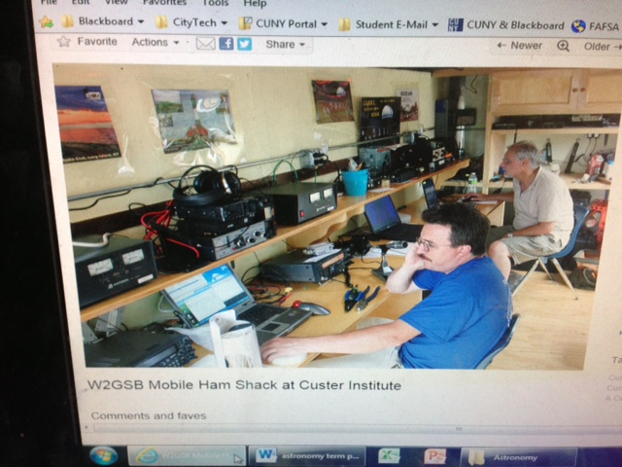
Some of the equiptment found in the shed at Custer (taken from Flickr)
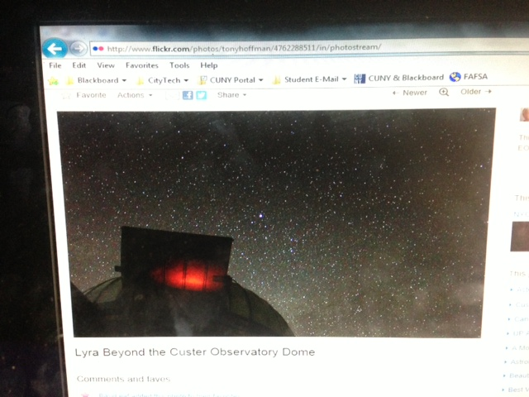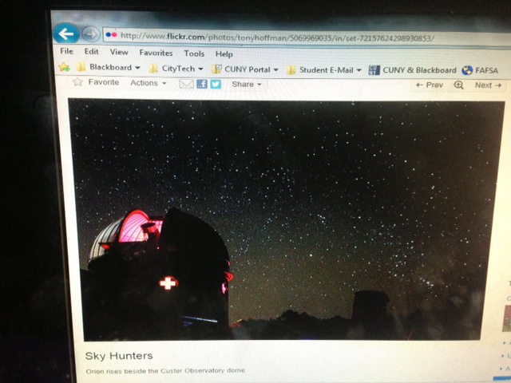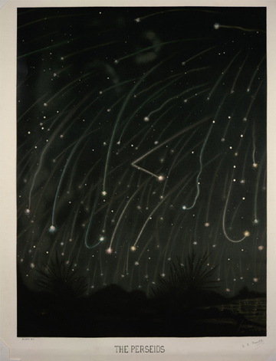

Taken directly from “http://www.custerobservatory.org/equipment.htm”

Custer Equipment
Custer has a large collection of telescopes of all sizes and description.
Equipment in BOLD are those most often used. Among them are:
- 25" Obsession Newtonian reflector (on loan from Suffolk Community College).
- 14" Celestron CGE-1400 Go-To Schmidt-Cassegrain (South Bay, Shed)
- 14" Meade LX200GPS-SMT
- 13" Newtonian Dobsonian ('Red Dob')
- 12½" Newtonian reflector
- 12½" Newtonian (long white one)
- 12" Springfield designed by Russell Porter.
- 10½" Newtonian reflector ('Blue Odyssey Dob in the Dome')
- 10" Astro-binoculars, designed and built by one of the observatory members, Rico Verticchio, and on loan to Custer.
- 8" Schmidt Newtonian.
- 8" Classic Cassegrain.
- 7" f/20 refractor
- 6" f/10 white Eichner refractor (in the Elmer room)
- 6" Alvan Clark Refractor circa 1900
- 5" Alvan Clark Student Model refractor
- 4" Unitron, f/14.7
- 3.5" Bausch & Lomb refractor, f/13.7
- 80mm Jaegers Refractor, f/15.4
- 2.4" brass telescope in the Elmer room (unknown mfg.)
- 7x21 Ross Camera, f/7 with a 3" lens, accepting 8x10 and 4x5 inch plate film.
- 8" SCT f/11 Canon TV Lens (mislabeled as a Maksutov; the corrector lens is definitely Schmidt); ex-NBC Corp; usable with eyepiece, but the matching mount is only usable for a small altitude range (meant for TV studio)
- 8" SCT f/5.6 SCT TV Lens (circa 1963-ish, some mfg. in Glen Cove); ex-NBC Corp; needs adaptor for visual eyepiece use, but would be a cool project to retrofit (originally meant for attaching to TV studio camera)

Refrences & Helpful Websites:
http://www.custerobservatory.org/
Custers Homepage

http://www.seasky.org/astronomy/astronomy-calendar-2013.html
My favorite Calendar to view upcoming events, year round

http://www.asliclub.org/ASLI/NEW_ASLI_Home.html
ASLI – Astronomical Society of Long Island

http://www.aosny.org/
ASO – Amateur Observers’ Society of New York

