My very educated mother just served us nine…. what no more pizzas?! But I love pizza! Now we must say: My very eager mother just served us nachos! Who eats nachos! If you love Pluto like me then you know what I am talking about.
Figure 1: Pluto
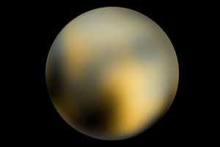

Clyde Tombaugh was the first to discover Pluto in 1930. He was given an assignment to come up with proof and in one region of space; he had two images that were taken two weeks apart. There was a moving object that would move from one image to the next. Over the next several months, he noticed the same object in one particular orbit, producing Planet X. And because of this discovery, he was given the honor of naming it. A young girl suggested the name Pluto, after the Roman god of the underworld.
Pluto has always been special compared to the other planets. It has an inclined orbit of about 17° and it intersects with Neptune’s. For about 20 years, Pluto was closer to Sun than Neptune. In 1978, James Christy from the Hubble Telescope discovered Pluto’s innermost moon. The unique relationship between Pluto and Charon is that they share the same common center of gravity, barycenter. They are referred to each other as a double planet because Charon is half the diameter of Pluto. Pluto is one of 70,000 large icy objects scattered in the Kupier Belt. Charon is not the only moon. Pluto also has two others: Hydra and Nix. When they were first discovered Hydra was thought to be a little brighter than Nix and about 20% bigger. But after several observations, they were found to be identical.

Figure 2: Pluto and its moons
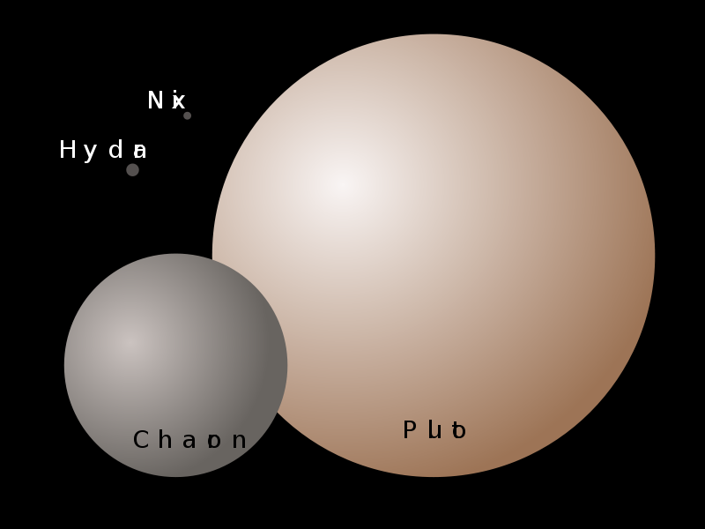
As telescopes became more powerful and technology grew, scientists discovered more and more in the Kupier Belt. Haumea with its two moons was discovered in 2005, and it measured smaller than Pluto. In 2005, Makemake was also smaller. Also in that same year, astronomers figured there would be something that would come along that would be bigger than these smaller objects; it was just a matter of time. And they had come across the tenth planet, Eris, from the Greek goddess of discord and strife. Eris measured about 5% bigger than Pluto; they decided that they were either parents or something else. But Eris was not automatically recognized as an official planet the International Astronomical Union (IAU) decided to wait on the status of it until they could actually define what a planet is considered.
In 2006, the IAU produced a new category for organizing new bodies found in space called the dwarf planet. A dwarf planet is “a celestial body orbiting the Sun that is massive enough to be spherical as a result of its own gravity, but has not cleared its neighboring region of planetesimals, and is not a satellite.” Astronomers determined on the three criteria that can determine whether a planet can actually be called a planet.
- The object must be in orbit around the Sun.
- The object must have enough gravity to pull itself into a spherical shape.
- The object needs to have “cleared its neighborhood” of its orbit.
Well, going off these three things. Pluto does go around the Sun. And for the second, since Pluto is smaller than Earth’s moon but of course there is no actual size determination. Astronomers just made it so that the object can pull enough gravity to pull itself into a spherical shape. And lo and behold it does. So naturally the last, characteristic was the problem: the object needs to have “cleared its neighborhood” which means there are no other flying objects around. But this is not the case. This is because Pluto is located in the Kupier Belt, which has numerous ice asteroids. Some of them could be a size of a potential planet. According to the IAU, Pluto only meets two out of the three characteristics. And this makes it a dwarf planet along with Haumea, Makemake, and Eris.
Luckily, Pluto is still the hearts of the

