Andrew Serva
PHYS 1117.8682
The Planet Neptune
Neptune is the farthest planet in our Solar System. It is also one of the most mysterious planets. Neptune was discovered on September 23, 1846 by a French mathematician named Urbain Joseph Le Verrier. He stated that the position and mass of another unknown planet that could cause the observed changes to Uranus' orbit. . Unlike the other planets Neptune was found by a prediction using mathematical formulas and concepts. Astronomers were looking at the planet Uranus when they saw a change in its orbit. Working together with mathematicians they proposed an idea that an unknown planet could be interfering with the orbit of Uranus. The mathematician Verrier predicted where Neptune would appear and sent his findings to an observatory in Germany. The planet was then found the next day by Johann Galle.
Neptune is a Jovian planet and is the farthest planet we have. It rotates around the Sun every 165 years. Neptune has a fast rotation speed so the days are only 16 hours long. The equator takes 18 hours to rotate and the poles take 12 hours. Neptune cannot be seen without a telescope due to its great distance from Earth. It has a mass of 1.0241 × 10²⁶ which is 17 times the mass of the Earth. It is 30 Astronomical Units away from the Sun. Being a Jovian planet Neptune has no surface as it is made up of gas. Neptune is usually compared to the planet Uranus as they are both similar like Venus and Earth are. The magnetosphere is 27 times stronger than Earth’s.
The atmosphere of Neptune is primarily made up of 80% hydrogen, 1.5% methane and 19% helium. The methane is the reason why Neptune appears to be the color blue. The methane that is infused with ice absorbs red light from the Sun and makes reflects blue light back. However, NASA states that “Neptune is a more vivid, brighter blue, so there must be an unknown component that causes the more intense color.”There is an unknown element that has not been discovered yet that gives Neptune such a strong blue glow.
Neptune has severe storms. Like Jupiter, Neptune has a huge dark spot moving around the planet. Winds speeds have been recorded at 600 m/s which are extremely fast almost passing the speed of sound. The space around Neptune is so cold but the core is so hot that the difference in temperatures causes these storms. Neptune releases Neptune has rings like Saturn. However, the rings are very faint. Some of Neptune’s moons orbit inside the planet inside these rings. The rings could have been created by asteroids and icy rock objects. Destroyed asteroids and moons are believed to be the foundation of the rings. The moon Galatea’s gravitational pull has an effect on the rings. Not a lot of data is available because the rings are so faint and Neptune is very far away to observe very accurately.
The atmosphere changes the deeper into the planet you go. There are high altitude .clouds that are very long and stretch for miles. The deeper into the atmosphere the more water and ice you will see. The atmosphere is made up of different type of ices. The interior of Neptune is very simple. The mantle of Neptune has water, ammonia and methane ice. The core is made up of rock and ice. Even though there is a lot of ice and water in the interior the elements are at a very high temperature and under an extreme amount of pressure. The pressure at Neptune’s core is twice as much as Earth’s and the temperature is thought to be at 5400k
Neptune’s Moons
Neptune has 13 moons they are composed of rock and ice. The majority of the moons rotate near Neptune’s equator. The 4 moons Naiad, Thalassa, Despina, and Galatea orbit so closely to the planet’s ring system that there is not a lot of information on them. The closest satellite to the planet is Naiad. Naiad is extremely small with a diameter of 58 kilometers. It orbits around the planet every 7 hours. All 4 moons are thought to be remnants of Neptune’s original moons that were torn apart when Neptune captured its largest moon Triton. On its website NASA states that “Naiad may eventually crash into Neptune's atmosphere or be torn apart and form a planetary ring.” This is because of tidal deceleration. It causes the moon to move closer to the planet while it is orbiting and eventually break apart. This is happening to each of the 4 inner moons of Neptune.
Larissa is the fourth largest moon of Neptune and is a little farther away than the 4 inner moons. Observations have shown that it is heavily cratered and has an almost perfect circular orbit with an eccentricity of 0.001. Not a lot of information is available on Larissa because of its distance from Earth.
Nereid is the third largest moon of Neptune. The most peculiar thing about Nereid is its eccentric orbit. This means that Nereid’s orbit is more elliptical then circular with a centricity of 0.7. Nereid is an irregular moon too with a non circular shape. Like the other moons the main theory is that when Neptune captured Triton Triton crashed into the other moons breaking them up into smaller satellites. The orbit is so eccentric it takes Nereid 360 Earth days to orbit around Neptune.
The next moon is Proteus. Proteus is the second largest moon that circles the planet Neptune. It orbits around the planet in 27 hours. Proteus is also very dark and hard to see. An interesting fact of Proteus is its shape. It has an irregular shape not spherical at all. It is not pulled into a spherical shape by its gravity like other moons. The moon is so close Neptune and is so dark that it is impossible to see with a telescope from Earth. The surface of Proteus has a lot of craters and is weirdly shaped. A theory behind this is when Neptune captured Triton it hot the other moons of Neptune and they broke apart becoming the new satellites it has now.
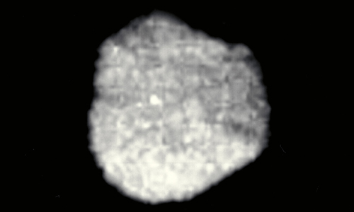

TRITON

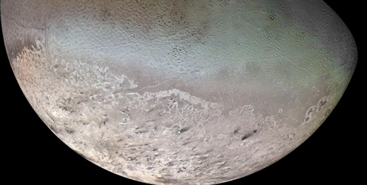
The first moon of Neptune to be discovered was the moon Triton. Triton is Neptune’s largest moon. Triton is believed to be a Kupier belt object that hit the planet Neptune. When it collided with Neptune Triton lost its acceleration and Neptune’s gravitational pull captured it as a moon. Out of all the moons Triton is the most interesting one. Unlike all other moons of Neptune, Triton has a retrograde orbit. This means that the moon orbits the opposite direction that the planet rotates. Triton is assumed to have a rocky core unlike the other moons which have icy cores. This is because the density of Triton is larger than the other moons of Neptune.
A special feature of Triton is that it has its own atmosphere. Very few moons have their own atmosphere. The atmosphere is mostly nitrogen with a small amount of methane. There are geysers on Triton that erupt but instead of lava it is nitrogen that shoots out. The nitrogen that is shot out of the geysers becomes the nitrogen in its atmosphere. It is the coldest object in the solar system with a temperature of -235 Celsius. The nitrogen on Triton is frozen so it creates an ice barrier on the surface of the moon that reflects 70% of the sunlight back.voc on the other moons. Due to Tritons bigger size it disrupted the others moons orbit causing them to either crash into each other and break away or to be absorbed into the planet Neptune itself.
Many theories state that when Neptune captured Triton it caused ha

In conclusion the planet Neptune has many mysteries and is one of the most interesting planets in the Solar System. The mysterious element that gives Neptune its blue color and the rings of Neptune decaying should be investigated. It is the planet that is ignored mostly because of its distance. More research should be done on the planet Neptune because it is the last planet we have in our solar system. The more information we can acquire about Neptune the better. With more information on Neptune we would be able to have more information on the Kupier belt and the objects in them. There are no missions planned to explore the planet Neptune right now.

Works Cited
Redd, Nola. "A Day on Neptune Is Less Than 16 Hours Long: Scientific American." A Day on Neptune Is Less Than 16 Hours Long: Scientific American. N.p., n.d. Web. 30 Nov. 2012. <http://www.scientificamerican.com/article.cfm?id=neptune-day-16-hours>.
"Solar System Exploration: Planets: Neptune: Overview." Solar System Exploration: Planets:
Neptune: Overview. N.p., n.d. Web. 30 Nov. 2012.
<http://solarsystem.nasa.gov/planets/profile.cfm?Object=Neptune>.

Dreifus, Claudia. "A CONVERSATION WITH HEIDI HAMMEL; 'We Have the Potential to Answer Questions about the Origins of Just about Everything in the Universe.'" The New York Times. The New York Times, 02 Sept. 2008. Web. 30 Nov. 2012. <http://www.nytimes.com/2008/09/02/science/02conv.html?ref=neptuneplanet>.

