Yersinia petstis

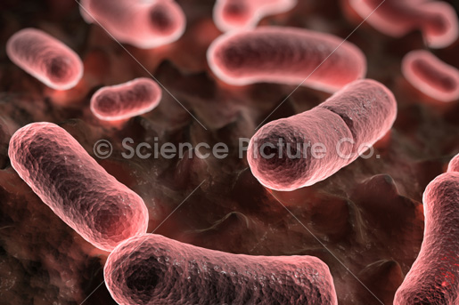

My name is Yersinia pestis, I’m a life threatening infection if not treated promptly. I was very famous in the 14 and early 20 century, where I caused several major epidemics in Europe and Asia. The plagues that I cause are famously known has, “the black death,” because I can cause skin sores that form black scabs.
My genetic material is a skein of a circular DNA localized as the nucleiod. My nucleiod lacks a nuclear membrane. My cytoplasm is filled with ribosome; they are somewhat smaller than my eukaryotic counterparts. My cell wall comprises of an inner phospholipids layer and an outer lipopolysaccharide layer. I have peptidoglycan which lies just exterior to my plasma membrane, and my gram stain is gram negative.
I am a rod shaped obligate intracellular and anaerobic fermented. I am mainly found in rodents, particularly rats and in the fleas that feed on them. The common way for me to infect people or animal is from a bite of an infected rodent. I can be transmitted in three ways:
- Inhaling infected droplets
- Direct contact with infected tissue or bodily fluids
- Bites from infected rodent fleas

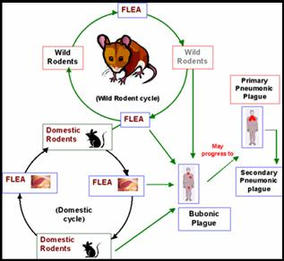
I am a pathogen than can cause three types of plagues:
- Bubonic plague- takes name from the lymph node “buboes” that I infect. Normally acquired through the bite of an infected flea
- Pneumonic plague- I cause this infection of the lungs by inhalation
- Septicemic plague- is the result of plague bacteria multiplying in the blood and disseminating throughout the body. Septimemc plague usually occurs as a result of untreated Bubonic plague.

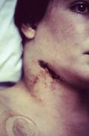
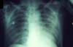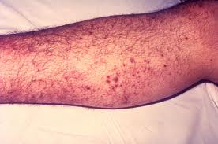

I am a member of Enterobacteriaceae and I encode two antigenic molecules: Fraction 1(F1) capsular antigen and VW antigen. Both molecules are needed for pathogenicity and are not expressed at temperature lower than 37 degree Celsius. This is why I don’t virulent in fleas, since their body temperature normally levels around 25 degree Celsius.

