Determination of oxygen consumption
In order to evaluate the oxygen uptake rate by microbial activity, the following material balance for oxygen can be established:
equation(1)

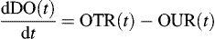
where OTR(t) and OUR(t) are the oxygen transfer rate from air bubbles to liquid media and the oxygen uptake rate at a given time (t), respectively. The term OTR(t) can be described in terms of the volumetric oxygen transfer coefficient (K_{L}a) and the driving force of mass transfer (difference between saturated (DO*) and bulk (DO(t)) oxygen concentration):

equation(2)

OTR(t)=KLa[DO*−DO(t)]OTR(t)=KLa[DO*−DO(t)]
where the K_{L}a value was estimated to be 25.2 × 10³ day⁻¹ by using unsteady state method as described elsewhere [7] and [13].
Here, it should be noted that in an oxygen-limited bioreaction system like the slurry bioreactor used in this study [7], the variation of dissolved oxygen (dDO(t)/dt) is much smaller than OTR(t) and the reactor operation can therefore be considered as quasi-steady state [13]. In the present study, dDO(t)/dt was only less than 0.02% of OTR(t) during whole experimental period. Therefore, with this quasi-steady state assumption, the material balance (Eq. (1)) is simplified as follows:
equation(3)

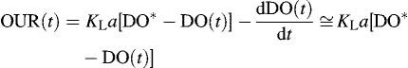
The cumulative amount of oxygen consumption during the slurry-phase decomposition of food wastes can calculated by integrating the oxygen uptake rate (OUR(t)) of the microorganisms:

equation(4)
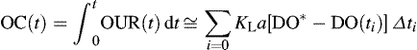
where OC(t) is the cumulative amount of oxygen consumption (g l⁻¹), OUR(t) is the oxygen uptake rate (g l⁻¹ day⁻¹) at time t, and t_{i} is the ith sampling time (day). The numerical integration in Eq. (4) was carried out by a trapezoidal method [2] using the technical computing software Mathematica [15].

Bacterial Growth formula in food decomposition

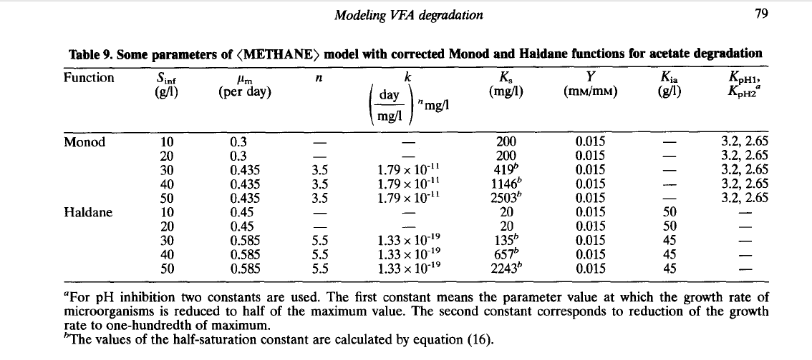

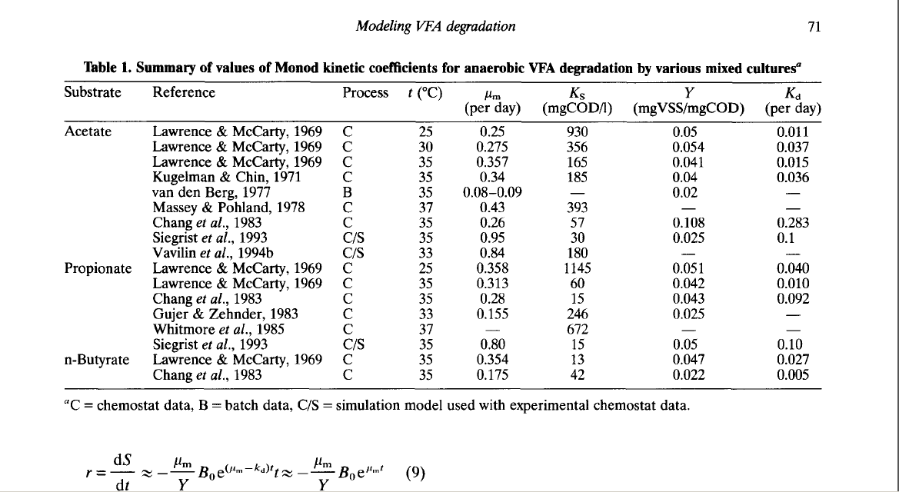

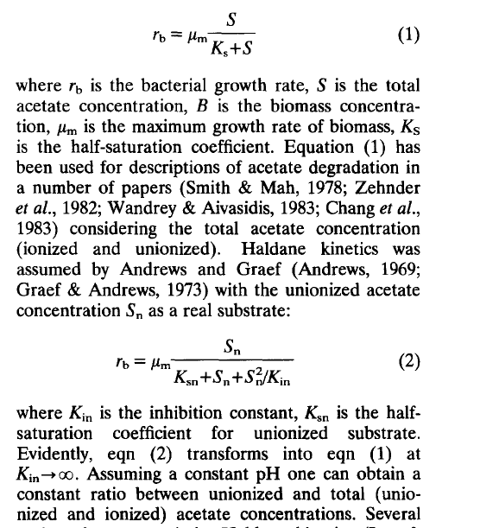

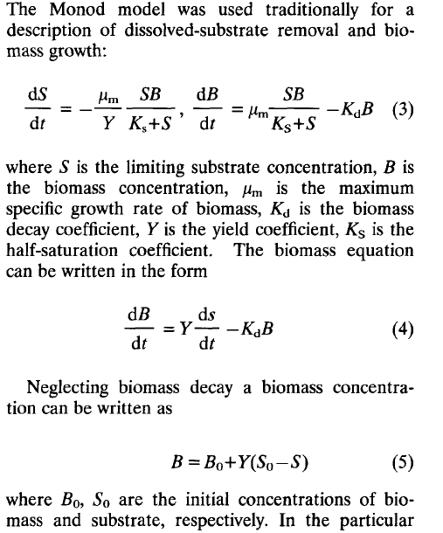

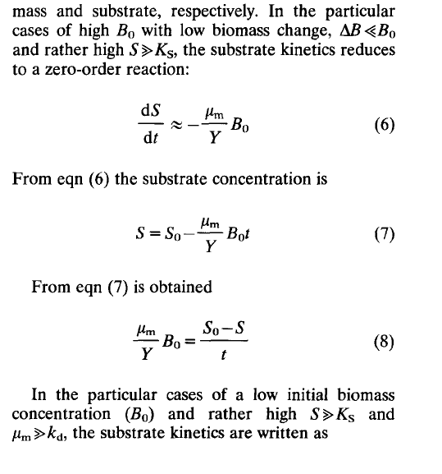

The Correlation of Oxygen consumption and decomposition of carbon molecule in food

