Practical # 2: Unknown
Parbattie Dhanraj
Professor: Dabydeen
Microbiology: 3303
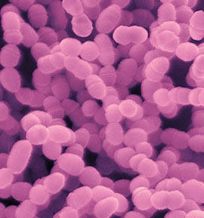
5/18/2012

Introduction:
Microbiology is the study of small living organism. In other words, these organisms are too tiny to see with our naked eyes and require the use of a microscope. These life forms are called microorganism or microbe which includes bacteria, virus, fungus and protozoa. As we know all living organisms are composed of one or more cells called the cell theory of life. However Viruses are not cellular, and are not considered being living organisms. Microbes such as bacteria, fungi and viruses play a role in many areas of everyday life. One very good reason to study them is because it is often the main cause of diseases. Microbes also play a role in food production and waste control, Alcohol in beer, wine etc. Form my microbiology class I have learnt to detect the living condition of some organism. For example, some live in very acidic or basic area some are anaerobic, aerobic, facultative anaerobic etc. Some ferment carbohydrate and produce acid while some produce gas, produce enzyme etc. They are so many more way to identifying and recognising this organism which are very beneficial to us. In this lab are going to try and identify unknown organism # 7. In order to do this we did a number of biochemical test such as; catalase, TSI, nitrate test, SIM, IMVIC, etc. we also did culture bacteria on selective mediu, for example, Blood agar plate (permits the growth of all bacteria) MSA differentiate (use to tell the difference between organism by the way they grew) MAC (encourage the growth of gram negative rods.

Material and method:
The materials used when doing our experiment were:
- Bunsen burner
- Inoculation loops/needle
- Nutrient agar ( hydrogen peroxide)
- Maconkey agar
- Blood agar plate
- Mannitol salt
- Triple sugar slant agar
- PEA agar plate
- Citrate agar slant
- Nitrate
- Bile salts
- Grams stain kit –crystal violet, safranin red, iodine, decolorizer.
- Oil immersion
- Microscope
- Slides
- Tray (for test tube)
- Nitrate reagent A &B ( sulfanilic acid and N-Dimethyl-l-naphthylaine and zinc)
- Indole reagent (kovac reagent)
- VP reagents ( reagent A: naphnol, reagent B: creatine)

Result:
- Gram stain (original)
- When doing the gram stain on Unknown #7 organism was not found under the microscope.

- Result from original agar plate
- Blood agar plate- From this plate I observed that they were oxidation of iron in hemoglobin, giving it a greenish color on blood agar. This is call alpha hemolytic.

- PEA plate media – an isolated culture was chosen and then inoculated into bili escalin slant, from the same isolated culture I then streak a MS plate and last streak NA agar plate.

- MAC plate media – an isolated culture was chosen and from that individual culture I inoculate TSI slant, SIM agar, MRVP broth, Nitrate broth, Urea broth and citrate slant.
Test result from MAC agar plat
- TSI result:
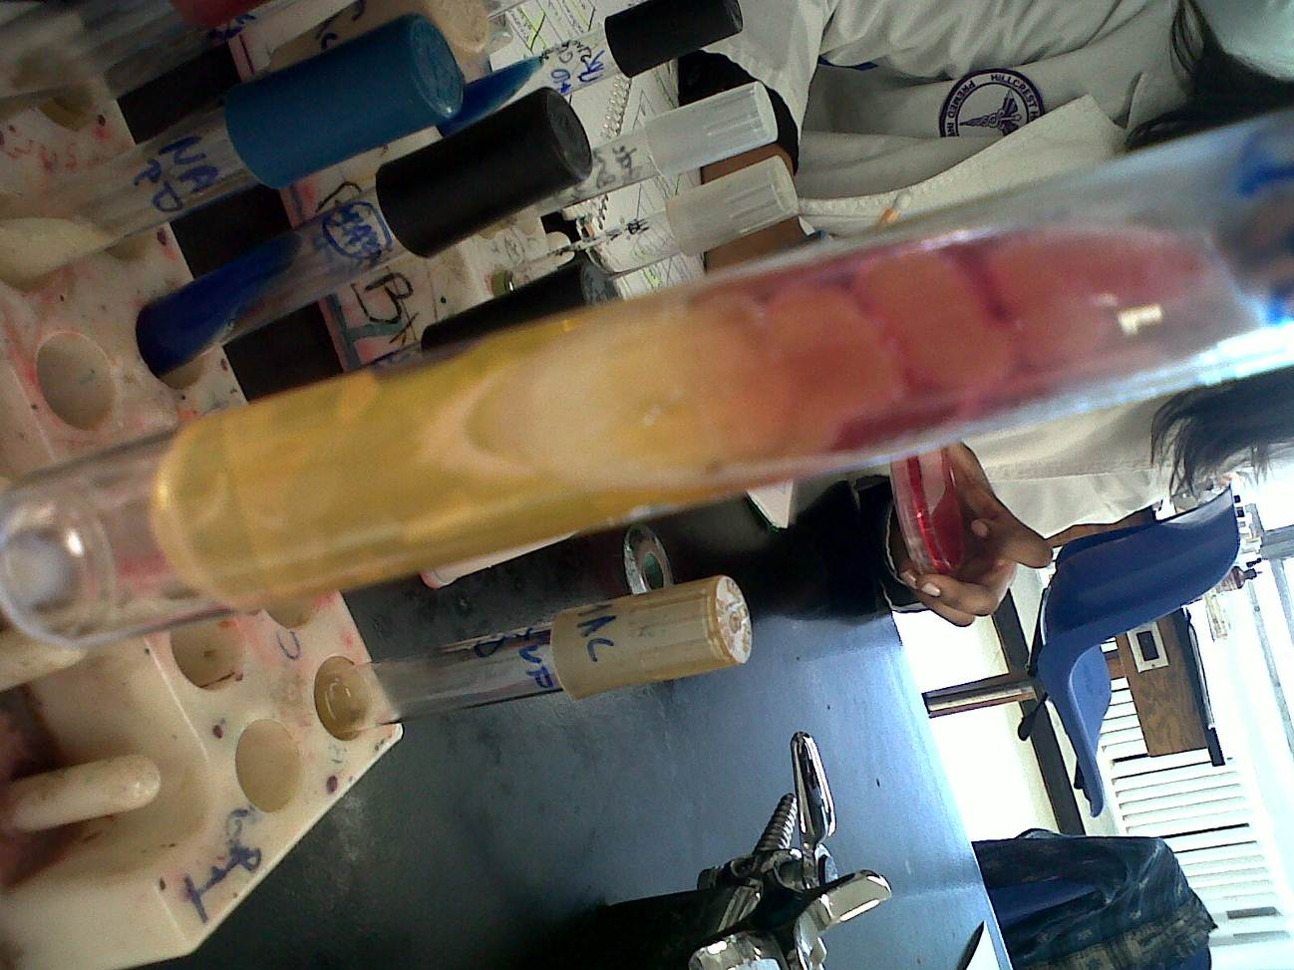
OBSERVATION: butt =yellow, slant=red)
From the observation, I can tell that this bacteria tested positive for gas protein utilization and glucose fermentation. And negative for H2S and sucrose and lactose fermentation.
TEST | RESULT
Gas | +
H2S | _
Protein utilization | +
Sucrose Lactose | _
Glucose | +

- SIM test result:
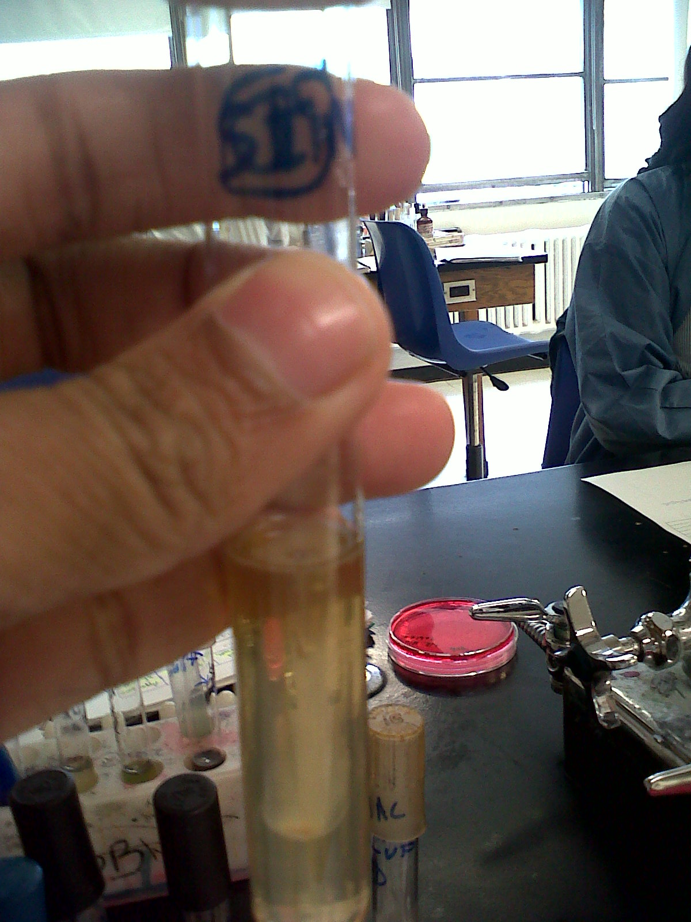
OBSERVATION - there was no blackening in the medium; however I saw that the bacteria spread from the original line it was inoculate in.
Because of bacterial spread I can say that the bacterium is motile and they were no H2S production because they were no blackening in the medium.
TEST | RESULT
Motility | +
H2S | -

- Nitrate test result:

OBSERVATION -add nitrate reagent A and B to nitrate broth and it became red.
Because I added the reagents I could tell that the bacteria produce nitrite, in other words, nitrate reduction positive.

TEST | RESULT
Nitrate reduction | +

- Citrate test result:
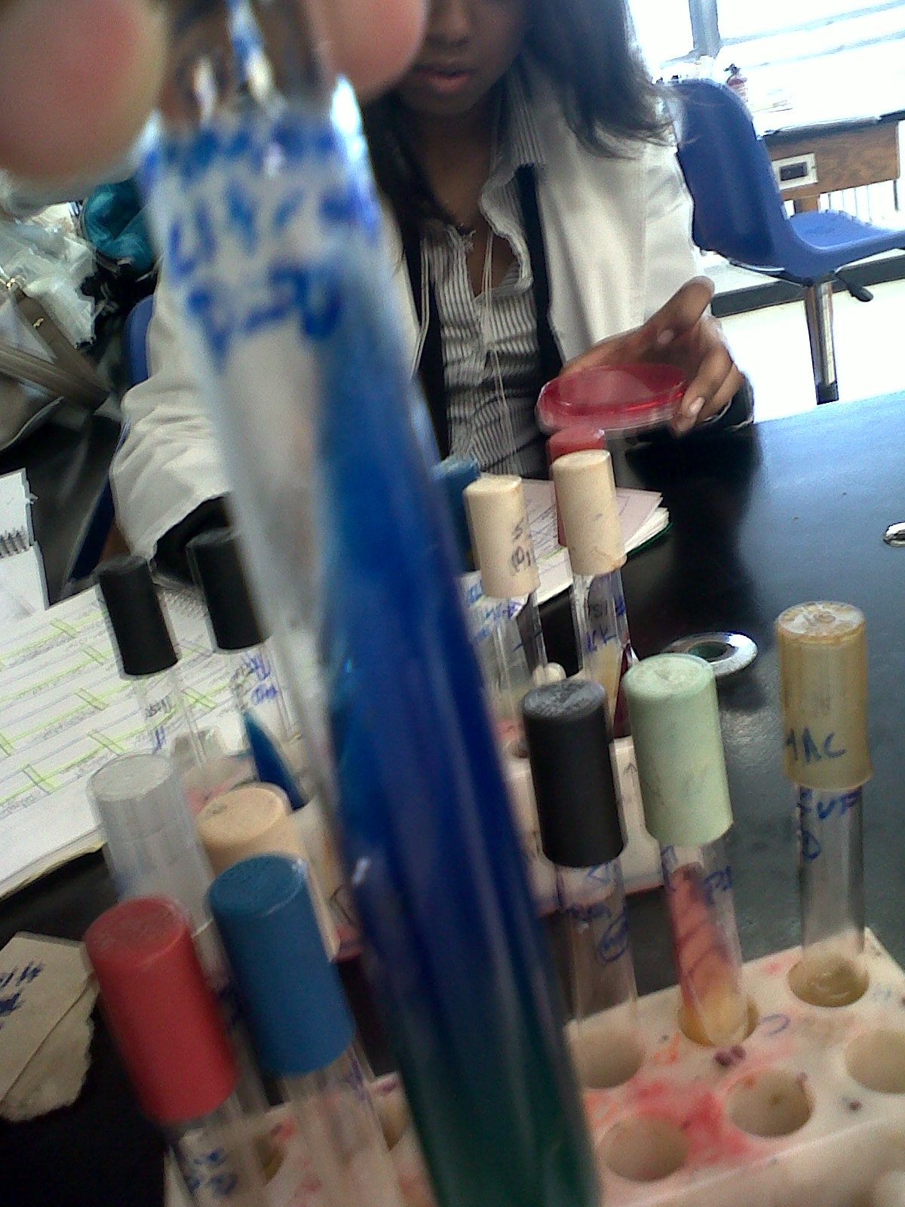
OBSERVATION - the top of the medium was dark blue (alkaline) while the bottom is green (under acidic condition).
The bacteria produce an” enzyme that enables citrate to enter the cell and use carbon as a source for its metabolism and growth”¹, turning the media blue on top which is consider alkaline. That is a positive test for citrate
TEST | RESULT
Citrate utilization | +

- Urea test result:
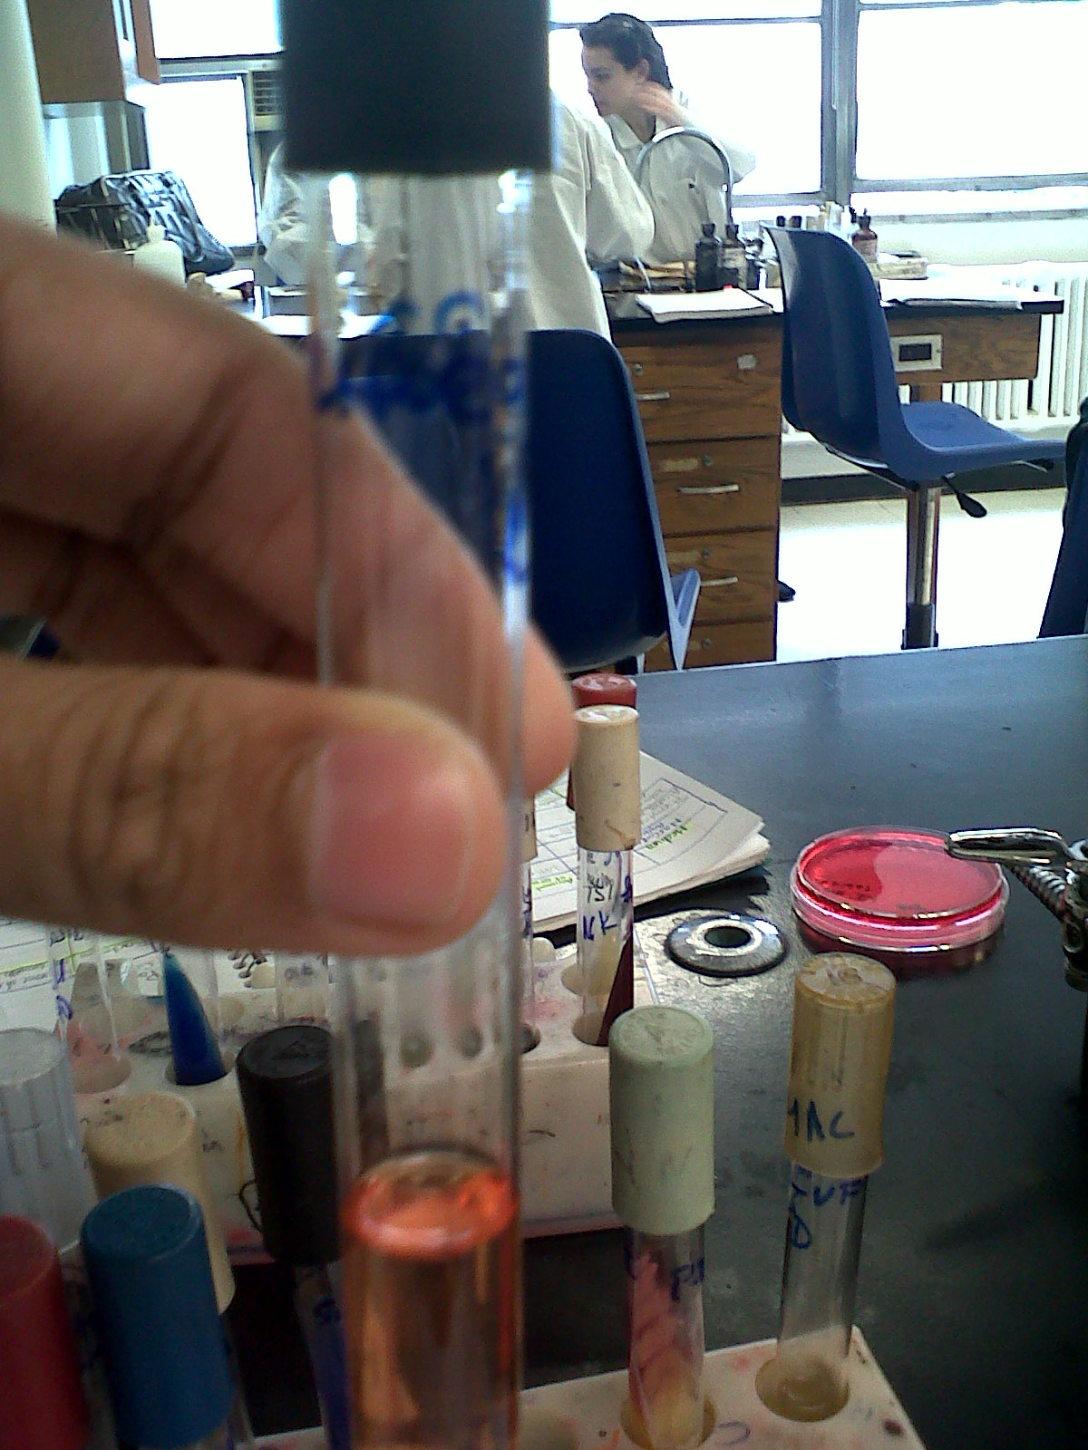
Observation- The urea broth was red in color.
When broth is red it means the broth is basic because bacteria produce urease that changes our waste product into ammonia.
TEST | RESULT
Urea hydrolyses | +

- VP test result:
OBSERVATION - first I add the VP reagents A &B and saw that the VP broth turned red
TEST | RESULT
Glucose/fermentation  Acetylmenthylcarbinol reaction | +

- MR test result:
Observation- the medium was turbulent
TEST | RESULT
Glucose fermentation | _

- Indole test result:
Observation- when add the indole reagent Kovac they were no change in color with.
This test was negative when means the organism cleave amino acid tryptophan into indole ammonia and pyruvic acid”1
TEST | RESULT
Tryptophan hydrolysis | _

Result from PEA agar plate:
Gram stain-
I took a sample of unknown bacteria from a PEA agar plate and did a gram stain. In my result I found gram negative cocci clustered.
- MS agar plate-
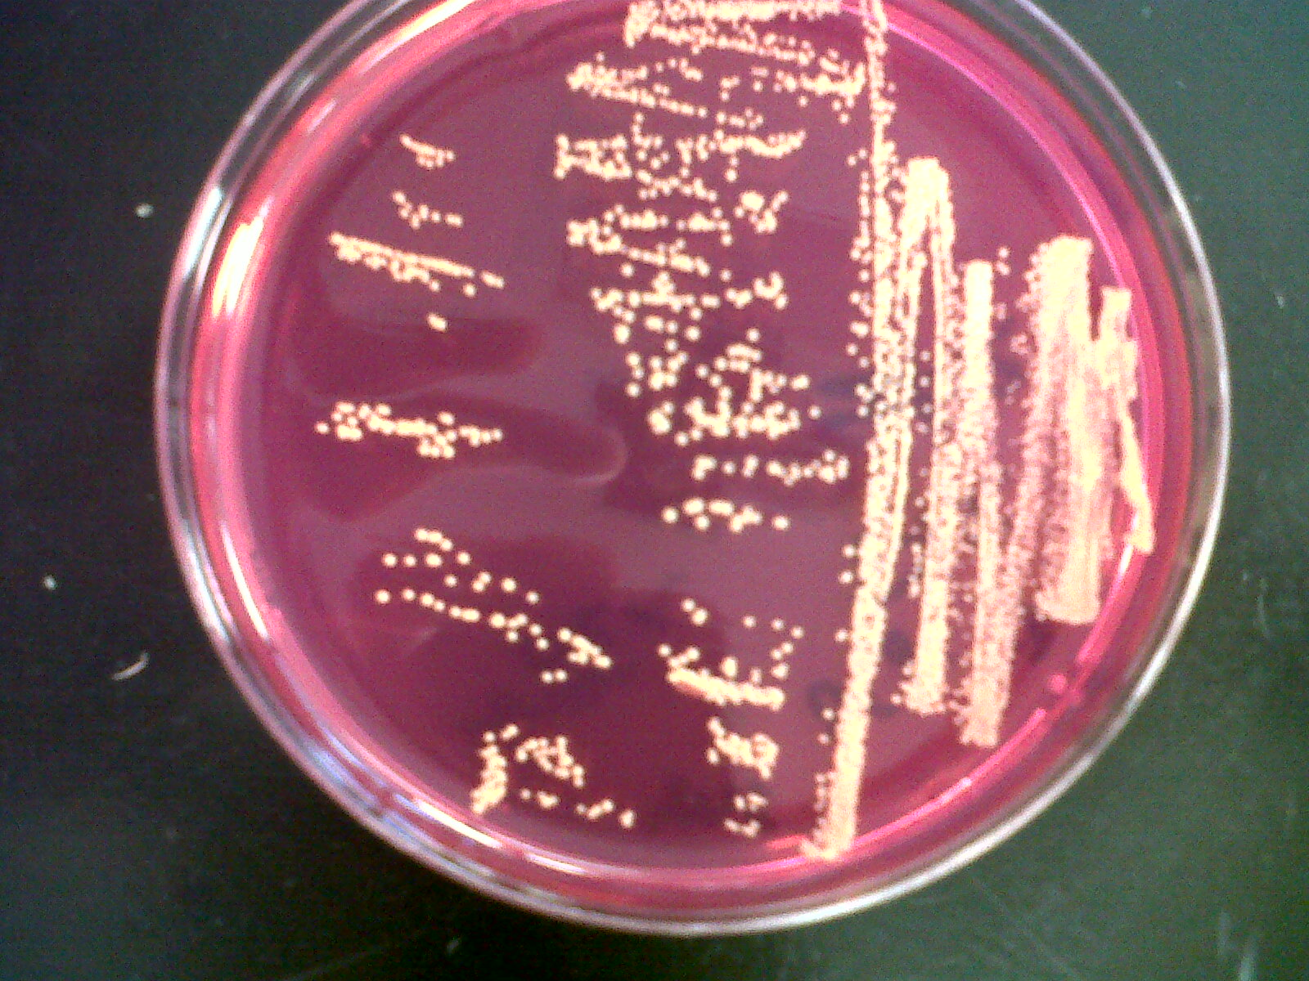
Observation- On this plate there was yellow colonies, however there were no yellow zone surrounding the growth.
TEST | RESULT
Fermentation of carbohydrate mannitol | _
Growth | +

- Catalyze test –
Observation- bubbles was present when I add the hydrogen peroxide
TEST | RESULT
Catalyze | +

Bile salt- (esculin hydrolysis)

Discussion:

Conclusion:

