Navigating Openlab as a member.

http://openlab.citytech.cuny.edu/groups/a-remote-monitoring-platform/
Once you arrive at the main page, you want to open up the dashboard. On the bottom right of the page, under "Project Site" you can choose to view the "Site" or the "Dashboard".

The option "Site" will take you to the section viewable to the public.
OpenLab gives you the option to make certain pages private so that only administrators and members can see them.

The "Dashboard" option takes you to the control panel of the site. Here we have options to create pages, upload files, add media and our privacy settings.
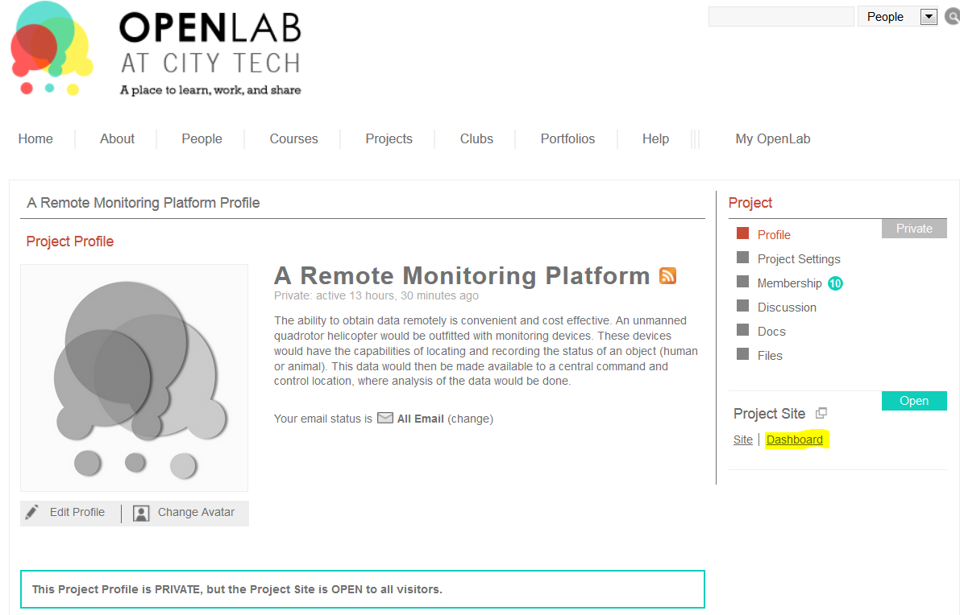

Or you can simply sign in, and hover over "My OpenLab", then select "My Dashboard". A list of all projects you are currently involved in will show up and then you can just click dashboard for the project you wish to work on.

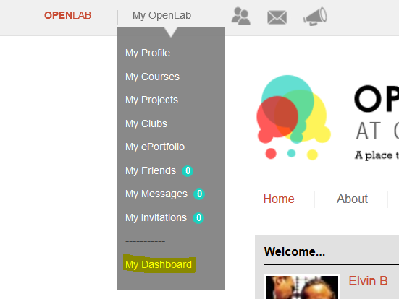

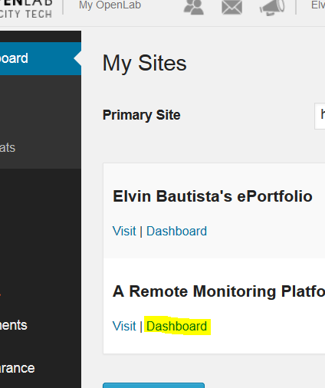

Once we get to the Dashboard, we want to edit the information placed in the pages section. So we navigate to the pages section on the left, then click the all pages selection to take use to the next page.

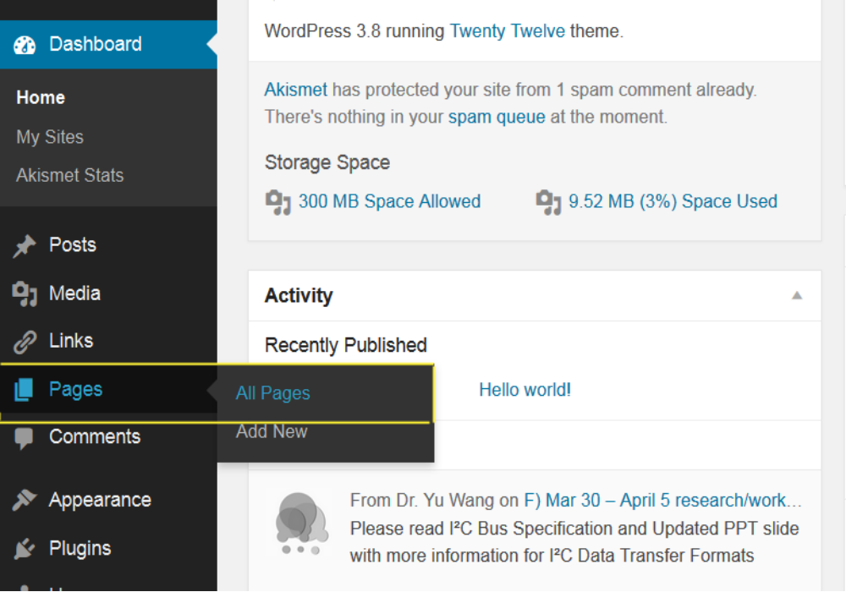

Since we are trying to take our files and organize them into sections divided by their corresponding weeks, pages were already created with those time frames in mind.
So we need to make a new page and make sure it becomes a sub-page of the week we worked on, or in this case, we can upload files to the reference folder.

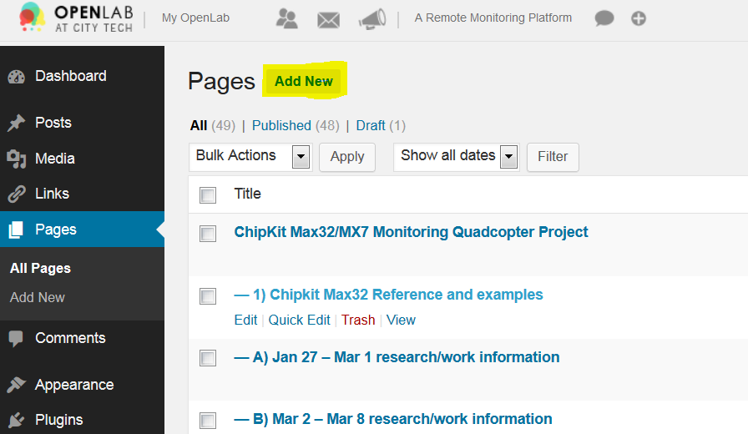

So After you click new page, its going to take you to the next screen where you can add the title and body of your new page.

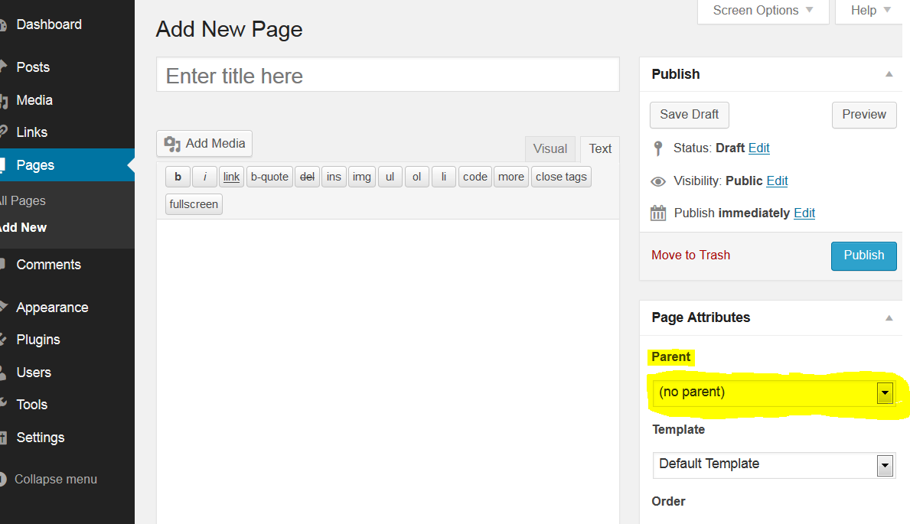
Under Page attributes, you will see a dropdown menu called parent. This option gives you the ability to take a pre-existing page, and make it the "parent" of the page you are creating. So the page you are creating becomes a sub-page of the parent page you choose.

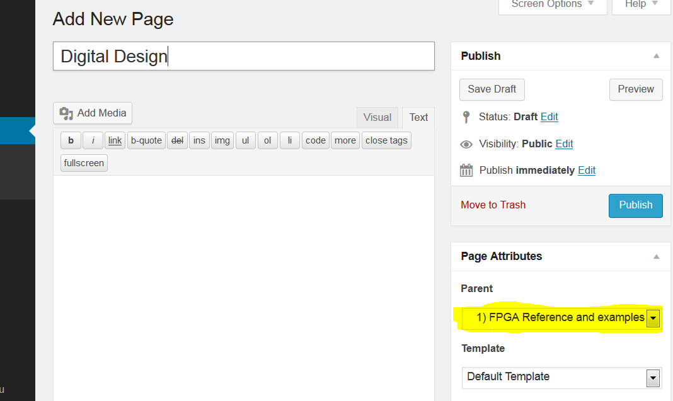

In this case, I want my digital design to belong to the "FPGA Reference and examples" category when other look for it on the main page.

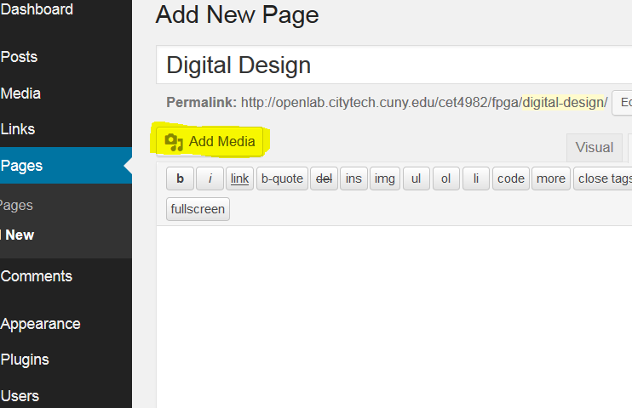
Now I need to use "Add Media" to upload the schematic to the reference page. When you click, add media, you then click the "Upload Files" tab and then the select file button will appear. Here I've found my schematic and now I will upload.
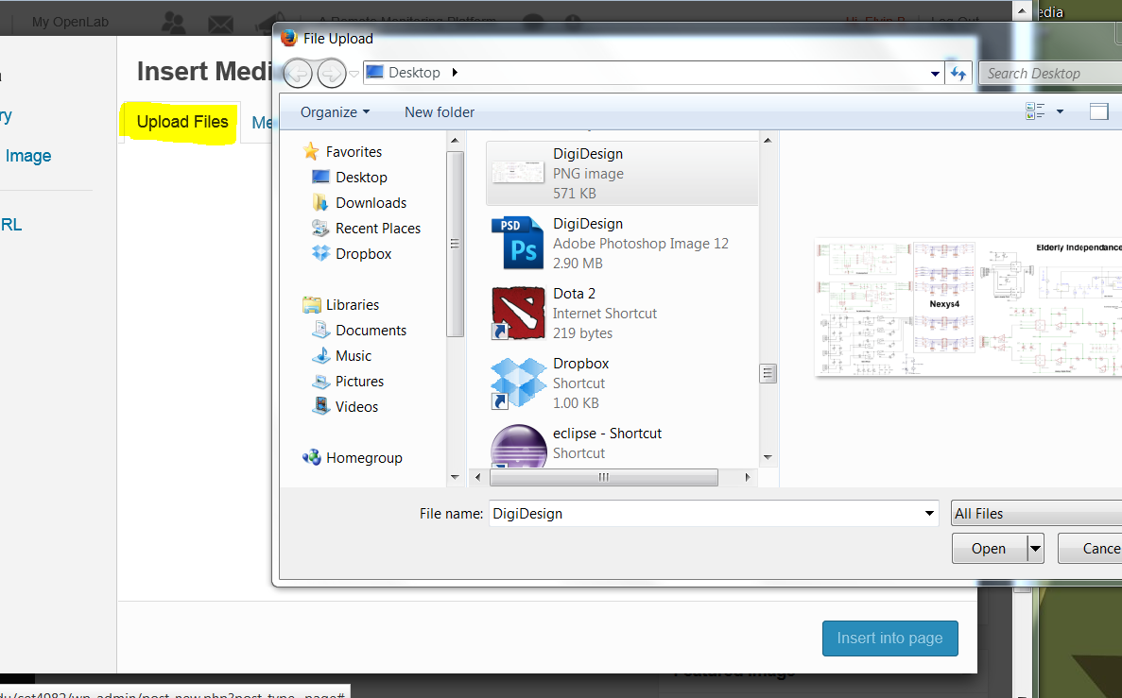

So after the upload is finished, you have to insert your file onto the page itself.

In this case, the media is a picture, so OpenLab will place a smaller thumbnail which can be expanded if the picture is too big.
If youre importing a PDF or some other sort of media that is not a picture or sound file, OpenLab will create a download link for it. So when you want to share things like datasheets, this will apply.
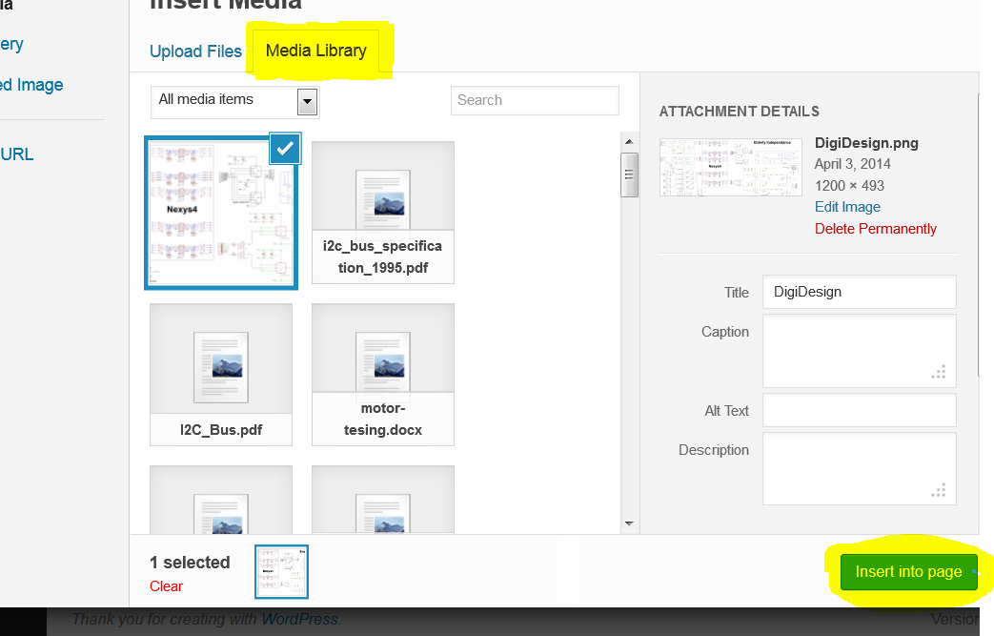
Last but not least, the privacy settings will determine if the user can see it on the main page or not. When a file is private, the only way to view it would be through the dashboard. Publish when you are finished.
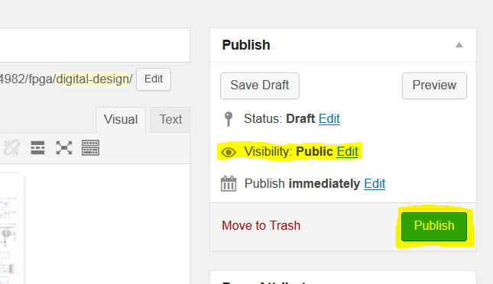

Now lets check it out on the main site and see if it worked.
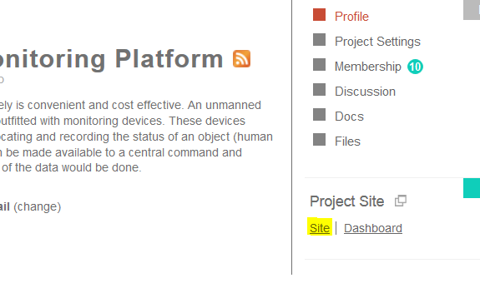
Here you can see the Sub-Category was successfully created.


